**Calendar of Events**

Sept 15 M/O Care Center Service @ 2:00 p.m.

Sept 16 Men’s Christian Fellowship @ 7:30 p.m.

Sept 17 W.O.C. Program at M/OCC @ 2:00 p.m.

Sept 18 Women’s Bible Study @ 9:30 a.m. & 6:00 p.m.

8th Grade Confirmation @ 3:30-5:15 p.m.

6/7th Grade Confirmation @ 5:30-7:00 p.m.

FCA at Menno Gym @ 7:30 p.m.

Sept 19 Prayer Group @ 12 Noon

Sept 22Prayer Time for Service @ 8:30 a.m.

Sunday School Classes @ 9:15 a.m.

Praise Music @ 10:15 a.m.

Worship Service @ 10:30 a.m.

**Upcoming Special Music**

Sunday, Sept 22 - Available

Sunday, Sept 29 - Available

**Announcements**

**Menno FCA:** The Fellowship of Christian Athletes will be meeting on the 1st & 3rd Wed. of each month at 7:30 PM. This is open to students in 8th thru 12th Grade.

**Christmas Eve Program Director:** We are in need of someone to direct our Christmas Eve Program this year. Please contact Lee Heckenlaible or Pastor Mike if you are interested. For questions about what this involves, please contact Emily Guthmiller. Special Thanks to Emily for directing the program for the last two years!

Planning for the program needs to begin by the end of September, so please respond soon if you are willing and able to direct the program.

**Church Pictorial Directory:** Pick up your copy of the new pictorial directory today after church. Special Thanks to the Committee Members who worked towards its completion!

**Weekend to Remember:** Here is a wonderful way to invest in your marriage! This is a 2 ½ day getaway that equips couples with practical tools and resources. It is scheduled for Nov. 15-17, 2024 in Sioux Falls. Check out their website for more information: *www.familylife.com*

**Salem Reformed Church – Who Are We?**

**We believe the Bible to be the inspired, inerrant, infallible Word of God in its original manuscripts. It is our supreme authority in all matters doctrine and practice. We are affiliated with the Conservative Congregational Christian Conference.**

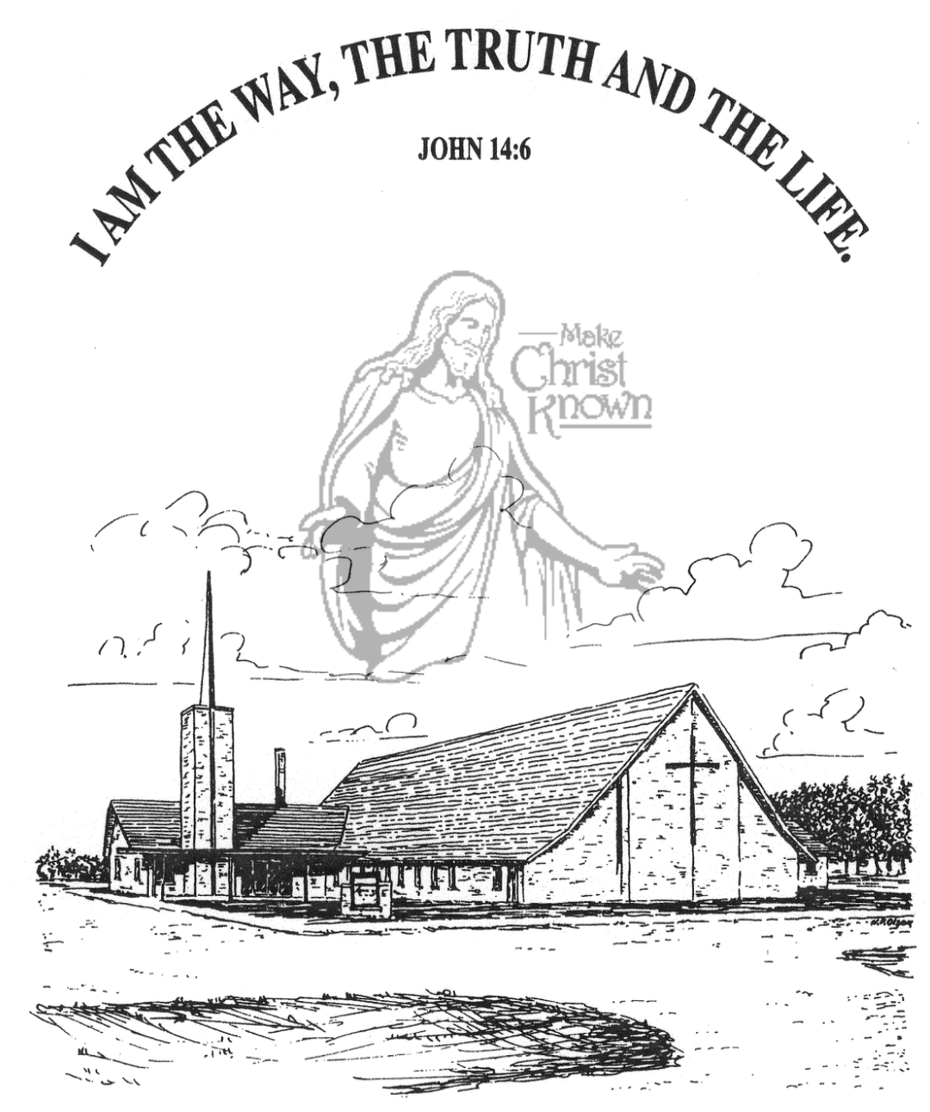

**Sunday, September 15, 2024**

**Salem Reformed Church**

**Menno, South Dakota**

..3

**Office Hours for Pastor Hecht**

Tuesday – Friday: 8:00 AM to Noon (Church Office)

Afternoons: Visitation or Church Office

Church: (605) 387-5334 Parsonage: (605) 387-2855

Pastor Mike’s Cell #: (605) 660-1803

Church Web Page: ***salemreformedchurch.com***

**Opportunities**

Greeters Today: Robert and Elaine Balogh

Greeters September 22nd:

Sunday Prayer Time: 8:30 a.m.

Sunday School Classes: 9:15 a.m.

Praise Music: 10:15 a.m.

Worship Service: 10:30 a.m.

**Announcements**

**Welcome:** We extend a warm welcome to our visiting guests this morning. Please sign our guest book in the Narthex. We ask God’s blessing upon you and we pray that you will return and worship with us again soon.

**Coffee Hour:** Please join us after church for a time of coffee, cookies and fellowship with one another in the Social Hall.

**Women of the Church:** The W.O.C. will plan to meet TODAY in the H.S. Room, following the morning worship service.

**Power Show Food Stand:** Our High School Youth Group will once again be hosting a Food Stand at the Power Show next weekend, Sept. 21/22. They will be serving chislic, burgers, hot dogs, and kuchen. Thanks to everyone who will be helping with this youth fundraiser!

**SD Right to Life Convention:** You are invited to attend this convention at the Calvary Baptist Church, Yankton, SD on September 20th & 21st. Please see the brochures on the Information Cabinet in the Narthex on how to register.

**W.O.C. Program:** The W.O.C. Program at the Menno/Olivet Care Center is on Tues., Sept. 17th. Please sign the sheet in the Narthex if you are able to attend. Jan Torres will be in charge of coordinating the program in September.

**Bingo Helpers in September:** The M/OCC is looking for two people to help with Bingo on Friday afternoons during the month of September at 2 PM. Please sign the sheet in the Narthex.

**Sunday Offerings:** Please note that we have an Offering Box/Pulpit at the back of the Sanctuary for people to place their tithes and offerings in during our worship services.

**SALEM REFORMED CHURCH**

Menno, South Dakota

Rev. Michael Hecht Pastor

Cindy Herrboldt Organist

10:30 AM – Worship Service September 15, 2024

Seventeenth Sunday after Pentecost

**Meditation:** *“I will exalt You, my God the King; I will praise Your name for ever and ever. Every day I will praise You and extol Your name for ever and ever. Great is the LORD and most worthy of praise; His greatness no one can fathom. One generation will commend Your works to another; they will tell of Your mighty acts. They will speak of the glorious splendor of Your majesty, and I will meditate on Your wonderful works. They will tell of the power of Your awesome works, and I will proclaim Your great deeds. They will celebrate Your abundant goodness and joyfully sing of Your righteousness. The LORD is gracious and compassionate, slow to anger and rich in love.”*  Psalm 145:1-8 NIV

**Praise Music:** #31, #45, #19, #18, #30, #32

**Ringing of the Bell**

**Welcome / Announcements**

**Opening Prayer**

**\*Hymn:** #18 “Our Great Savior”

**Sharing of Joys and Concerns**

**Our Time of Offering** II Peter 3:9 NIV

**\*Doxology** sung on page #815

**\*Lord’s Prayer** debts and debtors

**Kingdom Kids:** “Pointing Fingers – Throwing Stones”

**Hymn:** #340 “Turn Your Eyes Upon Jesus”

**The Holy Scriptures**

Romans 2:1-11

Large Print NIV 1984 Edition, pg. 1748

**Sermon: “You, Therefore, Have No Excuse”**

**\*Hymn:** #344 “Grace Greater Than Our Sin”

**\*Benediction:**

**\*Prayer for Our Nation:** “God Bless America”

**Postlude** (*denotes standing for those able)

The congregation will be ushered out after the Benediction

Youth Ushers: Addisyn Friesen, Emmalyn Heckenlaible, and Emmarie Rames