**Calendar of Events**

Sept 02 Men’s Christian Fellowship @ 7:30 p.m.

Sept 03 M/O Ministerial Meeting @ 11:30 a.m.

Sept 04 8th Grade Confirmation @ 3:30-5:15 p.m.

6/7th Grade Confirmation @ 5:30-7:00 p.m.

FCA at Menno Gym @ 7:30 p.m.

Sept 05 Prayer Group @ 12 Noon

Sept 08 **Sunday School Kick-Off**

Prayer Time for Service @ 8:30 a.m.

Sunday School Classes @ 9:15 a.m.

Praise Music @ 10:15 a.m.

Worship Service @ 10:30 a.m.

w/Pot Luck Dinner & Games Following

High School Youth Supper/Games @ 6:00 pm

**Upcoming Special Music**

Sunday, Sept 08 - Available

Sunday, Sept 15 - Available

**Announcements**

**Kuchen Donations:** Please sign the sheet in the Narthex if you are willing to bake and donate some kuchen for the Youth Group Food Stand at the Power Show. The Menno Pioneer Power Show is the weekend of September 21/22.

**SD Right to Life Convention:** You are invited to attend this convention at the Calvary Baptist Church, Yankton, SD on September 20th & 21st. Please see the brochures on the Information Cabinet in the Narthex on how to register.

**W.O.C. Program Date Change:** The date for the W.O.C. Program has been changed to Tues., Sept. 17th. Please sign the sheet in the Narthex if you are able to attend. Jan Torres will be in charge of coordinating the program in September.

**Salem Reformed Church – Who Are We?**

**We believe the Bible to be the inspired, inerrant, infallible Word of God in its original manuscripts. It is our supreme authority in all matters doctrine and practice. We are affiliated with the Conservative Congregational Christian Conference.**

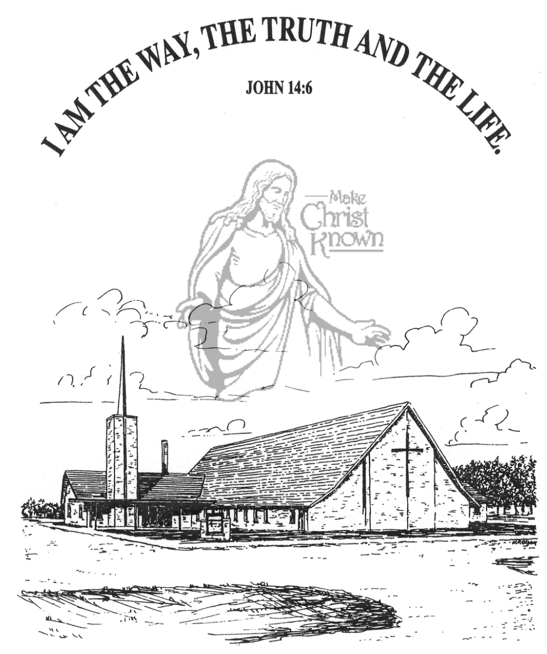

**Sunday, September 08, 2024**

**Salem Reformed Church**

**Menno, South Dakota**

..3

**Office Hours for Pastor Hecht**

Tuesday – Friday: 8:00 AM to Noon (Church Office)

Afternoons: Visitation or Church Office

Church: (605) 387-5334 Parsonage: (605) 387-2855

Pastor Mike’s Cell #: (605) 660-1803

Church Web Page: ***salemreformedchurch.com***

**Opportunities**

Greeters Today: Robert and Elaine Balogh

Greeters September 15th:

Sunday Prayer Time: 8:30 a.m.

Sunday School Classes: 9:15 a.m.

Praise Music: 10:15 a.m.

Worship Service: 10:30 a.m.

**Announcements**

**Welcome:** We extend a warm welcome to our visiting guests this morning. Please sign our guest book in the Narthex. We ask God’s blessing upon you and we pray that you will return and worship with us again soon.

**Pot Luck Dinner:** The CE Committee will host a Pot Luck Dinner after church TODAY! All are welcome to stay for a time of lunch and fellowship. Outside Games will follow for the children and youth!

**Menno FCA:** The 1st Meeting of the Fellowship of Christian Athletes will be Wed., September 4th @ 7:30 p.m. at the Menno Gym. This is open to students in 8th thru 12th Grade.

**Sunday Offerings:** Please note that we have an Offering Box/Pulpit at the back of the Sanctuary for people to place their tithes and offerings in during our worship services.

**SALEM REFORMED CHURCH**

Menno, South Dakota

Rev. Michael Hecht Pastor

Jennifer Herrboldt Pianist

10:30 AM – Worship Service September 08, 2024

Sixteenth Sunday after Pentecost

**Meditation:** *“But you must remain faithful to the things you have been taught. You know they are true, for you know you can trust those who taught you. You have been taught the holy Scriptures from childhood, and they have given you the wisdom to receive the salvation that comes by trusting in Christ Jesus.*  I Timothy 3:14,15 NLT

**Praise Music:** #83, #82, #118, #140

**Ringing of the Bell**

**Welcome / Announcements**

**Opening Prayer**

**\*Hymn:** #139 “Great Is Thy Faithfulness”

**Sharing of Joys and Concerns**

**Our Time of Offering** II Timothy 1:5 NIV

**\*Lord’s Prayer** sung on page #631

**\*Apostles’ Creed** see words on screen

**Presentation of Sunday School Teachers**

**Responsive Reading – taken from I Cor. 12:12-27**

**Covenant / Prayer of Affirmation**

**Hymn:** #189 “Alleluia”

**Presentation Of:** by Lee Heckenlaible, S.S. Superintendent

**ESV Children’s Bibles - 2nd Grade**

**Heidelberg Catechism - 4th Grade**

**Egermeier’s Bible Story Book - 6th Grade**

**The Holy Scriptures**

Various Selected Texts

Large Print NIV 1984 Edition, pg.

**Sermon/Skit: “The House Upon the Rock”**

**\*Hymn:** #23 “In Christ Alone”

**\*Benediction:**

**\*Prayer for Our Nation:** “God Bless America”

**Postlude** (*denotes standing for those able)

The congregation will be ushered out after the Benediction

Youth Ushers: Addisyn Friesen, Emmalyn Heckenlaible, and Emmarie Rames