**Calendar of Events**

Oct 01 M/O Ministerial Mtg. at Roosters @ 11:30 am

Oct 02 Women’s Bible Study @ 9:30 a.m. & 6:00 p.m.

8th Grade Confirmation @ 3:30-5:15 p.m.

6/7th Grade Confirmation @ 5:20-7:00 p.m.

FCA at Menno Gym @ 7:30 p.m.

Oct 03 Prayer Group @ 12 Noon

Oct 06Prayer Time for Service @ 8:30 a.m.

Sunday School Classes @ 9:15 a.m.

Praise Music @ 10:15 a.m.

Worship Service @ 10:30 a.m.

with Holy Communion

High School Youth Group @ 11:45 a.m.

Contemporary Service @ 7:00 p.m.

Oct 07 Men’s Christian Fellowship @ 7:30 p.m.

**Upcoming Special Music**

Sunday, Oct 06 - Holy Communion

Sunday, Oct 13 - Available

**Announcements**

**Mission Fest Service:** Mission Fest is scheduled for Sunday, October 20th. Our guest speaker will be someone from Servant Hearts Clinic in Yankton. Servant Hearts Clinic is a FREE health care clinic dedicated to providing health care to all we serve.

**Cherub Choir:** The Cherub Choir (ages 3 yrs. thru 3rd Grade) will plan to sing in church on Sunday, Oct. 20th! This is also our Mission Fest Sunday.

**Christmas Eve Program Director:** We are in need of someone to direct our Christmas Eve Program this year. Please contact Lee Heckenlaible or Pastor Mike if you are interested. For questions about what this involves, please contact Emily Guthmiller. Special Thanks to Emily for directing the program for the last two years!

Planning for the program needs to begin by the end of September, so please respond soon if you are willing and able to direct the program.

**Special Thanks:** Thanks to Ann Schultz for placing the flowers in the sanctuary during the month of September.

**Salem Reformed Church – Who Are We?**

**We believe the Bible to be the inspired, inerrant, infallible Word of God in its original manuscripts. It is our supreme authority in all matters doctrine and practice. We are affiliated with the Conservative Congregational Christian Conference.**

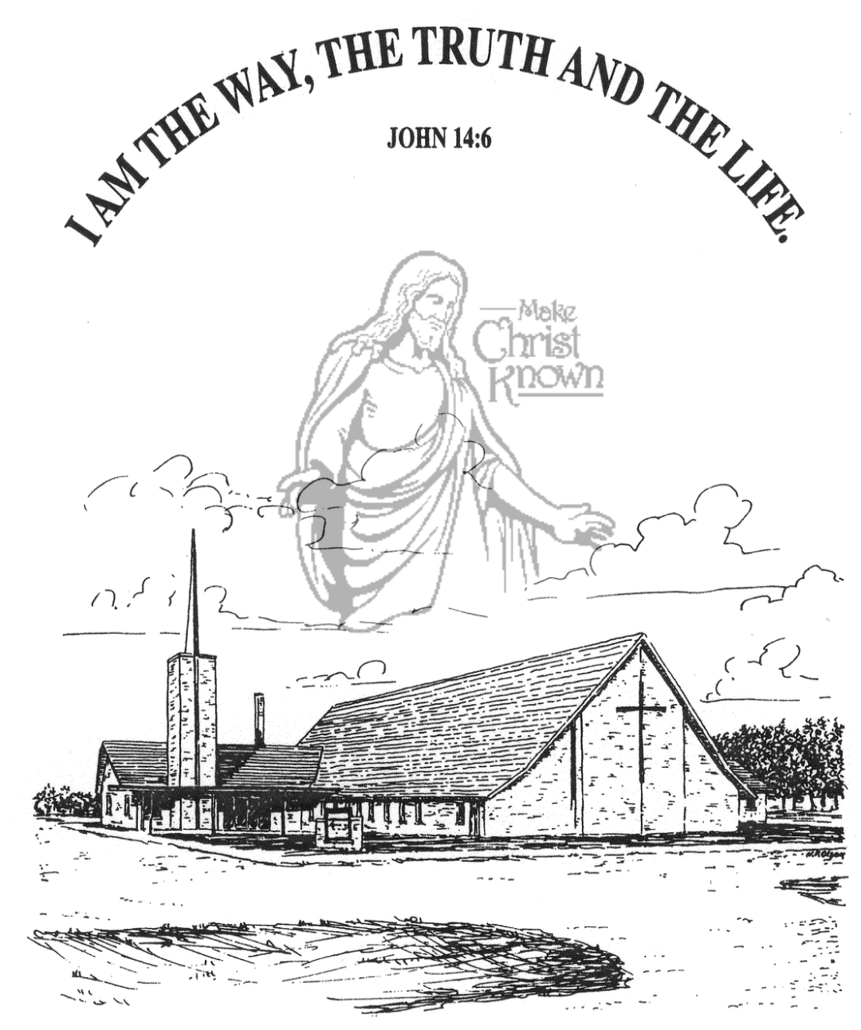

**Sunday, September 29, 2024**

**Salem Reformed Church**

**Menno, South Dakota**

..3

**Office Hours for Pastor Hecht**

Tuesday – Friday: 8:00 AM to Noon (Church Office)

Afternoons: Visitation or Church Office

Church: (605) 387-5334 Parsonage: (605) 387-2855

Pastor Mike’s Cell #: (605) 660-1803

Church Web Page: ***salemreformedchurch.com***

**Opportunities**

Greeters Today: Brian and Amber Cross Family

Greeters October 6th:

Sunday Prayer Time: 8:30 a.m.

Sunday School Classes: 9:15 a.m.

Praise Music: 10:15 a.m.

Worship Service: 10:30 a.m.

**Announcements**

**Welcome:** We extend a warm welcome to our visiting guests this morning. Please sign our guest book in the Narthex. We ask God’s blessing upon you and we pray that you will return and worship with us again soon.

**Power Show Food Stand:** THANK YOU to everyone who helped with the Youth Concession Stand at the Power Show last weekend! A BIG THANK YOU to Scott/Amy Nusz and Matt/Trishia Fischer for coordinating this fund raiser for our High School Youth! **\*NOTE:** There are left over items for sale today in the kitchen following our worship service.

**Vote NO on Amendment G:** We have Yard Signs available in the Social Hall if you would like to take one or two!

***Vote NO on Amendment G – It’s a Matter of LIFE or Death***

Let’s get the word out across South Dakota to defeat this very dangerous proposed amendment to our state constitution that would legalize abortions in our state.

**Weekend to Remember:** Here is a wonderful way to invest in your marriage! This is a 2 ½ day getaway that equips couples with practical tools and resources. It is scheduled for Nov. 15-17, 2024 in Sioux Falls. Check out their website for more information: *www.familylife.com*

**Sunday Offerings:** Please note that we have an Offering Box/Pulpit at the back of the Sanctuary for people to place their tithes and offerings in during our worship services.

**SALEM REFORMED CHURCH**

Menno, South Dakota

Rev. Michael Hecht Pastor

Marina Schaeffer Pianist

10:30 AM – Worship Service September 29, 2024

Nineteenth Sunday after Pentecost

**Meditation:** *“Each one should test his own actions. Then he can take pride in himself, without comparing himself to someone else, for each one should carry his own load. Anyone who receives instruction in the word must share all good things with his instructor. Do not be deceived: God cannot be mocked. A man reaps what he sows. The one who sows to his sinful nature, from that nature will reap destruction; the one who sows to please the Spirit, from the Spirit will reap eternal life. Let us not become weary in doing good, for at the proper time we will reap a harvest if we do not give up. Therefore, as we have opportunity, let us do good to all people, especially to those who belong to the family of believers.”* Galatians 6:4-10 NIV

**Praise Music:** #34, #14, #124, #150

**Ringing of the Bell**

**Welcome / Announcements**

**Opening Prayer**

**\*Hymn:** #562 “Be Thou My Vision”

**Sharing of Joys and Concerns**

**Our Time of Offering** Isaiah 9:2,3 NIV

**\*Doxology** sung on page #815

**\*Lord’s Prayer** debts and debtors

**Kingdom Kids:** “ ? ? ? ”

**Hymn:** #173 “I’m Forever Grateful”

**The Holy Scriptures**

Romans 3:21-31

Large Print NIV 1984 Edition, pg. 1750

**Sermon: “ ? ? ? ”**

**\*Hymn:** #135 “Mighty to Save” (praise book)

**\*Benediction:**

**\*Prayer for Our Nation:** “God Bless America”

**Postlude** (*denotes standing for those able)

The congregation will be ushered out after the Benediction

Youth Ushers: Addisyn Friesen, Emmalyn Heckenlaible, and Emmarie Rames