**Calendar of Events**

Aug 19 Men’s Christian Fellowship @ 7:30 p.m.

Aug 22 Prayer Group @ 12 Noon

Aug 25 Prayer Time for Service @ 8:30 a.m.

Praise Music @ 9:15 a.m.

Worship Service @ 9:30 a.m.

Adult Sunday School Class @ 11:00 a.m.

Aug 28 8th Grade Confirmation @ 3:30-5:15 p.m.

6/7th Grade Confirmation @ 5:30-7:00 p.m.

Aug 29-Sept 01 Pastor Mike/Ann Vacation to Waverly, IA

for Nathan’s Wedding!

Sept 01 Prayer Time for Service @ 8:30 a.m.

Praise Music @ 9:15 a.m.

Worship Service @ 9:30 a.m.

w/Rev. Ray DeLaurier

Adult Sunday School Class @ 11:00 a.m.

Sept 02 Men’s Christian Fellowship @ 7:30 p.m.

**Upcoming Special Music**

Sunday, Aug 25 - Available

Sunday, Sept 01 - Available

**Announcements**

**SD Right to Life Convention:** You are invited to attend this convention at the Calvary Baptist Church, Yankton, SD on September 20th & 21st. Please see the brochures on the Information Cabinet in the Narthex on how to register.

**Flower Assistance:** We are looking for people to place the flowers in the Sanctuary on Sunday mornings during the months of September, October and December. Please sign the sheet on the Bulletin Board in the Narthex if you are able to help. Thanks!

**Sunday School Kick-Off:** Sunday School Classes will resume on Sunday, September 8th, starting at 9:15 a.m. Praise Music at 10:15 a.m., with Worship Service at 10:30 a.m. There will be a Pot Luck Dinner following for the Congregation! We also have Sunday School Classes for the adults!

**Summer Christian Camps:** The W.O.C. will pay for our children to attend a Christian Camp this summer. Contact Joanie Handel to get reimbursed **BEFORE** the end of August!

**Salem Reformed Church – Who Are We?**

**We believe the Bible to be the inspired, inerrant, infallible Word of God in its original manuscripts. It is our supreme authority in all matters doctrine and practice. We are affiliated with the Conservative Congregational Christian Conference.**

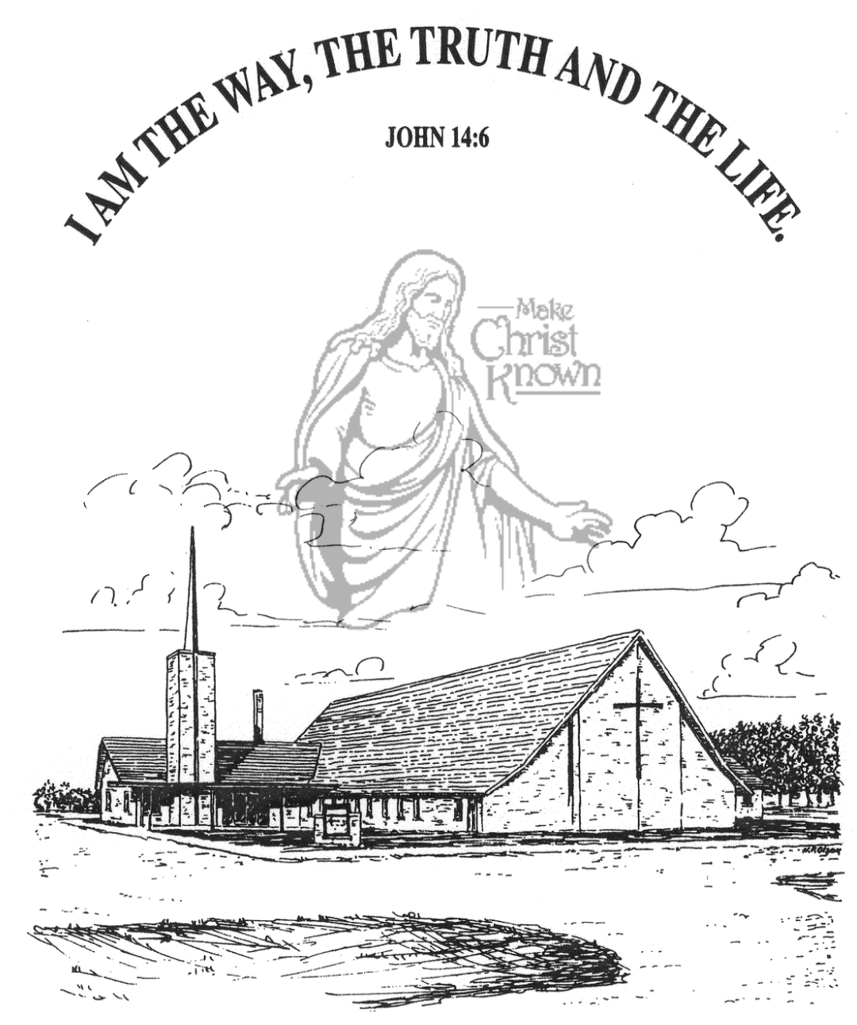

**Sunday, August 18, 2024**

**Salem Reformed Church**

**Menno, South Dakota**

**Office Hours for Pastor Hecht**

Tuesday – Friday: 8:00 AM to Noon (Church Office)

Afternoons: Visitation or Church Office

Church: (605) 387-5334 Parsonage: (605) 387-2855

Pastor Mike’s Cell #: (605) 660-1803

Church Web Page: ***salemreformedchurch.com***

**Opportunities**

Greeters Today: Brian and Steph Mehlhaf

Greeters August 25th:

Sunday Prayer Time: 8:30 a.m.

Praise Music: 9:15 a.m.

Worship Service: 9:30 a.m.

Adult Sunday School: 11:00 a.m.

**Announcements**

**Welcome:** We extend a warm welcome to our visiting guests this morning. Please sign our guest book in the Narthex. We ask God’s blessing upon you and we pray that you will return and worship with us again soon.

**W.O.C. Program Date Change:** The date for the W.O.C. Program has been changed to Tues., Sept. 17th. Please sign the sheet in the Narthex if you are able to attend. Jan Torres will be in charge of coordinating the program in September.

**CE Meeting:** The Christian Education Committee will plan to meet after church **TODAY**, in the High School SS Room!

**Coffee Hour:** Please join us after church for a time of coffee, cookies and fellowship with one another in the Social Hall.

**Heartfelt Thanks:** Pastor Mike & Ann wish to express our thanks to the congregation for your prayers, cards, food, flowers and words of kindness during the time of the passing of our Dad, Rev. Bryce Hecht. God Bless You All!

**School Supply Drive:** Trishia Fischer and Mollie Huber would like to express their THANKS to all who picked an apple from the tree and brought school supply items! Almost all of the apples were picked from the box!

**Menno FCA:** The 1st Meeting of the Fellowship of Christian Athletes will be Wed., September 4th @ 7:30 p.m. at the Menno Gym. This is open to students in 8th thru 12th Grade.

**Sunday Offerings:** Please note that we have an Offering Box/Pulpit at the back of the Sanctuary for people to place their tithes and offerings in during our worship services.

**Sunday School Kick-Off is September 8th**

**SALEM REFORMED CHURCH**

Menno, South Dakota

Rev. Michael Hecht Pastor

Joan Nusz Pianist

9:30 AM – Worship Service August 18, 2024

Thirteenth Sunday after Pentecost

**Meditation:** *“But now a righteousness from God, apart from the law, has been made known, to which the Law and the Prophets testify. This righteousness from God comes through FAITH in Jesus Christ to all who believe. There is no difference, for all have sinned and fall short of the glory of God, and are justified freely by His grace through the redemption that came by Christ Jesus. God presented Him as a sacrifice of atonement, through FAITH in His blood. He did this to demonstrate His justice, because in His forbearance He had left the sins committed beforehand unpunished – He did it to demonstrate His justice at the present time, so as to be just and the one who justifies those who have FAITH in Jesus.”* Romans 3:21-26 NIV

**Praise Music:** #104, #112, #13, #134, #762

**Ringing of the Bell**

**Welcome / Announcements**

**Opening Prayer**

**\*Hymn:** #82 “Praise the Lord! Ye Heavens, Adore Him”

**Sharing of Joys and Concerns**

**Our Time of Offering** Romans 1:16,17 NIV

**\*Doxology** sung on page #815

**\*Apostles’ Creed** see words on screen

**Kingdom Kids:** “The Door to the Greater Gift“

**Hymn:** #505 “He Touched Me”

**The Holy Scriptures**

Romans 1:24-32

Large Print NIV 1984 Edition, pg. 1747

**Sermon: “Exchanging the Truth of God For a Lie”**

**\*Hymn:** #492 “At Calvary”

**\*Benediction:**

**\*Prayer for Our Nation:** “God Bless America”

**Postlude**

(*denotes standing for those able)

The congregation will be ushered out after the Benediction