**Calendar of Events**

Aug 14 SS Teachers Meeting @ 6:00 p.m.

Consistory Meeting @ 7:30 p.m.

Aug 15 Prayer Group @ 12 Noon

Aug 18 Prayer Time for Service @ 8:30 a.m.

Praise Music @ 9:15 a.m.

Worship Service @ 9:30 a.m.

w/Coffee Hour Following

w/CE Committee Meeting Following

Adult Sunday School Class @ 11:00 a.m.

Aug 19 Men’s Christian Fellowship @ 7:30 p.m.

Aug 22 Prayer Group @ 12 Noon

Aug 25 Prayer Time for Service @ 8:30 a.m.

Praise Music @ 9:15 a.m.

Worship Service @ 9:30 a.m.

Adult Sunday School Class @ 11:00 a.m.

Aug 28 8th Grade Confirmation @ 3:30-5:15 p.m.

6/7th Grade Confirmation @ 5:30-7:00 p.m.

**Upcoming Special Music**

Sunday, Aug 18 - Available

Sunday, Aug 25 - Available

**Announcements**

**Confirmation Parents Meeting:** Pastor Mike would like to meet with the parents of the 6-8th Grade Confirmation Students after church **TODAY.** Plans are to have the 8th Graders come first, from 3:30 to 5:15 p.m. on Wednesdays. The 6/7th Graders will follow from 5:30 to 7:00 p.m. The first day of classes will be Wednesday, August 28th. Confirmation Sunday is planned for Palm Sunday, April 13th, 2025.

**Summer Christian Camps:** The W.O.C. will pay for our children to attend a Christian Camp this summer. Contact Joanie Handel to get reimbursed **BEFORE** the end of August!

**Coffee Hour:** We are looking for 5 volunteers to bring 2 dozen goodies for Coffee Hour on Sunday, August 18th. Please sign the sheet in the Narthex if you are able to help.

**Menno Community School Supply Drive:** Pick an Apple from the Box in the Social Hall, buy the item on the Apple, and return it to the Box by August 16th.

**Salem Reformed Church – Who Are We?**

**We believe the Bible to be the inspired, inerrant, infallible Word of God in its original manuscripts. It is our supreme authority in all matters doctrine and practice. We are affiliated with the Conservative Congregational Christian Conference.**

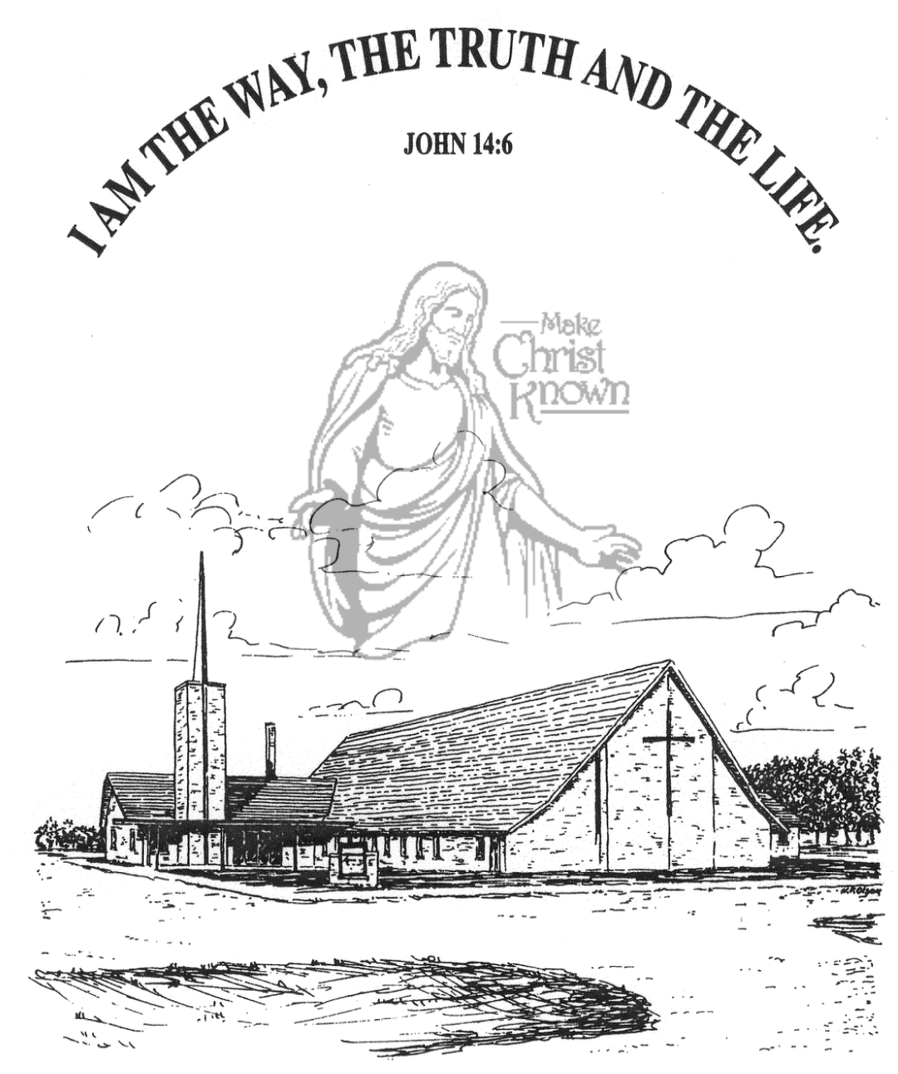

**Sunday, August 11, 2024**

**Salem Reformed Church**

**Menno, South Dakota**

**Office Hours for Pastor Hecht**

Tuesday – Friday: 8:00 AM to Noon (Church Office)

Afternoons: Visitation or Church Office

Church: (605) 387-5334 Parsonage: (605) 387-2855

Pastor Mike’s Cell #: (605) 660-1803

Church Web Page: ***salemreformedchurch.com***

**Opportunities**

Greeters Today: Harriet Schaeffer

Greeters August 18th: Brian and Steph Mehlhaf

Sunday Prayer Time: 8:30 a.m.

Praise Music: 9:15 a.m.

Worship Service: 9:30 a.m.

Adult Sunday School: 11:00 a.m.

**Announcements**

**Welcome:** We extend a warm welcome to our visiting guests this morning. Please sign our guest book in the Narthex. We ask God’s blessing upon you and we pray that you will return and worship with us again soon.

**Evangelism Seminar:** Rev. Ray DeLaurier will be presenting a seminar this Sat., Aug. 17th @ 7PM, at the Scotland Community Church. The seminar is titled *“Evangelism for Everyone – Even a 5th Grader”.* You are encouraged to attend!

**The Banquet:** A BIG THANK YOU to all who helped with *‘The Banquet’* this year. Your donations, time and effort in preparing and serving helped us bless 238 people with a delicious supper this past Thursday evening! Thank you for giving to the Lord! *Stephanie Wagner, Coordinator*

**W.O.C. Program Date Change:** The date for the W.O.C. Program has been changed to Tues., Sept. 17th. Please sign the sheet in the Narthex if you are able to attend. Jan Torres will be in charge of coordinating the program in September.

**Sunday School Teachers Meeting:** The Sunday School Teachers will plan to meet on Wed., August 14th at 6:00 p.m.

**CE Meeting:** The Christian Education Committee will plan to meet after church on Sunday, August 18th.

**Heartfelt Thanks:** Pastor Mike & Ann wish to express our thanks to the congregation for your prayers, cards, food, flowers and words of kindness during the time of the passing of our Dad, Rev. Bryce Hecht. God Bless You All!

**Sunday Offerings:** Please note that we have an Offering Box/Pulpit at the back of the Sanctuary for people to place their tithes and offerings in during our worship services.

**SALEM REFORMED CHURCH**

Menno, South Dakota

Rev. Michael Hecht Pastor

Cindy Herrboldt Organist

9:30 AM – Worship Service August 11, 2024

Twelfth Sunday after Pentecost

**Meditation:** *“But when the apostles Barnabas and Paul heard of this, they tore their clothes and rushed out into the crowd, shouting: ‘Men, why are you doing this? We too are only men, human like you. We are bringing you good news, telling you to turn from these worthless things to the living God, who made heaven and earth and sea and everything in them. In the past, He let all nations go their own way. Yet He has not left Himself without testimony: He has shown kindness by giving you rain from heaven and crops in their seasons; He provides you with plenty of food and fills your hearts with joy.’ Even with these words, they had difficulty keeping the crowd from sacrificing to them.”*

Acts 14:14-18 NIV

**Praise Music:** #17, #56, #36, #121, #32, #12

**Ringing of the Bell**

**Welcome / Announcements**

**Opening Prayer**

**\*Hymn:** #90 “Joyful, Joyful, We Adore Thee”

**Sharing of Joys and Concerns**

**Our Time of Offering** Psalm 19:1 AMP

**\*Doxology** sung on page #815

**\*Lord’s Prayer** debts and debtors

**Kingdom Kids:** “GOD is REAL!“

**Hymn:** #88 “More Precious Than Silver”

**The Holy Scriptures**

Romans 1:18-25

Large Print NIV 1984 Edition, pg. 1747

**Sermon: “Without Excuse”**

**\*Hymn:** #63 “All Creatures of Our God and King”

**\*Benediction:**

**\*Prayer for Our Nation:** “God Bless America”

**Postlude**

(*denotes standing for those able)

The congregation will be ushered out after the Benediction