**Calendar of Events**

July 27-Aug 2 4C’s Conference Meetings in Rhode Island

July 31 Blood Drive in Social Hall @ 12 to 6:00 p.m.

Aug 04 Prayer Time for Service @ 8:30 a.m.

Praise Music @ 9:15 a.m.

Worship Service @ 9:30 a.m.

w/Holy Communion

Adult Sunday School Class @ 11:00 a.m.

Aug 05 Men’s Christian Fellowship @ 7:30 p.m.

Aug 08 Prayer Group @ 12 Noon

Serving at *‘The Banquet’* in Yankton

Aug 11 Prayer Time for Service @ 8:30 a.m.

Praise Music @ 9:15 a.m.

Worship Service @ 9:30 a.m.

w/Confirmation Parents Mtg. Following

Adult Sunday School Class @ 11:00 a.m.

Aug 14 SS Teachers Meeting @ 6:00 p.m.

Consistory Meeting @ 7:30 p.m.

**Upcoming Special Music**

Sunday, Aug 04 - Holy Communion

Sunday, Aug 11 - Available

**Announcements**

**Community Blood Drive:** Mark your Calendars! This is scheduled for Wed., July 31st in our Social Hall from 12:30-6:00 p.m. Addisyn Friesen is coordinating this event for her senior project. There is a great need to replenish our local blood banks, especially during the summer months.

**Confirmation Parents Meeting:** Pastor Mike would like to meet with the parents of the 6-8th Grade Confirmation Students after church on Sunday, August 11th. Plans are to have the 8th Graders come first, from 3:30 to 5:15 p.m. on Wednesdays. The 6/7th Graders will follow from 5:30 to 7:00 p.m. The first day of classes will be Wednesday, August 28th. Confirmation Sunday is planned for Palm Sunday, April 13th, 2025.

**CE Meeting:** The Christian Education Committee will plan to meet after church on Sunday, August 18th.

**Sunday School Teachers Meeting:** The Sunday School Teachers will plan to meet on Wed., August 14th at 6:00 p.m.

**Salem Reformed Church – Who Are We?**

**We believe the Bible to be the inspired, inerrant, infallible Word of God in its original manuscripts. It is our supreme authority in all matters doctrine and practice. We are affiliated with the Conservative Congregational Christian Conference.**

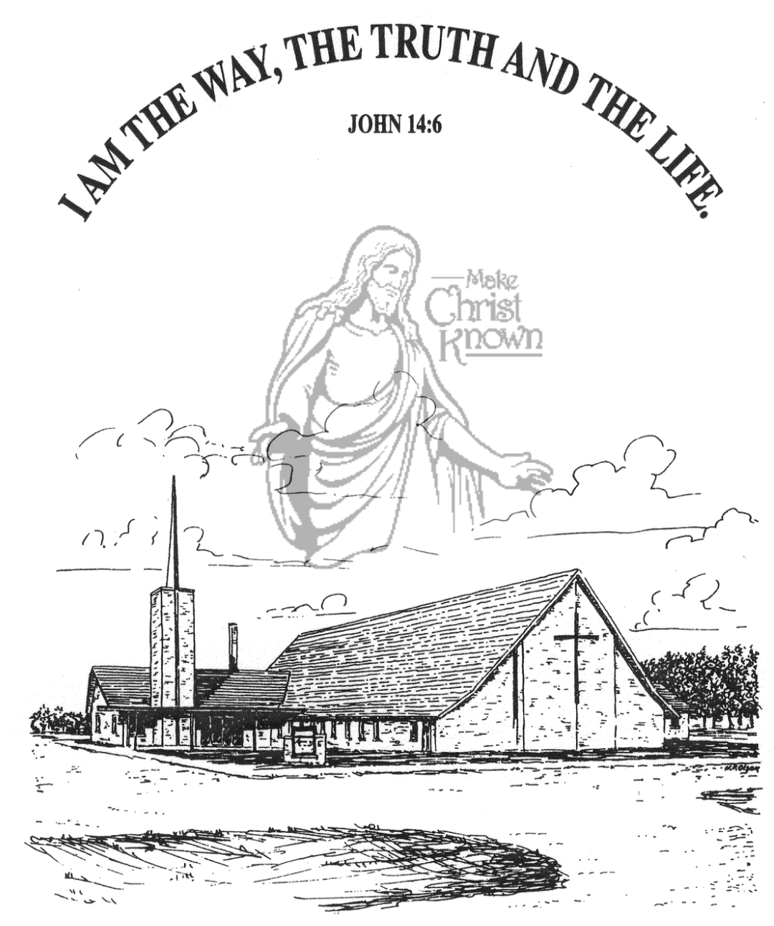

**Sunday, July 28, 2024**

**Salem Reformed Church**

**Menno, South Dakota**

**Office Hours for Pastor Hecht**

Tuesday – Friday: 8:00 AM to Noon (Church Office)

Afternoons: Visitation or Church Office

Church: (605) 387-5334 Parsonage: (605) 387-2855

Pastor Mike’s Cell #: (605) 660-1803

Church Web Page: ***salemreformedchurch.com***

**Opportunities**

Greeters Today: Gary & Jane Gramkow

Greeters August 4th:

Sunday Prayer Time: 8:30 a.m.

Praise Music: 9:15 a.m.

Worship Service: 9:30 a.m.

Adult Sunday School: 11:00 a.m.

**Announcements**

**Welcome:** We extend a warm welcome to our visiting guests this morning. Please sign our guest book in the Narthex. We ask God’s blessing upon you and we pray that you will return and worship with us again soon.

**CCCC 76th Annual Gathering:** Greg & Melanie Wilcoxon will be flying to Rhode Island on Sat., July 27th to attend these meetings. Pastor Mike & Ann are not able to attend this year due to Bryce Hecht being placed on Hospice Care this week.

**Serving at The Banquet:** Our Church is scheduled to serve at *‘The Banquet’* in Yankton on Thurs., Aug. 8th. Volunteers will be needed in the following areas:

1) 10 More Volunteers to assist at *‘The Banquet’* on Thurs., Aug. 8th from 5:30-7:00 p.m.

2) 1 More Volunteer to carry in supplies for the meal, prep the food and set up. Meet at the UCC Church in Yankton at 3:00 PM sharp on Thursday, August 8th.

**Please see the sign-up sheets in the Social Hall.

**W.O.C. Program:** The W.O.C. will present a program at M/OCC on Tuesday, August 20th at 2:00 p.m. Please sign the sheet in the Narthex if you are able to attend. Jan Torres will be in charge of coordinating the program this month.

**Summer Christian Camps:** The Women of the Church are willing to pay for the expense for our children to attend a Christian Camp this summer. Contact Joanie Handel to get reimbursed **BEFORE** the end of August!

**Sunday Offerings:** Please note that we have an Offering Box/Pulpit at the back of the Sanctuary for people to place their tithes and offerings in during our worship services.

**SALEM REFORMED CHURCH**

Menno, South Dakota

Rev. Michael Hecht Pastor

Joan Nusz Pianist

9:30 AM – Worship Service July 28, 2024

Tenth Sunday after Pentecost

**Meditation:** *“But if it is preached that Christ has been raised from the dead, how can some of you say that there is no resurrection from the dead? If there is no resurrection of the dead, then not even Christ has been raised. And if Christ has not been raised, our preaching is useless and so is your faith. More than that, we are then found to be false witnesses about God, for we have testified about God that He raised Christ from the dead. But He did not raise Him if in fact the dead are not raised. For if the dead are not raised, then Christ has not been raised either. And if Christ has not been raised, your faith is futile; you are still in your sins. Then those also who have fallen asleep in Christ are lost. If only for this life we have hope in Christ, we are to be pitied more than all men. But Christ has indeed been raised from the dead, the first fruits of those who have fallen asleep.”* I Corinthians 15:12-20 NIV

**Praise Music:** #36, #41, #54, #110, #24

**Ringing of the Bell**

**Welcome / Announcements / Opening Prayer**

**\*Hymn:** #128 “I Sing the Mighty Power of God”

**Sharing of Joys and Concerns**

**Our Time of Offering** I Corinthians 15:58 NIV

**\*Doxology** sung on page #815

**\*Lord’s Prayer** debts and debtors

**Kingdom Kids:** “Going Home“ shared by Ron Schaeffer

**Hymn:** #366 “I Live”

**The Holy Scriptures**

John 20:1-18

Large Print NIV 1984 Edition, pg. 1685

**Sermon: “Thank You, Jesus!”** by Phillip Heckenlaible

**\*Hymn:** #368 “He Lives”

**\*Benediction:**

**\*Prayer for Our Nation:** “God Bless America”

**Postlude** (*denotes standing for those able)

The congregation will be ushered out after the Benediction