**Calendar of Events**

July 25 Prayer Group @ 12 Noon

July 27-Aug 2 Pastor Mike/Ann at Conference Meetings

July 28 Prayer Time for Service @ 8:30 a.m.

Praise Music @ 9:15 a.m.

Worship Service @ 9:30 a.m.

w/Phillip Heckenlaible sharing

Adult Sunday School Class @ 11:00 a.m.

July 31 Blood Drive in Social Hall @ 12 to 6:00 p.m.

Aug 04 Prayer Time for Service @ 8:30 a.m.

Praise Music @ 9:15 a.m.

Worship Service @ 9:30 a.m.

w/Holy Communion

Adult Sunday School Class @ 11:00 a.m.

Aug 05 Men’s Christian Fellowship @ 7:30 p.m.

Aug 08 Serving at ‘The Banquet’ in Yankton

**Upcoming Special Music**

Sunday, July 28 - Available

Sunday, Aug 04 - Holy Communion

**Announcements**

**Community Blood Drive:** Mark your Calendars! This is scheduled for Wed., July 31st in our Social Hall from 12:30-6:00 p.m. Addisyn Friesen is coordinating this event for her senior project. There is a great need to replenish our local blood banks, especially during the summer months.

**Confirmation Parents Meeting:** Pastor Mike would like to meet with the parents of the 6-8th Grade Confirmation Students after church on Sunday, August 11th. Plans are to have the 8th Graders come first, from 3:30 to 5:00 p.m. on Wednesdays. The 6/7th Graders will follow from 5:30 to 7:00 p.m. The first day of classes will be Wednesday, August 28th. Confirmation Sunday is planned for Palm Sunday, April 13th, 2025.

**Signs Of The Times:** There is a DVD in the Library by Dr. Andy Woods titled *“Signs of the Times”*. It is available to be checked out by anyone who is interested.

**Jared & Devon Bush Family:** Jared & Devon are missionaries in the country of Nepal. Please pick up a prayer card about their ministry on the Information Cabinet in the Narthex.

**Salem Reformed Church – Who Are We?**

**We believe the Bible to be the inspired, inerrant, infallible Word of God in its original manuscripts. It is our supreme authority in all matters doctrine and practice. We are affiliated with the Conservative Congregational Christian Conference.**

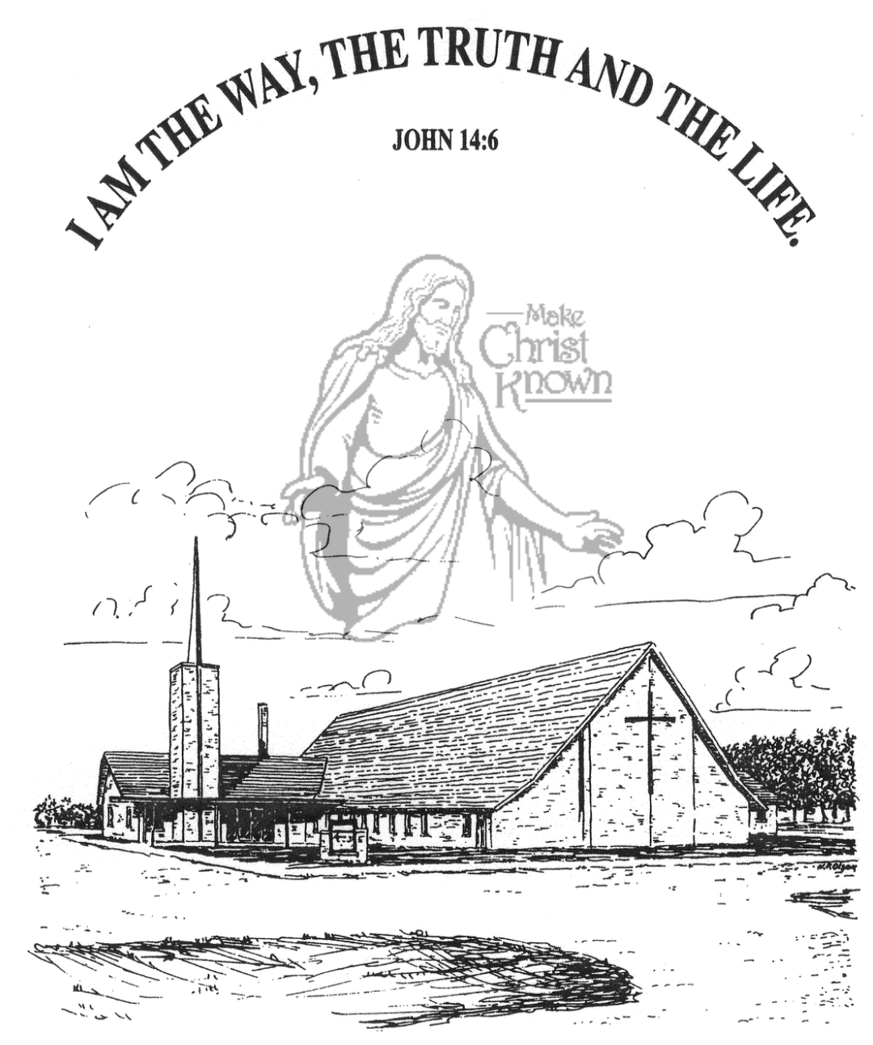

**Sunday, July 21, 2024**

**Salem Reformed Church**

**Menno, South Dakota**

**Office Hours for Pastor Hecht**

Tuesday – Friday: 8:00 AM to Noon (Church Office)

Afternoons: Visitation or Church Office

Church: (605) 387-5334 Parsonage: (605) 387-2855

Pastor Mike’s Cell #: (605) 660-1803

Church Web Page: ***salemreformedchurch.com***

**Opportunities**

Greeters Today: Matt and Trishia Fischer

Greeters July 28th:

Sunday Prayer Time: 8:30 a.m.

Praise Music: 9:15 a.m.

Worship Service: 9:30 a.m.

Adult Sunday School: 11:00 a.m.

**Announcements**

**Welcome:** We extend a warm welcome to our visiting guests this morning. Please sign our guest book in the Narthex. We ask God’s blessing upon you and we pray that you will return and worship with us again soon.

**CCCC 76th Annual Gathering:** Pastor Mike & Ann and Greg & Melanie Wilcoxon will be flying to Rhode Island on Sat., July 27th to attend these meetings. They plan to return late on Thursday night, August 1st.

**Coffee Hour:** Please join us after church for a time of coffee, cookies and fellowship with one another in the Social Hall.

**Serving at The Banquet:** Our Church is scheduled to serve at *‘The Banquet’* in Yankton on Thurs., Aug. 8th. Volunteers will be needed in the following areas:

1) 3 Volunteers to make Lasagna on Wed., Aug. 7th @ 2PM.

2) 3 Volunteers to bring 6 lbs. of hamburger each on Wed., Aug. 7th by Noon.

3) 9 Volunteers to bring a pan of Rice Krispie Bars on Wed., Aug. 7th by Noon.

4) 13 Volunteers to assist at *‘The Banquet’* on Thurs., Aug. 8th from 5:30-7:00 p.m.

**Please see the sign-up sheets in the Social Hall.

**Summer Christian Camps:** The Women of the Church are willing to pay for the expense for our children to attend a Christian Camp this summer. Contact Joanie Handel to get reimbursed **BEFORE** the end of August!

**Sunday Offerings:** Please note that we have an Offering Box/Pulpit at the back of the Sanctuary for people to place their tithes and offerings in during our worship services.

**SALEM REFORMED CHURCH**

Menno, South Dakota

Rev. Michael Hecht Pastor

Sharyl Herrboldt Pianist

9:30 AM – Worship Service July 21, 2024

Ninth Sunday after Pentecost

**Meditation:** *“Put to death, therefore, whatever belongs to your earthly nature: sexual immorality, impurity, lust, evil desires and greed, which is idolatry. Because of these, the wrath of God is coming. You used to walk in these ways, in the life you once lived. But now you must rid yourselves of all such things as these: anger, rage, malice, slander, and filthy language from your lips. Do not lie to each other, since you have taken off your old self with its practices and have put on the new self, which is being renewed in knowledge in the image of its Creator. Here there is no Greek or Jew, circumcised or uncircumcised, barbarian, Scythian, slave or free, but Christ is all, and is in all.”*

Colossians 3:5-11 NIV

**Praise Music:** #38, #56, #59, #96, #43

**Ringing of the Bell**

**Welcome / Announcements**

**Opening Prayer**

**\*Hymn:** #210 “Praise to the Lord, the Almighty”

**Sharing of Joys and Concerns**

**Our Time of Offering** II Corinthians 9:6,7 NIV

**\*Doxology** sung on page #815

**\*Apostles’ Creed** see words on screen

**Kingdom Kids:** “The Potter and the Clay“

**Special Music:** “Word of God Speak“

sung by Jay and Sharyl Herrboldt

**The Holy Scriptures**

Romans 1:18-25

Large Print NIV 1984 Edition, pg. 1747

**Sermon: “The Wrath of God”**

**\*Hymn:** #144 “Amazing Grace” (praise book)

**\*Benediction:**

**\*Prayer for Our Nation:** “God Bless America”

**Postlude** (*denotes standing for those able)

The congregation will be ushered out after the Benediction