**Calendar of Events**

June 16 **Happy Father’s Day!**

M/OCC Worship Service @ 2:00 p.m.

June 17 Men’s Christian Fellowship @ 7:30 p.m.

June 18 W.O.C. Program at M/OCC @ 2:00 p.m.

June 20 Prayer Group @ 12 Noon

June 23 Prayer Time for Service @ 8:30 a.m.

Praise Music @ 9:15 a.m.

Worship Service @ 9:30 a.m.

With Coffee Hour Following

Adult Sunday School Class @ 11:00 a.m.

Family Fun Event at Softball Field @ 5:00 p.m.

**Upcoming Special Music**

Sunday, June 23 - Available

Sunday, June 30 - Available

**Announcements**

**Sunday School:** The Adult S.S. Class will continue meeting through the summer months after church. They are currently working through the Book of Revelation. Please consider joining this class in studying God’s Word.

**Summer Christian Camps:** The Women of the Church are willing to pay for the expense for our children to attend a Christian Camp this summer. Contact Joanie Handel to get reimbursed.

**Community Patriotic Worship Service:** The M/O Ministerial Association will host this Worship Service in the Menno City Park on Sunday, July 7th at 10:00 a.m. Please bring your lawn chairs to the park. The Offering will be designated to the M/O Care Center to help with replacing the original floor tiles in some of the hallways and resident’s rooms.  Peace Christian Reformed is the host church this year.  NOTE:  In case of inclement weather, the service will be held in the Menno School/City Auditorium.

**Give-Where-You-Live:** The High School Youth Group will be doing a work day at the M/O Care Center on Tuesday, July 9th. This includes the incoming freshman class. Parents/Youth – please be watching your text messages for more information that will be coming from the Youth Group Advisors.

**Salem Reformed Church – Who Are We?**

**We believe the Bible to be the inspired, inerrant, infallible Word of God in its original manuscripts. It is our supreme authority in all matters doctrine and practice. We are affiliated with the Conservative Congregational Christian Conference.**

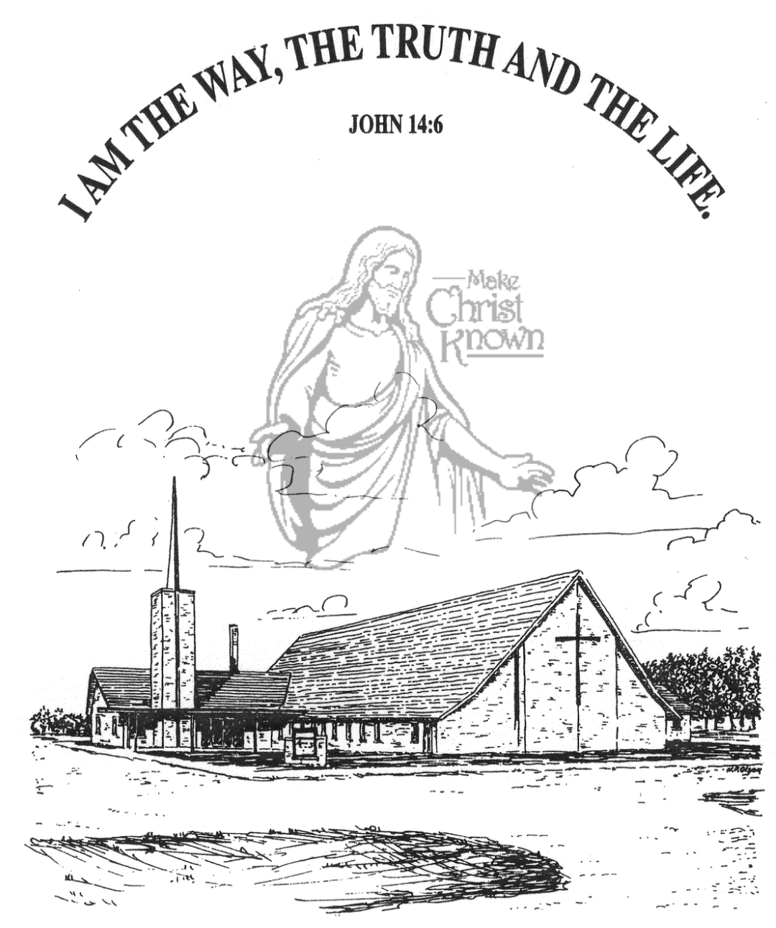

**Sunday, June 16, 2024**

**Salem Reformed Church**

**Menno, South Dakota**

**Office Hours for Pastor Hecht**

Tuesday – Friday: 8:00 AM to Noon (Church Office)

Afternoons: Visitation or Church Office

Church: (605) 387-5334 Parsonage: (605) 387-2855

Pastor Mike’s Cell #: (605) 660-1803

Church Web Page: ***salemreformedchurch.com***

**Opportunities**

Greeters Today: Robert and Elaine Balogh

Greeters June 23rd:

Sunday Prayer Time: 8:30 a.m.

Praise Music: 9:15 a.m.

Worship Service: 9:30 a.m.

Adult Sunday School: 11:00 a.m.

**Announcements**

**Welcome:** We extend a warm welcome to our visiting guests this morning. Please sign our guest book in the Narthex. We ask God’s blessing upon you and we pray that you will return and worship with us again soon.

**Annual Church Cleaning:** **THANKS** to all who helped during our annual church cleaning. As we all work together, we endeavor to keep this building looking beautiful for the glory of God! Your labor is not in vain!  **I Cor. 15:58**

**Family Fun Event:** The Christian Ed Committee is planning a summer Family Fun Event for all ages on Sunday, June 23rd at 5 PM! We will meet at the Menno Softball Field for a friendly co-ed softball game. There will also be kickball for the younger kids. Even if you don’t play softball, we need spectators to cheer on the teams! A light meal of hamburgers, hot dogs, and chips will be furnished. Please sign the sheet in the Narthex if you are planning to attend.

**Coffee Hour:** We are looking for 1 more volunteer to bring two dozen goodies for Coffee Hour on Sunday, June 23rd. Please sign the sheet in the Narthex.

**W.O.C. Program:** The Women will be hosting the program at the M/OCC on Tuesday, June 18th @ 2:00 p.m. You are invited to come and visit with the residents!

**Meals-on-Wheels:** Remember the dates in June that you signed up to deliver meals. Pick them up at M/OCC @ 11:20.

**Sunday Offerings:** Please note that we have an Offering Box/Pulpit at the back of the Sanctuary for people to place their tithes and offerings in during our worship services.

**SALEM REFORMED CHURCH**

Menno, South Dakota

Rev. Michael Hecht Pastor

Marina Schaeffer Pianist

9:30 AM – Worship Service June 16, 2024

Fourth Sunday after Pentecost

**Meditation:** *“Paul, an apostle of Christ Jesus by the command of God our Savior and of Christ Jesus our hope, To Timothy MY TRUE SON in the faith: Grace, mercy and peace from God the Father and Christ Jesus our Lord.”*

I Timothy 1:1,2 NIV

*“Paul, an apostle of Christ Jesus by the will of God, according to the promise of life that is in Christ Jesus, To Timothy, MY DEAR SON: Grace, mercy and peace from God the Father and Christ Jesus our Lord.”*

II Timothy 1:1,2 NIV

*“To Titus, MY TRUE SON in our common faith: Grace and peace from God the Father and Christ Jesus our Savior.”*

Titus 1:4 NIV

**Praise Music:** #34, #108, #124, #150

**Ringing of the Bell**

**Welcome / Announcements**

**Opening Prayer**

**\*Hymn:** #143 “This Is My Father’s World”

**Sharing of Joys and Concerns**

**Our Time of Offering** James 2:17,18 NIV

**\*Doxology** sung on page #815

**\*Lord’s Prayer** debts and debtors

**Kingdom Kids:** “Give Me an ‘F’ ”

**Hymn:** #387 “Holy Spirit, Thou Art Welcome”

**The Holy Scriptures**

Romans 1:1-7

Large Print NIV 1984 Edition, pg. 1746

**Sermon: “Set Apart For the Gospel”**

**\*Hymn:** #50 “Shout to the Lord”

**\*Benediction:**

**Postlude**

(*denotes standing for those able)

The congregation will be ushered out after the Benediction