**Calendar of Events**

June 27 Prayer Group @ 12 Noon

June 30 Prayer Time for Service @ 8:30 a.m.

Praise Music @ 9:15 a.m.

Worship Service @ 9:30 a.m.

w/Reception of New Members

Adult Sunday School Class @ 11:00 a.m.

July 01 Men’s Christian Fellowship @ 7:30 p.m.

July 02 Ministerial Meeting at Roosters @ 11:30 a.m.

July 04 **Happy 4th of July**

July 07 Patriotic Worship Service @ 10:00 a.m.

at the Menno City Park (weather permitting)

M/O Care Center Service @ 2:00 p.m.

July 09 *“Give Where You Live”* by High School Youth

**Upcoming Special Music**

Sunday, July 07 - Community Worship Service

Sunday, July 14 - Available

**Announcements**

**Special Thanks:** Special Thanks to Linda Zeeb for placing the flowers in the Sanctuary during the month of June!

**Sunday, July 7th:** There will not be services here at Salem Reformed Church on Sunday, July 7th. We will gather at the City Park for a Community Patriotic Worship Service at 10:00 a.m.

**Jared & Devon Bush Family:** Jared & Devon are missionaries in the country of Nepal. Please pick up a prayer card about their ministry on the Information Cabinet in the Narthex.

**Sunday School:** The Adult S.S. Class will continue meeting through the summer months after church. They are currently working through the Book of Revelation. Please consider joining this class in studying God’s Word.

**Summer Christian Camps:** The Women of the Church are willing to pay for the expense for our children to attend a Christian Camp this summer. Contact Joanie Handel to get reimbursed.

**Signs Of The Times:** There is a DVD in Pastor Mike’s office by Dr. Andy Woods titled *“Signs of the Times”*. It is available to be checked out by anyone who is interested.

**Salem Reformed Church – Who Are We?**

**We believe the Bible to be the inspired, inerrant, infallible Word of God in its original manuscripts. It is our supreme authority in all matters doctrine and practice. We are affiliated with the Conservative Congregational Christian Conference.**

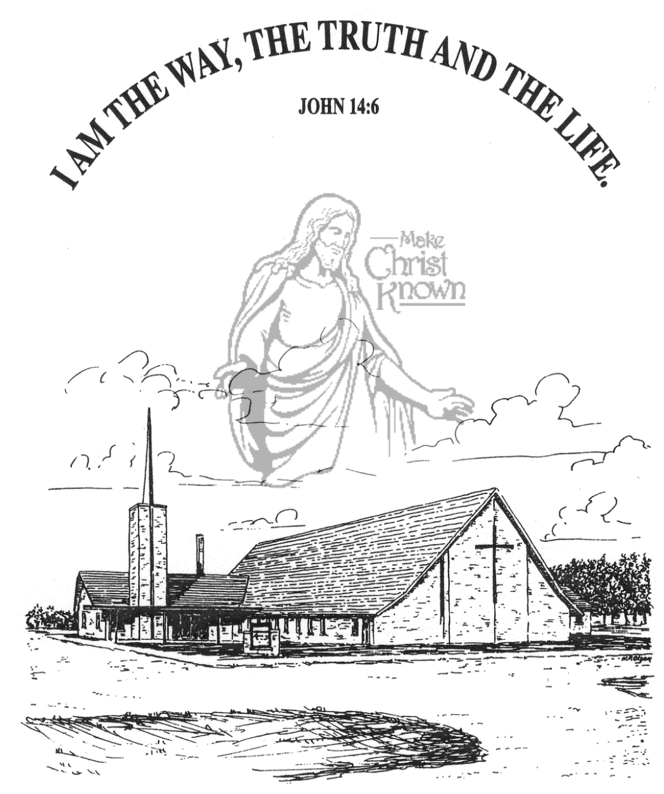

**Sunday, June 30, 2024**

**Salem Reformed Church**

**Menno, South Dakota**

**Office Hours for Pastor Hecht**

Tuesday – Friday: 8:00 AM to Noon (Church Office)

Afternoons: Visitation or Church Office

Church: (605) 387-5334 Parsonage: (605) 387-2855

Pastor Mike’s Cell #: (605) 660-1803

Church Web Page: ***salemreformedchurch.com***

**Opportunities**

Greeters Today: Kay Aisenbrey

Greeters July 07th: Worship at Menno City Park

Sunday Prayer Time: 8:30 a.m.

Praise Music: 9:15 a.m.

Worship Service: 9:30 a.m.

Adult Sunday School: 11:00 a.m.

**Announcements**

**Welcome:** We extend a warm welcome to our visiting guests this morning. Please sign our guest book in the Narthex. We ask God’s blessing upon you and we pray that you will return and worship with us again soon.

**Community Patriotic Worship Service:** The M/O Ministerial Association will host this Worship Service in the Menno City Park on Sunday, July 7th at 10:00 a.m. Please bring your lawn chairs to the park. The Offering will be designated to the M/O Care Center to help with replacing the original floor tiles in some of the hallways and resident’s rooms.  Peace Christian Reformed is the host church this year.  NOTE:  In case of inclement weather, the service will be held in the Menno School/City Auditorium.

**Give-Where-You-Live:** The High School Youth Group will be doing a work day at the M/O Care Center on Tuesday, July 9th. This includes the incoming freshman class. Parents/Youth – please be watching your text messages for more information that will be coming from the Youth Group Advisors.

**Meals-on-Wheels:** Special Thanks to all who have helped deliver meals during the month of June! You have been a blessing to many others in our community!

**The Banquet:** We are scheduled to host at The Banquet in Yankton on August 8th. Volunteers will be needed to donate, prepare and transfer food, set up tables, serve the meal, and clean up. Sign-up sheets will be available in the near future.

**Sunday Offerings:** Please note that we have an Offering Box/Pulpit at the back of the Sanctuary for people to place their tithes and offerings in during our worship services.

**SALEM REFORMED CHURCH**

Menno, South Dakota

Rev. Michael Hecht Pastor

Jennifer Herrboldt Pianist

9:30 AM – Worship Service June 30, 2024

Sixth Sunday after Pentecost

**Meditation:** *“For this reason, since the day we heard about you, we have not stopped praying for you and asking God to fill you with the knowledge of His will through all spiritual wisdom and understanding. And we pray this in order that you may live a life worthy of the Lord and may please Him in every way: bearing fruit in every good work, growing in the knowledge of God, being strengthened with all power according to His glorious might so that you may have great endurance and patience, and joyfully giving thanks to the Father, who has qualified you to share in the inheritance of the saints in the kingdom of light. For He has rescued us from the dominion of darkness and brought us into the kingdom of the Son He loves, in whom we have redemption, the forgiveness of sins.”*  Colossians 1:9-14 NIV

**Praise Music:** #63, #143, #72, #16

**Ringing of the Bell**

**Welcome / Announcements / Opening Prayer**

**\*Hymn:** #793 “For the Beauty of the Earth”

**Sharing of Joys and Concerns**

**Welcome of New Members –** Jacob & Madison Mehlhaf, and Jo Pirrung

**Our Time of Offering** Proverbs 3:1,2 NIV

**\*Lord’s Prayer** sung on page #631

**\*Apostles’ Creed** see words on screen

**Kingdom Kids:** “Serving God“ by Joanie Handel

**Hymn:** #520 “The Longer I Serve Him”

**The Holy Scriptures**

Romans 1:7-17

Large Print NIV 1984 Edition, pg. 1746

**Sermon: “Whole-Hearted Devotion”**

**\*Hymn:** #605 “Living for Jesus”

**\*Benediction:**

**\*Prayer for Our Nation:** “God Bless America”

**Postlude** (*denotes standing for those able)

The congregation will be ushered out after the Benediction