**Calendar of Events**

May 27-31 VBS Nightly from 5:45 p.m. to 9:00 p.m.

(Supper will be served from 5:45 to 6:15 PM)

May 30 Prayer Group @ 12 Noon

June 02 Prayer Time for Service @ 8:30 a.m.

VBS Program Practice @ 9:15 a.m.

VBS Program @ 10:30 a.m.

w/Pot Luck Dinner Following for the Congregation!

June 3-5 All Church Cleaning!

June 06 Prayer Group @ 12 Noon

June 09 **Summer Worship Schedule Begins**

Prayer Time for Service @ 8:30 a.m.

Praise Music @ 9:15 a.m.

Worship Service @ 9:30 a.m.

**With Holy Communion**

Adult Sunday School Class @ 11:00 a.m.

Women of His Will Conference @ 2-5:00 p.m.

**Upcoming Special Music**

Sunday, June 02 - VBS Program

Sunday, June 09 - Holy Communion

**Announcements**

**VBS Offerings:** The **Evening Offerings** will be divided between the Families of Tiffany Pommerville, Corey Kubal & Jennifer Bierle to help with medical expenses. These individuals are in a serious battle with Cancer, and each have young children at home.

**The **Sunday Morning Program Offering** will be given to Jerad & Devon Bush. They serve as Missionaries in the country of Nepal. Jerad is a graduate of Menno High School.

**Meals-on-Wheels:** Our church will be delivering meals during the month of **JUNE**. Drivers are needed for delivering lunches on Monday – Friday. They should be picked up at the M/OCC at 11:20 a.m.. Please sign the sheet in the Narthex if you are able to help.

**Summer Christian Camps:** The Women of the Church are willing to pay for the expense for our children to attend a Christian Camp this summer. Contact Joanie Handel to get reimbursed.

**Summer Worship Schedule:** Our Summer Schedule will begin on **Sunday, June 9th**, with Praise Music @ 9:15 a.m.; Worship Service @ 9:30 a.m.; Adult Sunday School @ 11:00 a.m. **We will have Holy Communion during the Worship Service on June 9th!

**Salem Reformed Church – Who Are We?**

**We believe the Bible to be the inspired, inerrant, infallible Word of God in its original manuscripts. It is our supreme authority in all matters doctrine and practice. We are affiliated with the Conservative Congregational Christian Conference.**

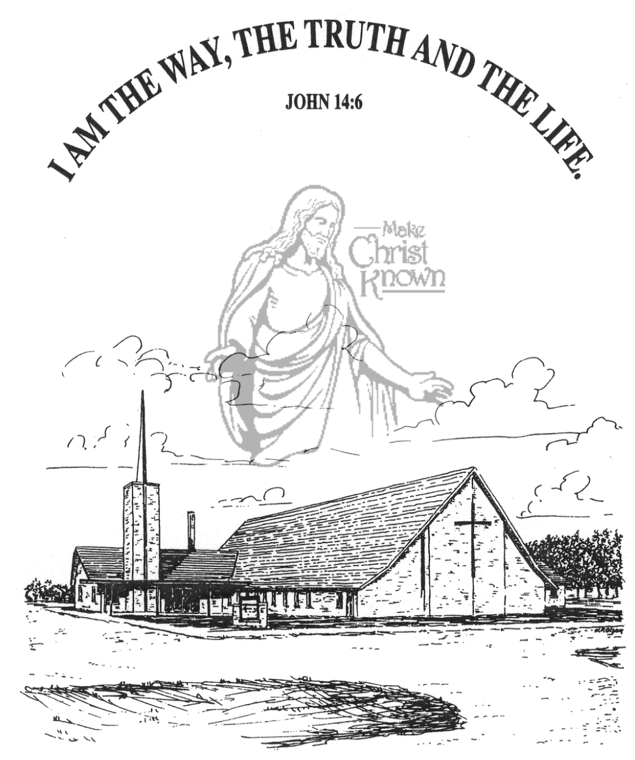

**Sunday, May 26, 2024**

**Salem Reformed Church**

**Menno, South Dakota**

**Office Hours for Pastor Hecht**

Tuesday – Friday: 8:00 AM to Noon (Church Office)

Afternoons: Visitation or Church Office

Church: (605) 387-5334 Parsonage: (605) 387-2855

Pastor Mike’s Cell #: (605) 660-1803

Church Web Page: ***salemreformedchurch.com***

**Opportunities**

Greeters May 26th: Ben & Julie Crick

Greeters June 02nd:

Sunday Prayer Time: 8:30 a.m.

Sunday School Classes: 9:15 a.m.

Praise Music: 10:15 a.m.

Worship Service: 10:30 a.m.

**Announcements**

**Welcome:** We extend a warm welcome to our visiting guests this morning. Please sign our guest book in the Narthex. We ask God’s blessing upon you and we pray that you will return and worship with us again soon.

**VBS Food:** Please **REMEMBER** what you signed up to bring for the VBS Supper each evening. This year we will again serve supper to those attending, beginning at 5:45 p.m. to 6:15 p.m. each evening. (Parents are welcome to join us!)

**Sunday School:** The Adult S.S. Class will continue meeting through the summer months after church. They are currently working through the Book of Revelation. Please consider joining this class in studying God’s Word.

**Annual Church Cleaning:** The annual church cleaning is scheduled for Monday thru Wednesday, June 3-5, 2024. Cleaning assignments have been mailed out. MEN – You are welcome and encouraged to come and help!

**High School Youth:** You are scheduled to come and clean the sanctuary floor on Wed., June 5th at 5:00 p.m.

**Special Thanks:** Thanks to Stephanie Wagner for placing the flowers in the Sanctuary during the month of May!

**Sunday Offerings:** Please note that we have an Offering Box/Pulpit at the back of the Sanctuary for people to place their tithes and offerings in during our worship services.

**VBS – *“The Great Jungle Journey”***

**Mon., May 27th – Friday, May 31st 6:30 to 9:00 Nightly!**

**Supper is Served from 5:45 to 6:15 PM**

**VBS Program is Sun., June 2nd w/Pot Luck Meal Following**

**SALEM REFORMED CHURCH**

Menno, South Dakota

Rev. Michael Hecht Pastor

Cindy Herrboldt Organist

10:30 AM – Worship Service May 26, 2024

First Sunday after Pentecost

**Meditation:** *“I will remain in the world no longer, but they are still in the world, and I am coming to You. Holy Father, protect them by the power of Your Name – the Name You gave Me – so that they may be one as we are One. While I was with them, I protected them and kept them safe by that name You gave Me. None has been lost except the one doomed to destruction so that Scripture would be fulfilled.*

*“I am coming to You now, but I say these things while I am still in the world, so that they may have the full measure of My joy within them. I have given them Your word and the world has hated them, for they are not of the world any more than I am of the world. My prayer is not that You take them out of the world but that You protect them from the evil one.”*  John 17:11-15 NIV

**Praise Music:** #7, #19, #57, #47, #32, #12

**Ringing of the Bell**

**Welcome / Announcements / Opening Prayer**

**\*Hymn:** #435 “God of Grace and God of Glory”

**Sharing of Joys and Concerns**

**Our Time of Offering** Galatians 5:1 NIV

**\*Doxology** sung on page #815

**\*Lord’s Prayer** debts and debtors

**Kingdom Kids:** “The Comforter”

**Hymn:** #464 “Dwell in Me, O Blessed Spirit” (see insert)

**The Holy Scriptures**

Acts 1:12-26

Large Print NIV 1984 Edition, pg. 1690

**Sermon: “Waiting and Ready”**

**\*Hymn:** #572 “Blessed Assurance”

**\*Benediction:**

**\*Prayer for Our Nation:** “God Bless America”

**Postlude**

(*denotes standing for those able)

The congregation will be ushered out after the Benediction

Youth Ushers: Micah Goehring and Jayden Zeeb