**Calendar of Events**

May 12 **Happy Mother’s Day!**

May 15 VBS Work Day @ 8:30 to 11:30 a.m.

4-O’s Women in Social Hall @ 12 Noon

May 16 Prayer Group @ 12 Noon

May 19Prayer Time for Service @ 8:30 a.m.

Sunday School Classes @ 9:15 a.m.

Praise Music @ 10:15 a.m.

Worship Service @ 10:30 a.m.

w/Coffee Hour Following

May 20 Men’s Christian Fellowship @ 7:30 p.m.

May 20-25 Pastor Mike & Ann on Vacation

May 27-31 VBS Nightly from 5:45 p.m. to 9:00 p.m.

(Supper will be served from 5:45 to 6:15 PM)

**Upcoming Special Music**

Sunday, May 19 - Junior Choir

Sunday, May 26 - Available

**Announcements**

**Sunday School:** The Last Day of classes for the children will be Sunday, May 19th. The Adult S.S. Class will continue meeting as usual. They are currently working through the Book of Revelation. Please consider joining this class in studying God’s Word.

**Coffee Hour:** We are looking for 2 more individuals to bring 2 dozen goodies for Coffee Hour on Sunday, May 19th. Please sign the sheet in the Narthex if you are able to help.

**Summer Christian Camps:** The Women of the Church are willing to pay for the expense for our children to attend a Christian Camp this summer. Contact Joanie Handel to get reimbursed.

**Excuse the Mess:** Please excuse the MESS, our bathroom remodel project has begun! Both bathrooms in the Narthex will be the Women’s bathrooms. The Men’s bathroom will be in the Sunday School wing.

**Summer Worship Schedule:** Our Summer Schedule will begin on **Sunday, June 9th**, with Praise Music @ 9:15 a.m.; Worship Service @ 9:30 a.m.; Adult Sunday School @ 11:00 a.m.

**Special Thanks:** Special Thanks to all of our S.S. Teachers, Helpers, and Choir Directors/Accompanists for all of your work throughout this past school year! We appreciate your dedication in teaching our children God’s Word!

**Salem Reformed Church – Who Are We?**

**We believe the Bible to be the inspired, inerrant, infallible Word of God in its original manuscripts. It is our supreme authority in all matters doctrine and practice. We are affiliated with the Conservative Congregational Christian Conference.**

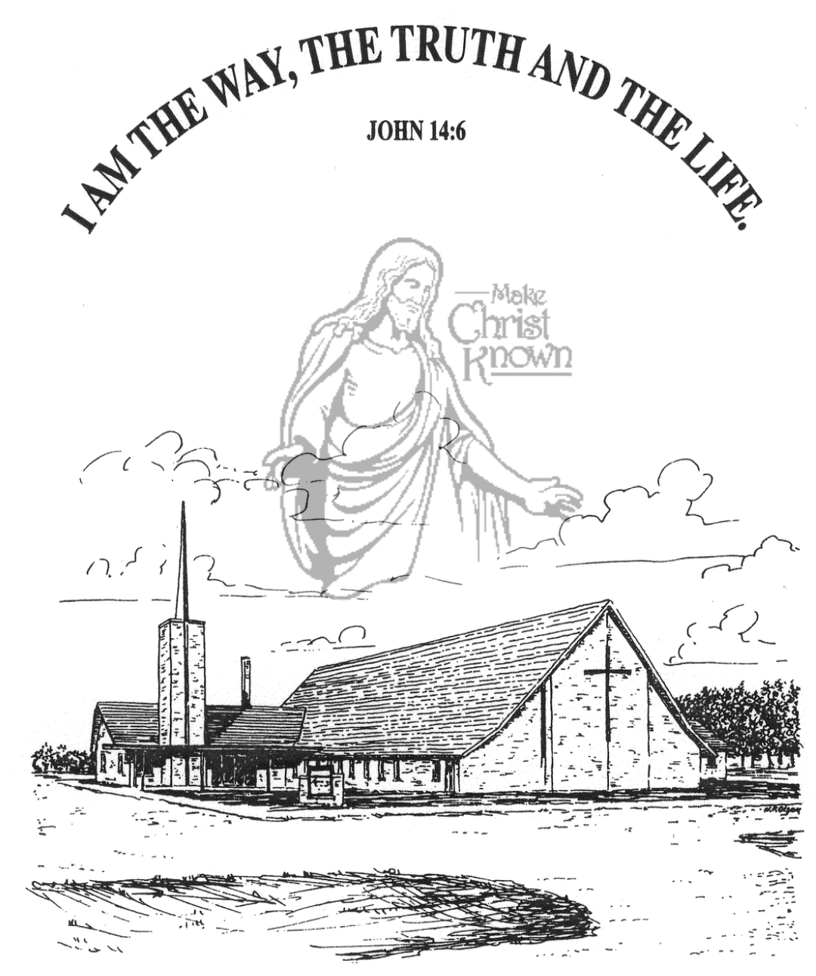

**Sunday, May 12, 2024**

**Salem Reformed Church**

**Menno, South Dakota**

**Office Hours for Pastor Hecht**

Tuesday – Friday: 8:00 AM to Noon (Church Office)

Afternoons: Visitation or Church Office

Church: (605) 387-5334 Parsonage: (605) 387-2855

Pastor Mike’s Cell #: (605) 660-1803

Church Web Page: ***salemreformedchurch.com***

**Opportunities**

Greeters May 12th: Johnny & Lori Woehl

Greeters May 19th:

Sunday Prayer Time: 8:30 a.m.

Sunday School Classes: 9:15 a.m.

Praise Music: 10:15 a.m.

Worship Service: 10:30 a.m.

**Announcements**

**Welcome:** We extend a warm welcome to our visiting guests this morning. Please sign our guest book in the Narthex. We ask God’s blessing upon you and we pray that you will return and worship with us again soon.

**Conference Sunday:** The offering received last Sunday for the CCCC was $8,584.00! Praise the Lord for such generous giving. 25% of this goes to the position of our Regional Pastor.

**VBS Work Day:** Please come and help on Wed., May 15th at our VBS Work Day. This will involve making the Tavern Meat, as well as working on decorations for VBS. Let’s have a good turnout of Helpers!

**4-O’s Women:** This women’s group will plan to meet on Wed., May 15th in the Social Hall at 12 Noon. Join us for a meal of different foods that were often served during the Depression Era! Please bring something to share.

**VBS Food Sign-Up Sheets:** Please see the sign-up sheets in the Social Hall for food items needed for VBS. This year we will again serve supper to those attending, beginning at 5:45 p.m. to 6:15 p.m. each evening.

**Junior Choir:** The Junior Choir will plan to sing in church on Sunday, May 19th. This choir consists of children in grades 4 through 8.

**Annual Church Cleaning:** The annual church cleaning is scheduled for Monday thru Wednesday, June 3-5, 2024. Cleaning assignments will be mailed out next week.

**Sunday Offerings:** Please note that we have an Offering Box/Pulpit at the back of the Sanctuary for people to place their tithes and offerings in during our worship services.

**SALEM REFORMED CHURCH**

Menno, South Dakota

Rev. Michael Hecht Pastor

Sharyl Herrboldt Pianist

10:30 AM – Worship Service May 12, 2024

Sixth Sunday after Easter

**Meditation:** *“By faith Moses’ parents hid him for three months after he was born, because they saw he was no ordinary child, and they were not afraid of the king’s edict. By faith Moses, when he had grown up, refused to be known as the son of Pharaoh’s daughter. He chose to be mistreated along with the people of God rather than to enjoy the pleasures of sin for a short time. He regarded disgrace for the sake of Christ as of greater value than the treasures of Egypt, because he was looking ahead to his reward. By faith he left Egypt, not fearing the king’s anger; he persevered because he saw him who is invisible. By faith he kept the Passover and the sprinkling of blood, so that the destroyer of the firstborn would not touch the firstborn of Israel.”*  Hebrews 11:23-28 NIV

**Praise Music:** #38, #18, #17, #49, #144

**Ringing of the Bell**

**Welcome / Announcements / Opening Prayer**

**\*Hymn:** #21 “O for a Thousand Tongues to Sing”

**Sharing of Joys and Concerns**

**Our Time of Offering** I Thess. 2:6b-8 NIV

**\*Doxology** sung on page #815

**\*Lord’s Prayer** debts and debtors

**Special Music:** “If I Were A Butterfly” & “Mother, I Love You”

Sung by the Cherub Choir, Ages 3yrs. thru 3rd Grade

**Kingdom Kids:** “It’s Mother’s Day!”

**The Holy Scriptures**

Exodus 2:1-10

Large Print NIV 1984 Edition, pg. 89

**Sermon: “No Ordinary Child”**

**\*Hymn:** #581 “Tis So Sweet to Trust in Jesus

**\*Benediction:**

**\*Prayer for Our Nation:** “God Bless America”

**Postlude** (*denotes standing for those able)

The congregation will be ushered out after the Benediction

Youth Ushers: Micah Goehring and Jayden Zeeb