**Calendar of Events**

April 07 FCA Spring Banquet @ 6:00 p.m.

April 10 6/7th Grade Confirmation @ 3:30-5:00 p.m.

8th Grade Confirmation @ 5:30-7:00 p.m.

Consistory Meeting @ 7:30 p.m.

April 11 Prayer Group @ 12 Noon

April 12 The Garms Family @ 7:00 p.m.

April 14 **CONFIRMATION SUNDAY**

No Sunday School Classes Today

Praise Music @ 9:45 a.m.

Worship Service @ 10:00 a.m.

April 15 Men’s Christian Fellowship @ 7:30 p.m.

April 16 W.O.C. Program at M/OCC @ 2:00 p.m.

April 17 8th Grade Confirmands to Dairy Bar @ 3:30pm

**Upcoming Special Music**

Sunday, April 14 - Mia Barnes

Sunday, April 21 - Available

**Announcements**

**Church Pictorial Directory:** We are making a new pictorial directory and want **YOU** to be included – it won’t be complete without you! A pictorial directory is a powerful tool in our church to help each of us know each other better! Please make an appointment to have your picture taken! The dates for picture taking are May 2,3,4, 2024. Committee Members are Stephanie Wagner, Mary Heckenlaible, Cassie Wielenga, Shirley Mettler.

**VBS Food Sign-Up Sheets:** Please see the sign-up sheets in the Social Hall for food items needed for VBS. This year we will again serve supper to those attending, beginning at 5:45 p.m. each evening. We will not be having a snack later.

**VBS Registration:** Mark your Calendars! Our VBS is scheduled for May 27th-31st! The VBS Program will be on Sunday, June 2nd. Helpers and Students can begin to register **NOW**, at the following website: ***salem.myanswers.com***

There are also boxes to check on the registration site if you are willing to help in certain areas before the VBS week.

**Sunday School Class Pictures:** We will plan to take pictures of our Sunday School Classes on Sunday, April 21st. These pics will be for our Church Pictorial Directory.

**Salem Reformed Church – Who Are We?**

**We believe the Bible to be the inspired, inerrant, infallible Word of God in its original manuscripts. It is our supreme authority in all matters doctrine and practice. We are affiliated with the Conservative Congregational Christian Conference.**

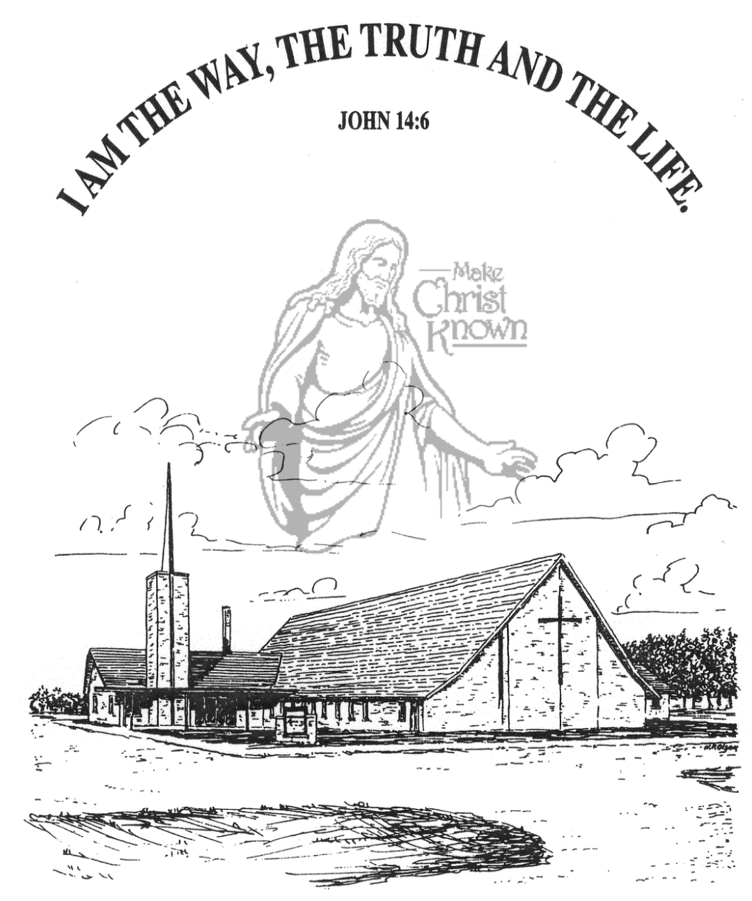

**Sunday, April 07, 2024**

**Salem Reformed Church**

**Menno, South Dakota**

**Office Hours for Pastor Hecht**

Tuesday – Friday: 8:00 AM to Noon (Church Office)

Afternoons: Visitation or Church Office

Church: (605) 387-5334 Parsonage: (605) 387-2855

Pastor Mike’s Cell #: (605) 660-1803

Church Web Page: ***salemreformedchurch.com***

**Opportunities**

Greeters April 07th: Billy and Jennifer Masterson

Greeters April 14th:

Sunday Prayer Time: 8:30 a.m.

Sunday School Classes: 9:15 a.m.

Praise Music: 10:15 a.m.

Worship Service: 10:30 a.m.

**Announcements**

**Welcome:** We extend a warm welcome to our visiting guests this morning. Please sign our guest book in the Narthex. We ask God’s blessing upon you and we pray that you will return and worship with us again soon.

**Christian Ed. Committee:** The CE Committee will plan to meet after church TODAY in the High School S.S. Room.

**FCA Spring Banquet:** The Banquet will be held THIS EVENING @ 6PM at the Menno City/School Auditorium. Our guest speaker will be Coach John Stiegelmeier, former SDSU Jacks Football Coach!

**The Garms Family:** We’re excited to have The Garms Family of 8 back with us again! They will be here in concert on Friday, April 12th @ 7PM. Invite your friends and family! A free-will offering will be received.

**Confirmation Sunday:** Confirmation for our 8th Graders will take place on Sunday, April 14th at 10:00 a.m. There will not be Sunday School Classes on that day. Those being confirmed are: Ashlyn Derby, Emmalyn Heckenlaible, Hannah Masterson, Luke Plooster, Autumn Rames and Emmarie Rames.

**Program at M/OCC:** Please sign the sheet in the Narthex if you are willing to help with the program at M/OCC on Tuesday, April 16th at 2:00 p.m. The program theme is “Aprons”, so please bring one to display. Thanks!

**Sunday Offerings:** Please note that we have an Offering Box/Pulpit at the back of the Sanctuary for people to place their tithes and offerings in during our worship services.

**SALEM REFORMED CHURCH**

Menno, South Dakota

Rev. Michael Hecht Pastor

Jennifer Herrboldt Pianist

10:30 AM – Worship Service April 07, 2024

First Sunday after Easter

**Meditation:** *“When Jesus had finished speaking, He said to Simon, ‘Put out into deep water, and let down the nets for a catch.’ Simon answered, ‘Master, we’ve worked hard all night and haven’t caught anything. But because You say so, I will let down the nets.’ When they had done so, they caught such a large number of fish that their nets began to break. So they signaled their partners in the other boat to come and help them, and they came and filled both boats so full that they began to sink. When Simon Peter saw this, he fell at Jesus’ knees and said, ‘Go away from me, Lord; I am a sinful man!’ For he and all his companions were astonished at the catch of fish they had taken, and so were James and John, the sons of Zebedee, Simon’s partners. Then Jesus said to Simon, ‘Don’t be afraid; from now on you will catch men.’ So they pulled their boats up on shore, left everything and followed Him.”* Luke 5:4-11 NIV

**Praise Music:** #48, #80, #143, #23

**Ringing of the Bell**

**Welcome / Announcements / Opening Prayer**

**\*Hymn:** #368 “He Lives!”

**Sharing of Joys and Concerns**

**Our Time of Offering** Luke 24:33,34 NIV

**\*Doxology** sung on page #815

**\*Lord’s Prayer** debts and debtors

**Kingdom Kids:** “Believe It or Not!”

**Special Music:** “He’s Alive” by Ron & Marina Schaeffer

**The Holy Scriptures**

John 21:1-14

Large Print NIV 1984 Edition, pg. 1687

**Sermon: “Friends, Have You Caught Any Fish?”**

**\*Hymn:** #358 “Because He Lives”

**\*Benediction:**

**\*Prayer for Our Nation:** “God Bless America”

**Postlude** (*denotes standing for those able)

The congregation will be ushered out after the Benediction

Youth Ushers: Taylor Freier and Amanda Rames