**Calendar of Events**

April 21 M/O Care Center Service @ 2:00 p.m.

April 24 Women’s Bible Study @ 6:00 p.m.

April 25 Prayer Group @ 12 Noon

April 28 Prayer Time for Service @ 8:30 a.m.

Sunday School Classes @ 9:15 a.m.

Praise Music @ 10:15 a.m.

Worship Service @ 10:30 a.m.

May 1-4 Church Pictorial Directory Pictures

May 01 FCA at Menno City Park @ 7:30 p.m.

May 02 Prayer Group @ 12 Noon

**Upcoming Special Music**

Sunday, April 28 - Available

Sunday, May 05 - Available

**Announcements**

**Spaghetti Fundraiser:** The Menno Athletic Club will be hosting a Spaghetti Dinner **TODAY** at the Legion Hall from 11AM to 1:30 PM. This is to raise funds for the summer recreation programs.

**Cherub Choir:** The Cherub Choir will plan to sing in church on Sunday, May 12th (Mother’s Day). This choir consists of the children from age 3 yrs. thru 3rd Grade. Please have your children here by 9:15 a.m. on Sunday mornings for practice and Sunday School.

**Junior Choir:** The Junior Choir will plan to sing in church on Sunday, May 19th. This choir consists of children in grades 4 thru 8. They also practice at 9:15 a.m. on Sunday mornings.

**Church Pictorial Directory:** We are making a new pictorial directory and want **YOU** to be included – it won’t be complete without you! A pictorial directory is a powerful tool in our church to help each of us know one another better! Please make an appointment to have your picture taken! The dates for picture taking are May 1-4. Committee Members are Stephanie Wagner, Mary Heckenlaible, Cassie Wielenga, Shirley Mettler.

**CCCC Annual Gathering:** This will be held in Warwick, RI, during the week of July 29th. Please contact Pastor Mike if you are interested in attending.

**MHS Baccalaureate Service:** The M/O Ministerial Association will host the Baccalaureate Service in the New Gym on Saturday, May 11th @ 1:30 p.m. The Commencement Ceremony will be held in the New Gym @ 2:30 p.m.

**Salem Reformed Church – Who Are We?**

**We believe the Bible to be the inspired, inerrant, infallible Word of God in its original manuscripts. It is our supreme authority in all matters doctrine and practice. We are affiliated with the Conservative Congregational Christian Conference.**

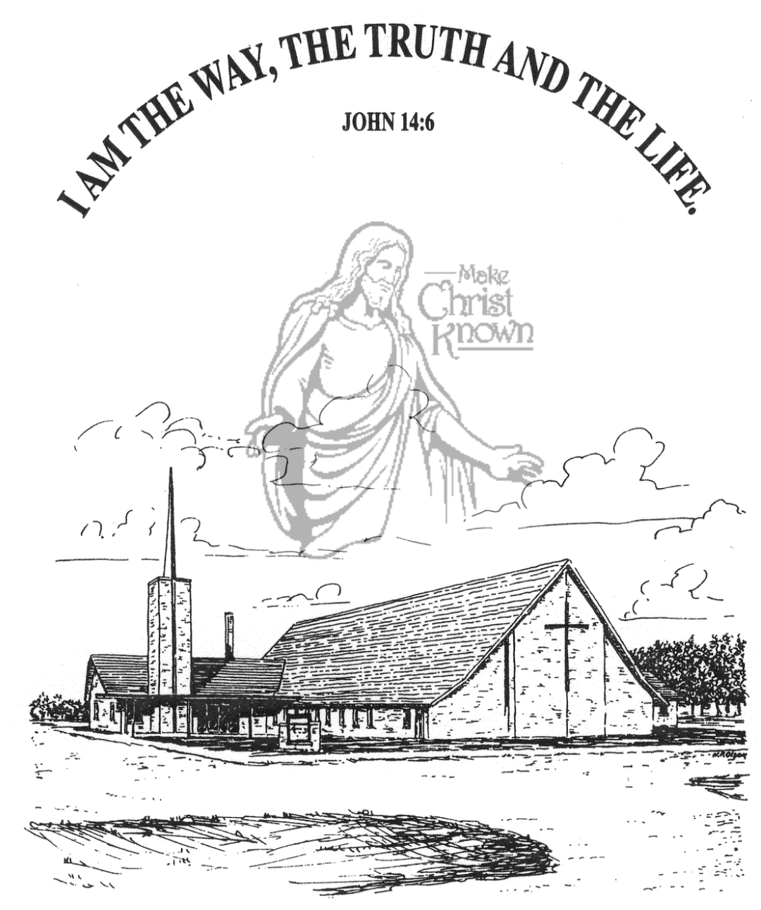

**Sunday, April 21, 2024**

**Salem Reformed Church**

**Menno, South Dakota**

**Office Hours for Pastor Hecht**

Tuesday – Friday: 8:00 AM to Noon (Church Office)

Afternoons: Visitation or Church Office

Church: (605) 387-5334 Parsonage: (605) 387-2855

Pastor Mike’s Cell #: (605) 660-1803

Church Web Page: ***salemreformedchurch.com***

**Opportunities**

Greeters April 21st: Brian & Steph Mehlhaf

Greeters April 28th: Ray & Beverly Gossen

Sunday Prayer Time: 8:30 a.m.

Sunday School Classes: 9:15 a.m.

Praise Music: 10:15 a.m.

Worship Service: 10:30 a.m.

**Announcements**

**Welcome:** We extend a warm welcome to our visiting guests this morning. Please sign our guest book in the Narthex. We ask God’s blessing upon you and we pray that you will return and worship with us again soon.

**Congratulations:** We rejoice with the Family of Zane Allen Gregerson at his baptism! Zane’s parents are Jordan and Kennedy Gregerson. He joins his older sister, Asher. We extend a warm welcome to all of their family and friends who may be present in our worship service today.

**VBS Food Sign-Up Sheets:** Please see the sign-up sheets in the Social Hall for food items needed for VBS. This year we will again serve supper to those attending, beginning at 5:45 p.m. each evening.

**VBS Registration:** Mark your Calendars! Our VBS is scheduled for May 27th-31st! The VBS Program will be on Sunday, June 2nd. Please register your children **ASAP**, at the following website: ***salem.myanswers.com***

**Golden Age Banquet:** The CE Committee will be hosting this Banquet for those in our church who are 65 years and older. The date is Sunday, May 5th at 5:30 p.m.

**Excuse the Mess:** Please excuse the MESS, our bathroom remodel project has begun! Both bathrooms in the Narthex will be the Women’s bathrooms. The Men’s bathroom will be in the Sunday School wing.

**Sunday Offerings:** Please note that we have an Offering Box/Pulpit at the back of the Sanctuary for people to place their tithes and offerings in during our worship services.

**SALEM REFORMED CHURCH**

Menno, South Dakota

Rev. Michael Hecht Pastor

Cindy Herrboldt Organist

10:30 AM – Worship Service April 21, 2024

Third Sunday after Easter

**Meditation:** *“This is how God showed His love among us: He sent His one and only Son into the world that we might live through Him. This is love: not that we loved God, but that He loved us and sent His Son as an atoning sacrifice for our sins. Dear friends, since God so loved us, we also ought to love one another. No one has ever seen God; but if we love one another, God lives in us and His love is made complete in us. We know that we live in Him and He in us, because He has given us of His Spirit.”* I John 4:9-13 NIV

**Praise Music:** #45, #56, #57, #28, #12, #32

**Ringing of the Bell**

**Welcome / Announcements / Opening Prayer**

**\*Hymn:** #3 “Holy, Holy, Holy! Lord God Almighty”

**Sharing of Joys and Concerns**

**Our Time of Offering** Psalm 127:3-5 NLT

**\*Doxology** sung on page #815

**\*Apostles’ Creed** words on screen

**Baptism: Zane Allen Gregerson**

**Questions of Candidates / Congregational Assent**

**Education Committee Pledge** Kevin Holzwarth

**Act of Baptism**

**Congregational Song:** “Yes, Jesus Loves You!”

**Kingdom Kids:** “Peter’s 2nd Chance”

**Hymn:** #366“I Live”

**The Holy Scriptures**

John 21:15-25

Large Print NIV 1984 Edition, pg. 1687

**Sermon: “Do You Truly Love Me?”**

**\*Hymn:** #575 “Leaning on the Everlasting Arms”

**\*Benediction:**

**\*Prayer for Our Nation:** “God Bless America”

**Postlude** (*denotes standing for those able)

The congregation will be ushered out after the Benediction

Youth Ushers: Taylor Freier and Amanda Rames