**Calendar of Events**

March 04 Men’s Christian Fellowship @ 7:00 p.m.

Cantata Practice at Zion Reformed @ 7:30p.m.

March 05 M/O Ministerial Mtg at Roosters @ 11:30 a.m.

March 06 Women’s Bible Study @ 9:30 a.m.

6/7th Grade Confirmation @ 3:30-5:15 p.m.

8th Grade Confirmation @ 5:30-7:00 p.m.

Women’s Bible Study @ 6:00 p.m.

FCA at Menno Gym @ 7:30 p.m.

March 07 Prayer Group @ 12 Noon

March 10 Prayer Time for Service @ 8:30 a.m.

Sunday School Classes @ 9:15 a.m.

Praise Music @ 10:15 a.m.

Worship Service @ 10:30 a.m.

with Jenna Spellerberg from the Alpha Center

Contemporary Service @ 7:00 pm

Sunday, March 10 - Available

Sunday, March 13 - Available

**Announcements**

**Youth Group Meeting:** The High School Youth will meet today after church. Lunch will be provided!

**Women’s Salad Supper:** This is scheduled for Monday, April 1st at 6PM! The guest speaker will be Holly Hoffman, who was actually a contestant on Season 21 of Survivor. Invite your friends and come to this enjoyable and inspirational evening! Young Ladies, 8th Grade and Older are also encouraged to attend! **MEN:** We’ll need your help again with serving the coffee/water and washing the dishes.

**Contemporary Service:** We will plan to hold a Contemporary

Service next Sunday evening, March 10th at 7:00 p.m. Please contact Pastor Mike or Ann if you have a brief testimony that you would like to share. Thanks!

**Alpha Center Banquet:** The Alpha Center Friends & Fellowship Dinner will be Friday, April 26, 2024 at the Sioux Falls Convention Center. Please contact Lee Herrboldt if you are interested in attending. We will celebrate the Sanctity of Human Life here at church on Sunday, March 10th.

**Salem Reformed Church – Who Are We?**

**We believe the Bible to be the inspired, inerrant, infallible Word of God in its original manuscripts. It is our supreme authority in all matters doctrine and practice. We are affiliated with the Conservative Congregational Christian Conference.**

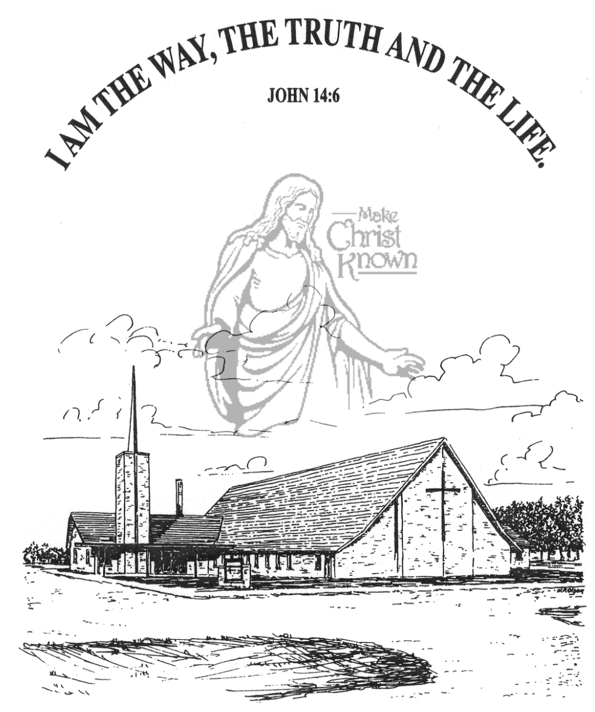

**Sunday, March 03, 2024**

**Salem Reformed Church**

**Menno, South Dakota**

**Office Hours for Pastor Hecht**

Tuesday – Friday: 8:00 AM to Noon (Church Office)

Afternoons: Visitation or Church Office

Church: (605) 387-5334 Parsonage: (605) 387-2855

Pastor Mike’s Cell #: (605) 660-1803

Church Web Page: ***salemreformedchurch.com***

**Opportunities**

Greeters Today: Jim and Deb Christensen

Greeter March 10th: Harriet Schaeffer

Greeters March 13th:

Sunday Prayer Time: 8:30 a.m.

Sunday School Classes: 9:15 a.m.

Praise Music: 10:15 a.m.

Worship Service: 10:30 a.m.

**Announcements**

**Welcome:** We extend a warm welcome to our visiting guests this morning. Please sign our guest book in the Narthex. We ask God’s blessing upon you and we pray that you will return and worship with us again soon.

**Adult Sunday School Class:** The Older Adult Class started a study on the Book of Revelation this Morning.! This is a DVD led study by Rev. Adrian Rogers. Please consider joining the class for this exciting and informative study through the Book of Revelation! Class starts at 9:15 a.m.

**Family Fun Event:** This is happening TODAY at the Bowling Alley in Yankton @ 3:00 p.m., followed by supper at Pizza Ranch. Bring the whole family and we’ll have a great time! **NOTE:** Bowling is $4.50 per game; Shoe Rental is $3.00. Melanie Walter will be collecting the money for our church group at the bowling alley.

**Cherub Choir:** Parents of the Cherub Choir (3yrs. - 3rd Grade), please note that your children will be singing in church on Palm Sunday, March 24th.

**Sunday Offerings:** Please note that we have an Offering Box/Pulpit at the back of the Sanctuary for people to place their tithes and offerings in.

***“God loves a cheerful giver.”* II Corinthians 9:7**

**Upcoming Lenten Services**

**Wednesday, March 13th @ 7 PM**

**Maundy Thursday, March 28th @ 7 PM**  (w/Holy Communion)

**SALEM REFORMED CHURCH**

Menno, South Dakota

Rev. Michael Hecht Pastor

Jennifer Herrboldt Pianist

10:30 AM – Worship Service March 03, 2024

3rd Sunday in Lenten Season

**Meditation:** *“The acts of the sinful nature are obvious: sexual immorality, impurity and debauchery; idolatry and witchcraft; hatred, discord, jealousy, fits of rage, selfish ambition, dissensions, factions and envy; drunkenness, orgies, and the like. I warn you, as I did before, that those who live like this will not inherit the kingdom of God. But the fruit of the Spirit is love, joy, peace, patience, kindness, goodness, faithfulness, gentleness and self-control. Against such things there is no law. Those who belong to Christ Jesus have crucified the sinful nature with its passions and desires. Since we live by the Spirit, let us keep in step with the Spirit. Let us not become conceited, provoking and envying each other.”*  Galatians 5:19-26 NIV

**Praise Music:** #63, #131, #147, #140

**Ringing of the Bell**

**Welcome / Announcements / Opening Prayer**

**\*Hymn:** #348 “My Savior’s Love”

**Sharing of Joys and Concerns**

**Our Time of Offering** Hebrews 13:15,16 NIV

**\*Lord’s Prayer** sung on page #631

**\*Apostles’ Creed** see words on screen

**Kingdom Kids:** “The Fruit of the Spirit“

**Hymn:** #768 “My Savior First of All”

**The Holy Scriptures**

John 15:1-11

Large Print NIV 1984 Edition, pg. 1676

**Sermon: “That You Bear Much Fruit”**

**\*Hymn:** #318 “I Believe In a Hill Called Mount Calvary”

**\*Benediction:**

**\*Prayer for Our Nation:** “God Bless America”

**Postlude**

(*denotes standing for those able)

The congregation will be ushered out after the Benediction

Youth Ushers: Lexie McNinch and Madison Schaeffer