**Calendar of Events**

March 24 Community Easter Cantata @ 7:00 p.m.

March 27 6/7th Grade Confirmation @ 3:30-5:15 p.m.

8th Grade Confirmation @ 5:30-7:00 p.m.

Women’s Bible Study @ 6:00 p.m.

March 28 Prayer Group @ 12 Noon

**Maundy Thursday Service @ 7:00 p.m.**

(with Holy Communion)

March 30 Youth Group Breakfast Prep @ 10:00 a.m.

March 31 **Resurrection Day! Happy Easter!**

Easter Breakfast from 8:30-10:00 a.m.

Children’s DVD @ 9:30 a.m.

Praise Music @ 10:15 a.m.

Worship Service @ 10:30 a.m.

April 01 W.O.C. Salad Supper @ 6:00 p.m.

Men’s Christian Fellowship @ 7:30 p.m.

**Upcoming Special Music**

Thursday, March 28 - Jennifer Schultz

Sunday, March 31 - Handbell Choir

**Announcements**

**Adult Sunday School Class:** The Older Adult Class started a study on the Book of Revelation, by Rev. Adrian Rogers. Class starts at 9:15 a.m. You are welcome to attend!

**Women’s Salad Supper:** This is scheduled for Monday, April 1st at 6PM! The guest speaker will be Holly Hoffman, who was actually a contestant on Season 21 of Survivor. Invite your friends and come to this enjoyable and inspirational evening! Young Ladies, 8th Grade and Older are also encouraged to attend!

**Church Pictorial Directory:** We are making a new pictorial directory and want **YOU** to be included – it won’t be complete without you! A pictorial directory is a powerful tool in our church to help each of us know each other better! Please make an appointment to have your picture taken! Committee Members will be in the Social Hall on the following Sundays to assist you: March 24th, and 31st! The dates for picture taking are May 2,3,4, 2024. Committee Members are Stephanie Wagner, Mary Heckenlaible, Cassie Wielenga, Shirley Mettler.

**Salem Reformed Church – Who Are We?**

**We believe the Bible to be the inspired, inerrant, infallible Word of God in its original manuscripts. It is our supreme authority in all matters doctrine and practice. We are affiliated with the Conservative Congregational Christian Conference.**

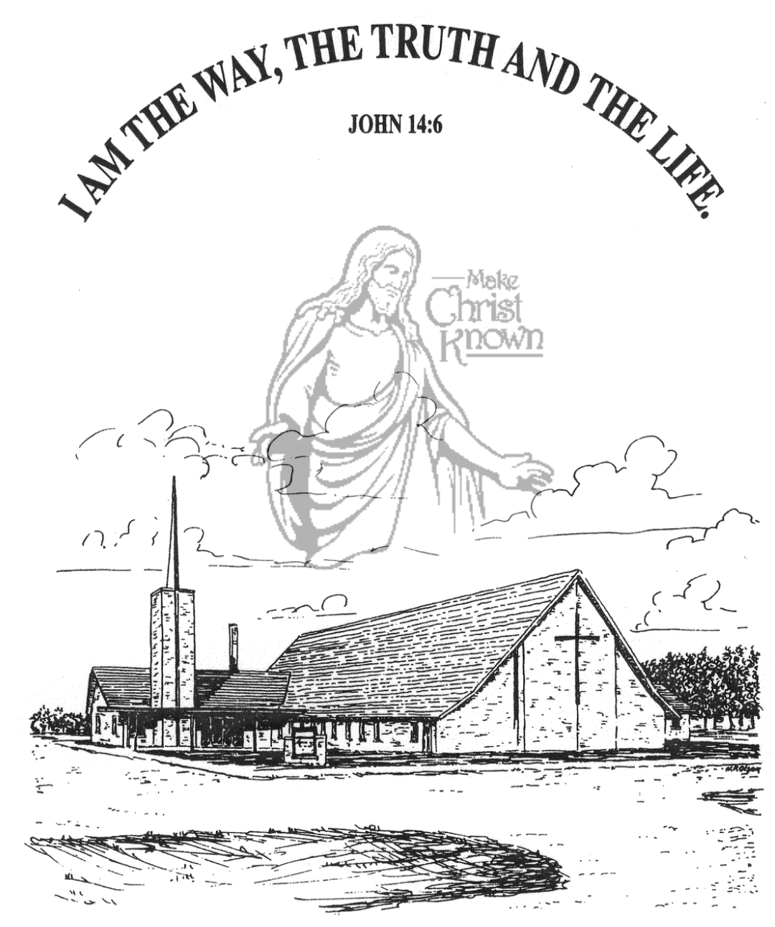

**Sunday, March 24, 2024**

**Salem Reformed Church**

**Menno, South Dakota**

**Office Hours for Pastor Hecht**

Tuesday – Friday: 8:00 AM to Noon (Church Office)

Afternoons: Visitation or Church Office

Church: (605) 387-5334 Parsonage: (605) 387-2855

Pastor Mike’s Cell #: (605) 660-1803

Church Web Page: ***salemreformedchurch.com***

**Opportunities**

Greeters March 24th: Jim & Donna Sattler

Greeters March 28th: Ryan & Cassie Wielenga Family

Greeters March 31st: Jeremy & Denise Handel

Sunday Prayer Time: 8:30 a.m.

Sunday School Classes: 9:15 a.m.

Praise Music: 10:15 a.m.

Worship Service: 10:30 a.m.

**Announcements**

**Welcome:** We extend a warm welcome to our visiting guests this morning. Please sign our guest book in the Narthex. We ask God’s blessing upon you and we pray that you will return and worship with us again soon.

**Easter Lilies in Memory of Loved Ones:** On Easter Sunday, March 31st, we have the opportunity to place Easter Lilies in the sanctuary in memory of departed loved ones. Please contact the florist of your choice.

**M/O Community Easter Cantata:** The Cantata will be here THIS EVENING @ 7PM. This year’s selection is *“Worthy: Song of the Ages”.* A freewill offering will be taken to help support the projects of the M/O Ministerial Association. Please plan to attend and bring your friends along!

**Easter Breakfast:** The High School Youth Group will host an Easter Breakfast in the Social Hall from 8:30-10:00 a.m. on Sunday, March 31st. Breakfast includes Egg Bake, Muffins, and Fresh Fruit. Free-will donations are accepted.

**Sunday Offerings:** Please note that we have an Offering Box/Pulpit at the back of the Sanctuary for people to place their tithes and offerings in during our worship services.

**FCA Spring Banquet:** This will be held on Sunday, April 7th at 6PM at the Menno City/School Auditorium. Our guest speaker will be Coach John Stiegelmeier, former SDSU Jacks Football Coach! Please **RSVP** to the Church Office or Text Ivory Wintersteen @ (605) 680-2595 if planning to attend.

**SALEM REFORMED CHURCH**

Menno, South Dakota

Rev. Michael Hecht Pastor

Marina Schaeffer Pianist

10:30 AM – Worship Service March 24, 2024

Palm Sunday

**Meditation:** *“Therefore many of the Jews who had come to visit Mary, and had seen what Jesus did, put their faith in Him. But some of them went to the Pharisees and told them what Jesus had done. Then the chief priests and the Pharisees called a meeting of the Sanhedrin. ‘What are we accomplishing?’ they asked. ‘Here is this man performing many miraculous signs. If we let Him go on like this, everyone will believe in Him, and then the Romans will come and take away both our place and our nation.’ Then one of them, named Caiaphas, who was high priest that year, spoke up, ‘You know nothing at all! You do not realize that it is better for you that one man die for the people than that the whole nation perish.’ He did not say this on his own, but as high priest that year he prophesied that Jesus would die for the Jewish nation.”* John 11:45-51 NIV

**Praise Music:** #29, #34, #90, #133

**Ringing of the Bell**

**Welcome / Announcements / Opening Prayer**

**\*Hymn:** #297 “Hosanna, Loud Hosanna”

**Sharing of Joys and Concerns**

**Our Time of Offering** Luke 19:37 NIV

**\*Doxology** sung on page #815

**\*Lord’s Prayer** debts and debtors

**Special Music:** “Shout Hosanna” and “Alive, Alive”

Sung by the Cherub Choir (3 yrs. old thru 3rd Grade)

**Kingdom Kids:** “Imagine the First Palm Sunday”

**The Holy Scriptures**

John 12:9-19

Large Print NIV 1984 Edition, pg. 1671

**Sermon: “The Hope of Christ’s Visitation”**

**\*Hymn:** #91 “Hope of the Nations” (praise book)

**\*Benediction:**

**\*Prayer for Our Nation:** “God Bless America”

**Postlude** (*denotes standing for those able)

The congregation will be ushered out after the Benediction

Youth Ushers: Lexie McNinch and Madison Schaeffer