**Calendar of Events**

March 17 M/O Care Center Service @ 2:00 p.m.

March 18 Cantata Practice - Salem Reformed @7:30 pm

Men’s Christian Fellowship @ 7:30 p.m.

March 20 Women’s Bible Study @ 9:30 a.m.

4-O’s in Social Hall @ 12 Noon

6/7th Grade Confirmation @ 3:30-5:15 p.m.

8th Grade Confirmation @ 5:30-7:00 p.m.

Women’s Bible Study @ 6:00 p.m.

FCA at Menno Gym @ 7:30 p.m.

March 21 Prayer Group @ 12 Noon

Cantata Practice – Salem Reformed @7:30 pm

March 24 **PALM SUNDAY**

Prayer Time for Service @ 8:30 a.m.

Sunday School Classes @ 9:15 a.m.

Praise Music @ 10:15 a.m.

Worship Service @ 10:30 a.m.

Community Easter Cantata @ 7:00 p.m.

**Upcoming Special Music**

Sunday, March 17 - Available

Sunday, March 24 - Cherub Choir

**Announcements**

**M/OCC Spaghetti Fundraiser:** You are invited to this Spaghetti Supper Fundraiser at the Menno-Olivet Care Center on Wed., March 20th from 4 – 8 PM. Free-will donations for salad, spaghetti, garlic toast and dessert will go towards new dining room chairs. They will also have a “To-Go” option. Thanks for your support!

**Adult Sunday School Class:** The Older Adult Class started a study on the Book of Revelation, by Rev. Adrian Rogers. Class starts at 9:15 a.m. You are welcome to attend!

**Women’s Salad Supper:** This is scheduled for Monday, April 1st at 6PM! The guest speaker will be Holly Hoffman, who was actually a contestant on Season 21 of Survivor. Invite your friends and come to this enjoyable and inspirational evening! Young Ladies, 8th Grade and Older are also encouraged to attend! **MEN:** We’ll need your help again with serving the coffee/water and washing the dishes.

**Salem Reformed Church – Who Are We?**

**We believe the Bible to be the inspired, inerrant, infallible Word of God in its original manuscripts. It is our supreme authority in all matters doctrine and practice. We are affiliated with the Conservative Congregational Christian Conference.**

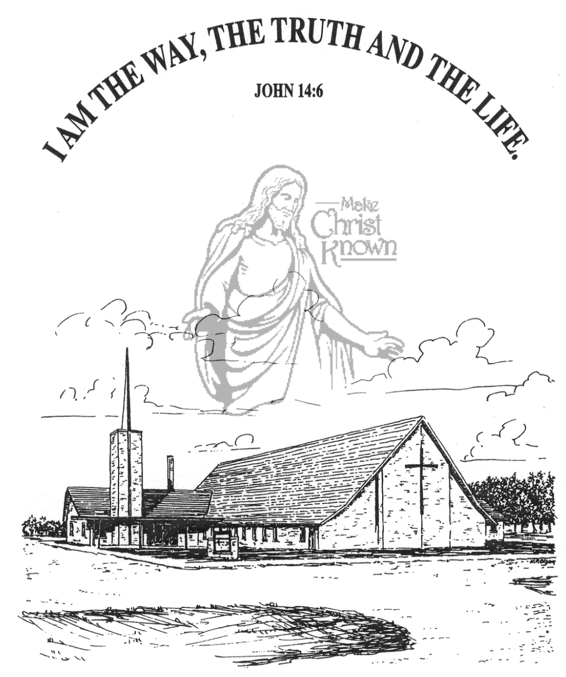

**Sunday, March 17, 2024**

**Salem Reformed Church**

**Menno, South Dakota**

**Office Hours for Pastor Hecht**

Tuesday – Friday: 8:00 AM to Noon (Church Office)

Afternoons: Visitation or Church Office

Church: (605) 387-5334 Parsonage: (605) 387-2855

Pastor Mike’s Cell #: (605) 660-1803

Church Web Page: ***salemreformedchurch.com***

**Opportunities**

Greeters March 17th: David and Peg Walloch

Greeters March 24th:

Greeters March 28th: Ryan & Cassie Wielenga Family

Sunday Prayer Time: 8:30 a.m.

Sunday School Classes: 9:15 a.m.

Praise Music: 10:15 a.m.

Worship Service: 10:30 a.m.

**Announcements**

**Welcome:** We extend a warm welcome to our visiting guests this morning. Please sign our guest book in the Narthex. We ask God’s blessing upon you and we pray that you will return and worship with us again soon.

**W.O.C. Meeting / Coffee Hour:** The Women of the Church will plan to meet **TODAY** after church in the SS Wing. We will also have Coffee Hour in the Social Hall. Please Stay!

**Sanctity of Human Life:** The offering received last Sunday for the Alpha Center was $4,343.00! We praise the Lord that we are able to partner with this ministry as they stand for the lives of the unborn!

**4-O’s Women:** Ladies, we will plan to meet in the Social Hall next Wed., March 20th at 12 Noon. We will get the main dish from the Dairy Bar, but you are encouraged to bring something else to add to the meal. Please sign the sheet in the Narthex if you are planning to attend.

**Cherub Choir:** Parents of the Cherub Choir (3yrs. - 3rd Grade), please note that your children will be singing in church on Palm Sunday, March 24th.

**Easter Lilies in Memory of Loved Ones:** On Easter Sunday, March 31st, we have the opportunity to place Easter Lilies in the sanctuary in memory of departed loved ones. Please contact the florist of your choice.

**Sunday Offerings:** Please note that we have an Offering Box/Pulpit at the back of the Sanctuary for people to place their tithes and offerings in during our worship services.

**SALEM REFORMED CHURCH**

Menno, South Dakota

Rev. Michael Hecht Pastor

Joan Nusz Pianist

10:30 AM – Worship Service March 17, 2024

5th Sunday in Lenten Season

**Meditation:** (Part of Paul’s Testimony before King Agrippa.)

*“I too was convinced that I ought to do all that was possible to oppose the Name of Jesus of Nazareth. And that is just what I did in Jerusalem. On the authority of the chief priests I put many of the saints in prison, and when they were put to death, I cast my vote against them. Many a time I went from one synagogue to another to have them punished, and I tried to force them to blaspheme. In my obsession against them, I even went to foreign cities to persecute them. On one of these journeys I was going to Damascus with the authority and commission of the chief priests. About noon, O king, as I was on the road, I saw a light from heaven, brighter than the sun, blazing around me and my companions. We all fell to the ground, and I heard a voice saying to me in Aramaic, ‘Saul, Saul, why do you persecute Me? It is hard for you to kick against the goads.’* Acts 26:9-14 NIV

**Praise Music:** #104, #36, #41, #13, #762

**Ringing of the Bell**

**Welcome / Announcements / Opening Prayer**

**\*Hymn:** #17 “Our Great Savior”

**Sharing of Joys and Concerns**

**Our Time of Offering** I Peter 2:21-23 NIV

**\*Lord’s Prayer** sung on page #631

**\*Apostles’ Creed** words on screen

**Kingdom Kids:** “Be a Swan, Not a Duck”

**Hymn:** #660 “I Will Serve Thee”

**The Holy Scriptures**

John 15:18-27

Large Print NIV 1984 Edition, pg. 1677

**Sermon: “Persecuted For Christ”**

**\*Hymn:** #353 “Victory In Jesus”

**\*Benediction:**

**\*Prayer for Our Nation:** “God Bless America”

**Postlude** (*denotes standing for those able)

The congregation will be ushered out after the Benediction

Youth Ushers: Lexie McNinch and Madison Schaeffer