**Calendar of Events**

March 14 Prayer Group @ 12 Noon

March 17 Prayer Time for Service @ 8:30 a.m.

Sunday School Classes @ 9:15 a.m.

Praise Music @ 10:15 a.m.

Worship Service @ 10:30 a.m.

With Coffee Hour & W.O.C. Mtg. Following

M/O Care Center Service @ 2:00 p.m.

March 18 Cantata Practice - Salem Reformed @7:30 pm

Men’s Christian Fellowship @ 7:30 p.m.

March 20 Women’s Bible Study @ 9:30 a.m.

4-O’s in Social Hall @ 12 Noon

6/7th Grade Confirmation @ 3:30-5:15 p.m.

8th Grade Confirmation @ 5:30-7:00 p.m.

FCA at Menno Gym @ 7:30 p.m.

**Upcoming Special Music**

Sunday, March 17 - Available

Sunday, March 24 - Cherub Choir

**Announcements**

**W.O.C. Meeting:** The Women of the Church will plan to meet next Sunday, March 17th, following our worship service.

**M/OCC Spaghetti Fundraiser:** You are invited to this Spaghetti Supper Fundraiser at the Menno-Olivet Care Center on Wed., March 20th from 4 – 8 PM. Free-will donations for salad, spaghetti, garlic toast and dessert will go towards new dining room chairs. They will also have a “To-Go” option. Thanks for your support!

**Women’s Salad Supper:** This is scheduled for Monday, April 1st at 6PM! The guest speaker will be Holly Hoffman, who was actually a contestant on Season 21 of Survivor. Invite your friends and come to this enjoyable and inspirational evening! Young Ladies, 8th Grade and Older are also encouraged to attend! **MEN:** We’ll need your help again with serving the coffee/water and washing the dishes.

**Alpha Center Banquet:** The Alpha Center Friends & Fellowship Dinner will be Friday, April 26, 2024 at the Sioux Falls Convention Center. Please contact Lee Herrboldt if you are interested in attending.

**Salem Reformed Church – Who Are We?**

**We believe the Bible to be the inspired, inerrant, infallible Word of God in its original manuscripts. It is our supreme authority in all matters doctrine and practice. We are affiliated with the Conservative Congregational Christian Conference.**

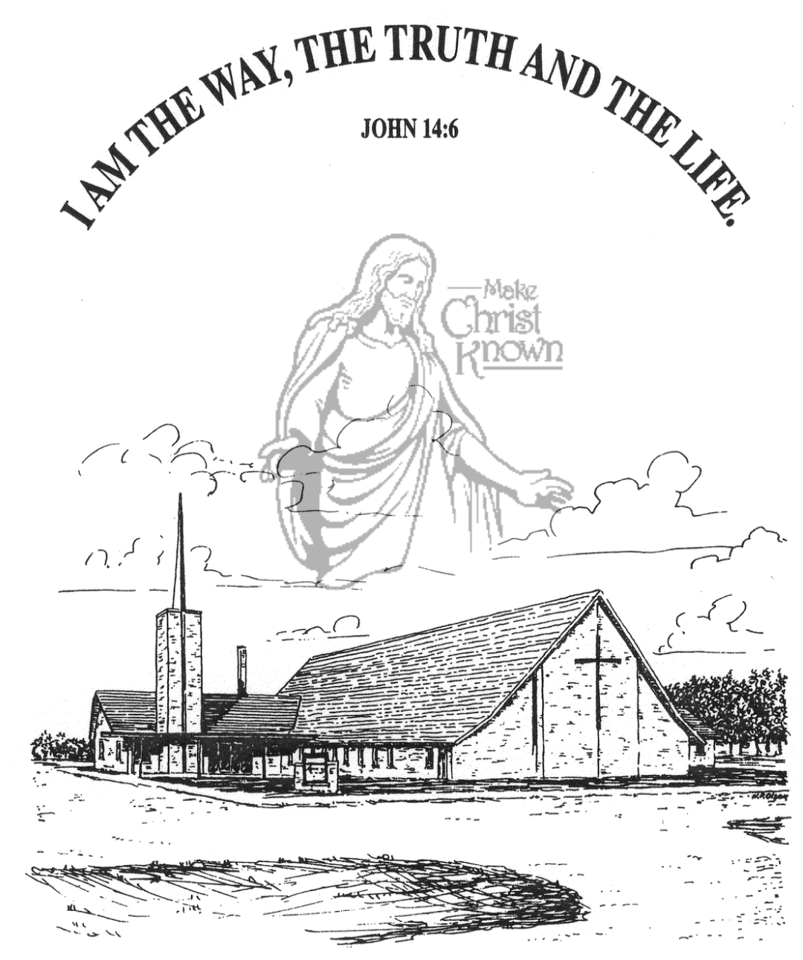

**Wednesday, March 13, 2024**

**Salem Reformed Church**

**Menno, South Dakota**

**Office Hours for Pastor Hecht**

Tuesday – Friday: 8:00 AM to Noon (Church Office)

Afternoons: Visitation or Church Office

Church: (605) 387-5334 Parsonage: (605) 387-2855

Pastor Mike’s Cell #: (605) 660-1803

Church Web Page: ***salemreformedchurch.com***

**Opportunities**

Greeter Tonight: Shirley Mettler

Greeters March 17th: David and Peg Walloch

Greeters March 24th:

Sunday Prayer Time: 8:30 a.m.

Sunday School Classes: 9:15 a.m.

Praise Music: 10:15 a.m.

Worship Service: 10:30 a.m.

**Announcements**

**Welcome:** We extend a warm welcome to our visiting guests this evening. Please sign our guest book in the Narthex. We ask God’s blessing upon you and we pray that you will return and worship with us again soon.

**Sanctity of Human Life:** The offering received last Sunday for the Alpha Center was $4,323.00! We praise the Lord that we are able to partner with this ministry as they stand for the lives of the unborn!

**4-O’s Women:** Ladies, we will plan to meet in the Social Hall next Wed., March 20th at 12 Noon. We will get the main dish from the Dairy Bar, but you are encouraged to bring something else to add to the meal. Please sign the sheet in the Narthex if you are planning to attend.

**Adult Sunday School Class:** The Older Adult Class started a study on the Book of Revelation, by Rev. Adrian Rogers. Class starts at 9:15 a.m. You are welcome to attend!

**Cherub Choir:** Parents of the Cherub Choir (3yrs. - 3rd Grade), please note that your children will be singing in church on Palm Sunday, March 24th.

**Easter Lilies in Memory of Loved Ones:** On Easter Sunday, March 31st, we have the opportunity to place Easter Lilies in the sanctuary in memory of departed loved ones. Please contact the florist of your choice.

**Sunday Offerings:** Please note that we have an Offering Box/Pulpit at the back of the Sanctuary for people to place their tithes and offerings in during our worship services.

**SALEM REFORMED CHURCH**

Menno, South Dakota

Rev. Michael Hecht Pastor

Joan Nusz Pianist

7:00 PM – Worship Service March 13, 2024

Mid-Week Lenten Service

**Meditation:** *“But someone will say, ‘You have faith; I have deeds.’ Show me your faith without deeds, and I will show you my faith by what I do. You believe that there is one God. Good! Even the demons believe that – and shudder. You foolish man, do you want evidence that faith without deeds is useless? Was not our ancestor Abraham considered righteous for what he did when he offered his son Isaac on the altar? You see that his faith and his actions were working together, and his faith was made complete by what he did. And the Scripture was fulfilled that says, ‘Abraham believed God, and it was credited to him as righteousness,’ and he was called God’s FRIEND. You see that a person is justified by what he does and not by faith alone.*  James 2:18-26 NIV

**Prelude Music:** Joan Nusz

**Ringing of the Bell**

**Welcome / Announcements / Opening Prayer**

**\*Hymn:** #308 “There Is a Redeemer”

**Sharing of Joys and Concerns**

**Our Time of Offering** I Peter 4:10 NLT

**\*Doxology** sung on page #815

**\*Lord’s Prayer** debts and debtors

**Kingdom Kids:** “My Best Friend is Jesus!”

**Special Music:** “An Easter Hallelujah”

sung by Linda Kronaizl

**The Holy Scriptures**

John 15:9-17

Large Print NIV 1984 Edition, pg. 1677

**Sermon: “I Am A Friend Of God”**

**\*Hymn:** #310 “Lead Me to Calvary”

**\*Benediction:**

**Postlude** (*denotes standing for those able)

The congregation will be ushered out after the Benediction

Youth Ushers: Lexie McNinch and Madison Schaeffer