**Calendar of Events**

March 11 Cantata Practice at Grace Lutheran @ 7:30 pm

March 12 Consistory Meeting @ 7:00 p.m.

March 13 Women’s Bible Study @ 9:30 a.m.

6/7th Grade Confirmation @ 3:30-5:00 p.m.

8th Grade Confirmation @ 5:00-6:15 p.m.

Lenten Service @ 7:00 p.m.

March 14 Prayer Group @ 12 Noon

March 17 Prayer Time for Service @ 8:30 a.m.

Sunday School Classes @ 9:15 a.m.

Praise Music @ 10:15 a.m.

Worship Service @ 10:30 a.m.

with Coffee Hour & W.O.C. Mtg. Following

M/O Care Center Service @ 2:00 p.m.

**Upcoming Special Music**

Wednesday, March 13 - Linda Kronaizl

Sunday, March 17 - Available

**Announcements**

**W.O.C. Meeting:** The Women of the Church will plan to meet next Sunday, March 17th, following our worship service. There will also be Coffee Hour for a time of fellowship!

**M/OCC Spaghetti Fundraiser:** You are invited to this Spaghetti Supper Fundraiser at the Menno-Olivet Care Center on Wed., March 20th from 4 – 8 PM. Free-will donations for salad, spaghetti, garlic toast and dessert will go towards new dining room chairs. They will also have a “To-Go” option. Thanks for your support!

**Women’s Salad Supper:** This is scheduled for Monday, April 1st at 6PM! The guest speaker will be Holly Hoffman, who was actually a contestant on Season 21 of Survivor. Invite your friends and come to this enjoyable and inspirational evening! Young Ladies, 8th Grade and Older are also encouraged to attend! **MEN:** We’ll need your help again with serving the coffee/water and washing the dishes.

**Alpha Center Banquet:** The Alpha Center Friends & Fellowship Dinner will be Friday, April 26, 2024 at the Sioux Falls Convention Center. Please contact Lee Herrboldt if you are interested in attending.

**Salem Reformed Church – Who Are We?**

**We believe the Bible to be the inspired, inerrant, infallible Word of God in its original manuscripts. It is our supreme authority in all matters doctrine and practice. We are affiliated with the Conservative Congregational Christian Conference.**

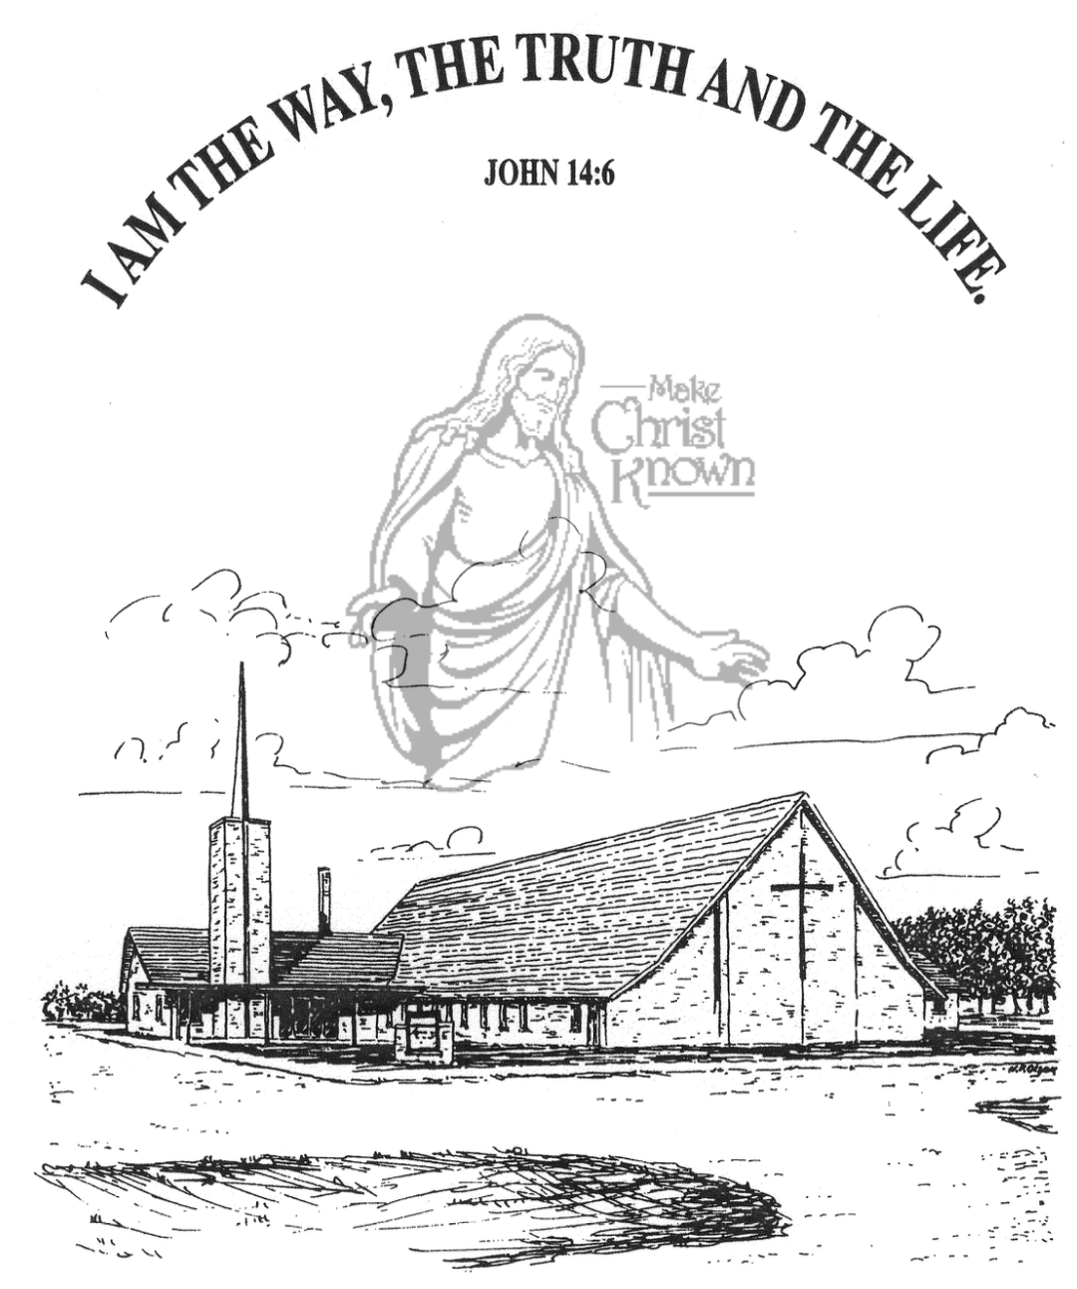

**Sunday, March 10, 2024**

**Salem Reformed Church**

**Menno, South Dakota**

**Office Hours for Pastor Hecht**

Tuesday – Friday: 8:00 AM to Noon (Church Office)

Afternoons: Visitation or Church Office

Church: (605) 387-5334 Parsonage: (605) 387-2855

Pastor Mike’s Cell #: (605) 660-1803

Church Web Page: ***salemreformedchurch.com***

**Opportunities**

Greeter Today: Harriet Schaeffer

Greeter March 13th: Shirley Mettler

Greeters March 17th: David and Peg Walloch

Sunday Prayer Time: 8:30 a.m.

Sunday School Classes: 9:15 a.m.

Praise Music: 10:15 a.m.

Worship Service: 10:30 a.m.

**Announcements**

**Welcome:** We extend a warm welcome to our visiting guests this morning. Please sign our guest book in the Narthex. We ask God’s blessing upon you and we pray that you will return and worship with us again soon.

**Sanctity of Human Life:** We extend a special welcome to Jenna Spellerberg from the Alpha Center, who is with us today to share about the Alpha Center’s Pro-Life work and ministry in our region. An Offering Plate is placed at the back of the sanctuary for gifts to the Alpha Center.

**Contemporary Service:** This service will be TONIGHT at 7:00 p.m. Please contact Pastor Mike or Ann if you have a brief testimony that you would like to share. Thanks!

**Adult Sunday School Class:** The Older Adult Class started a study on the Book of Revelation, by Rev. Adrian Rogers. Please consider joining the class for this exciting and informative study. Class starts at 9:15 a.m.

**Cherub Choir:** Parents of the Cherub Choir (3yrs. - 3rd Grade), please note that your children will be singing in church on Palm Sunday, March 24th.

**Easter Lilies in Memory of Loved Ones:** On Easter Sunday, March 31st, we have the opportunity to place Easter Lilies in the sanctuary in memory of departed loved ones. Please contact the florist of your choice.

**Sunday Offerings:** Please note that we have an Offering Box/Pulpit at the back of the Sanctuary for people to place their tithes and offerings in during our worship services.

**SALEM REFORMED CHURCH**

Menno, South Dakota

Rev. Michael Hecht Pastor

Cindy Herrboldt Organist

10:30 AM – Worship Service March 10, 2024

4th Sunday in Lenten Season

**Meditation:** *“The God who made the world and everything in it is the Lord of heaven and earth and does not live in temples built by hands. And He is not served by human hands, as if He needed anything, because He Himself gives all men life and breath and everything else. From one man He made every nation of men, that they should inhabit the whole earth; and He determined the times set for them and the exact places where they should live. God did this so that men would seek Him and perhaps reach out for Him and find Him, though He is not far from each one of us. ‘For in Him we live and move and have our being.’ As some of your own poets have said, ‘We are His offspring.’ “*  Acts 17:24-28 NIV

**Praise Music:** #31, #37, #28, #45, #32, #12

**Ringing of the Bell**

**Welcome / Announcements / Opening Prayer**

**\*Hymn:** #210 “Praise to the Lord, the Almighty”

**Sharing of Joys and Concerns**

**Our Time of Offering** Jeremiah 1:4,5 NIV

**\*Doxology** sung on page #815

**\*Lord’s Prayer** debts and debtors

**Kingdom Kids:** “Irreplaceable” – Ps. 139 by Jenna Spellerberg

**Special Music:** “Holy Forever” sung by the Junior Choir

**The Holy Scriptures**

John 4:13,14 Deuteronomy 20:4

Large Print NIV 1984 Edition, pg. 1651 pg. 304

**Sermon: “Rescuing a Life”** Jenna Spellerberg

**\*Hymn:** #139 “Great Is Thy Faithfulness”

**\*Benediction:**

**\*Prayer for Our Nation:** “God Bless America”

**Postlude**

(*denotes standing for those able)

The congregation will be ushered out after the Benediction

Youth Ushers: Lexie McNinch and Madison Schaeffer