**Calendar of Events**

Feb 05 Men’s Christian Fellowship @ 7:00 p.m.

Feb 07 Women’s Bible Study @ 9:30 a.m.

6/7th Grade Confirmation @ 3:30 – 5:15 p.m.

8th Grade Confirmation @ 5:30 – 6:45 p.m.

Women’s Bible Study @ 6:30 p.m.

Consistory Meeting @ 7:00 p.m.

FCA at Menno Gym @ 7:30 p.m.

Feb 08 Prayer Group @ 12 Noon

Feb 11 Prayer Time for Service @ 8:30 a.m.

Sunday School Classes @ 9:15 a.m.

Praise Music @ 10:15 a.m.

Worship Service @ 10:30 a.m.

**w/Baptism of Ella Ann Handel**

**Upcoming Special Music**

Sunday, February 11 - Available

Ash Wed., February 14 - High School Youth

Sunday, February 18 - Available

**Announcements**

**8th Grade Parent Meeting:** Pastor Mike will meet with the Parents of the 8th Grade Confirmation Students TODAY, following the morning worship service.

**Confirmation Fun Trip:** Our Trip to Air Madness is TODAY! We will plan to leave from church after the 8th Grade Parents Meeting. Lunch will be at Pizza Ranch in Tea, and then on to Air Madness. We should return by 5:30 p.m.

**High School Youth:** The High School Youth will plan to meet after church today. Lunch will be provided.

**Annual Meeting Lunch:** Thanks to the Consistory/Spouses for serving a delicious meal to the congregation last Sunday!

**Coffee Hour:** We are looking for 8 volunteers to bring 2 dozen goodies for Coffee Hour on Sun., Feb. 18th. Please sign the sheet in the Narthex if you are able to help.

**Alpha Center Banquet:** Mark your Calendars! The Alpha Center Friends & Fellowship Dinner will be Friday, April 26, 2024 at the Sioux Falls Convention Center. We will celebrate the Sanctity of Human Life on Sunday, March 10th.

**Salem Reformed Church – Who Are We?**

**We believe the Bible to be the inspired, inerrant, infallible Word of God in its original manuscripts. It is our supreme authority in all matters doctrine and practice. We are affiliated with the Conservative Congregational Christian Conference.**

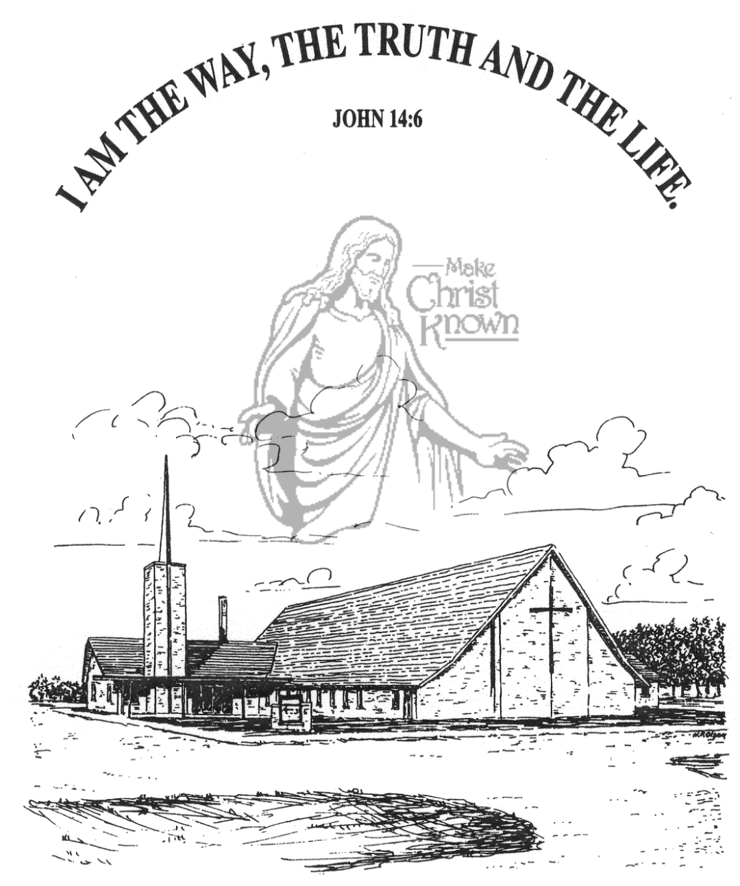

**Sunday, February 04, 2024**

**Salem Reformed Church**

**Menno, South Dakota**

**SALEM REFORMED CHURCH**

Menno, South Dakota

Rev. Michael Hecht Pastor

Cindy Herrboldt Organist

10:30 AM – Worship Service February 04, 2024

5th Sunday After Epiphany

**Meditation:** *“[For my determined purpose is] that I may know Him [that I may progressively become more deeply and intimately acquainted with Him, perceiving and recognizing and understanding the wonders of His Person more strongly and clearly], and that I may in that same way come to know the power outflowing from His resurrection [which it exerts over believers], and that I may so share His sufferings as to be continually transformed [in spirit into His likeness even] to His death.”* Hebrews 4:10 AMP

**Praise Music:** #28, #56, #57, #115, Psalm 92, #32

**Ringing of the Bell / Welcome / Announcements**

**Opening Prayer**

**\*Hymn:** #90 “Joyful, Joyful, We Adore Thee”

**Sharing of Joys and Concerns**

**Recognition of Consistory Members**

**Our Time of Offering**  I Peter 1:18,19 NIV

**\*Doxology** sung on page #815

**\*Lord’s Prayer** debts and debtors

**Kingdom Kids:** “Symbols of Faith”

**\*Hymn:** #47 “Jesus, Lord to Me”

**The Holy Scriptures**

Hebrews 4:14-16; 7:22-28

Large Print NIV 1984 Edition, pg. 1866

**Sermon: “Jesus Lives Forever!”**

**Prayer of Confession**

#319 “Near the Cross”

#336 “There Is a Fountain”

**Sacrament of Holy Communion**

**\*Hymn:** #705 “It Is Well With My Soul”

**\*Benediction:**

**Postlude**

(*denotes standing for those able)

The congregation will be ushered out after the Benediction

Youth Ushers: Ethan McCoy, Austen Soukup, Jaxon Stoebner

**Office Hours for Pastor Hecht**

Tuesday – Friday: 8:00 AM to Noon (Church Office)

Afternoons: Visitation or Church Office

Church: (605) 387-5334 Parsonage: (605) 387-2855

Pastor Mike’s Cell #: (605) 660-1803

Church Web Page: ***salemreformedchurch.com***

**Opportunities**

Greeters Today: Brian and Steph Mehlhaf

Greeters Feb. 11:

Greeter Feb. 14: Shirley Mettler

Sunday Prayer Time: 8:30 a.m.

Sunday School Classes: 9:15 a.m.

Praise Music: 10:15 a.m.

Worship Service: 10:30 a.m.

**Announcements**

**Welcome:** We extend a warm welcome to our visiting guests this morning. Please sign our guest book in the Narthex. We ask God’s blessing upon you and we pray that you will return and worship with us again soon.

**Holy Communion:** We at Salem Reformed Church recognize an open communion table. All are welcome to partake of the bread and wine and accept the gift of grace that God offers to us through Jesus Christ, our Savior and Lord. **The inner most ring of the communion tray contains grape juice. All other rings contain wine.

**Congratulations:** The following individuals were elected to serve on our Consistory:

Ken Stepanek Elder 2nd Term

Shirley Mettler Elder 2nd Term

Tyler Miller Deacon 2nd Term

**Assistant Pastor Position:** The Ballot Vote on this new position was 82 in Favor and 6 Opposed. Motion passed! The Consistory will proceed in working out the details for the search process. More information will be coming.

**Annual Report:** Church Members may pick up a copy of the Annual Report from the Information Cabinet.

**Sunday Offerings:** Please note that we have an Offering Box/Pulpit at the back of the Sanctuary for people to place their tithes and offerings in.

***“God loves a cheerful giver.”* II Corinthians 9:7**