**Calendar of Events**

Feb 26 Cantata Practice at Peace CRC @ 7:30 p.m.

Feb 28 Women’s Bible Study @ 9:30 a.m.

6/7th Grade Confirmation @ 3:30-5:00 p.m.

8th Grade Confirmation @ 5:00-6:15 p.m.

Lenten Service @ 7:00 p.m. w/Youth Helping

Feb 29 Prayer Group @ 12 Noon

March 03 Prayer Time for Service @ 8:30 a.m.

Sunday School Classes @ 9:15 a.m.

Praise Music @ 10:15 a.m.

Worship Service @ 10:30 a.m.

Youth Group Meeting @ 11:45 a.m.

Family Fun Event in Yankton @ 3:00 p.m.

March 04 Men’s Christian Fellowship @ 7:00 p.m.

Cantata Practice at Zion Reformed @ 7:30p.m.

Sunday, March 03 - Available

Sunday, March 10 - Available

**Announcements**

**Adult Sunday School Class:** The Older Adult Class will be starting a study on the Book of Revelation on Sunday, March 3rd. This will be a DVD led study by Rev. Adrian Rogers. Please consider joining the class for this exciting and informative study through the Book of Revelation!

**Family Fun Event:** This is scheduled for Sunday, March 3rd at the Bowling Alley in Yankton @ 3:00 p.m., followed by supper at Pizza Ranch. Bring the whole family and we’ll have a great time! Please sign the sheet in the Narthex if you are planning to attend. **NOTE:** Bowling is $4.50 per game; Shoe Rental is $3.00. Melanie Walter will be collecting the money for our church group at the bowling alley.

**Cherub Choir:** Parents of the Cherub Choir (3yrs. - 3rd Grade), please note that your children will be singing in church on Palm Sunday, March 24th.

**Alpha Center Banquet:** The Alpha Center Friends & Fellowship Dinner will be Friday, April 26, 2024 at the Sioux Falls Convention Center. Please contact Lee Herrboldt if you are interested in attending. We will celebrate the Sanctity of Human Life here at church on Sunday, March 10th.

**Salem Reformed Church – Who Are We?**

**We believe the Bible to be the inspired, inerrant, infallible Word of God in its original manuscripts. It is our supreme authority in all matters doctrine and practice. We are affiliated with the Conservative Congregational Christian Conference.**

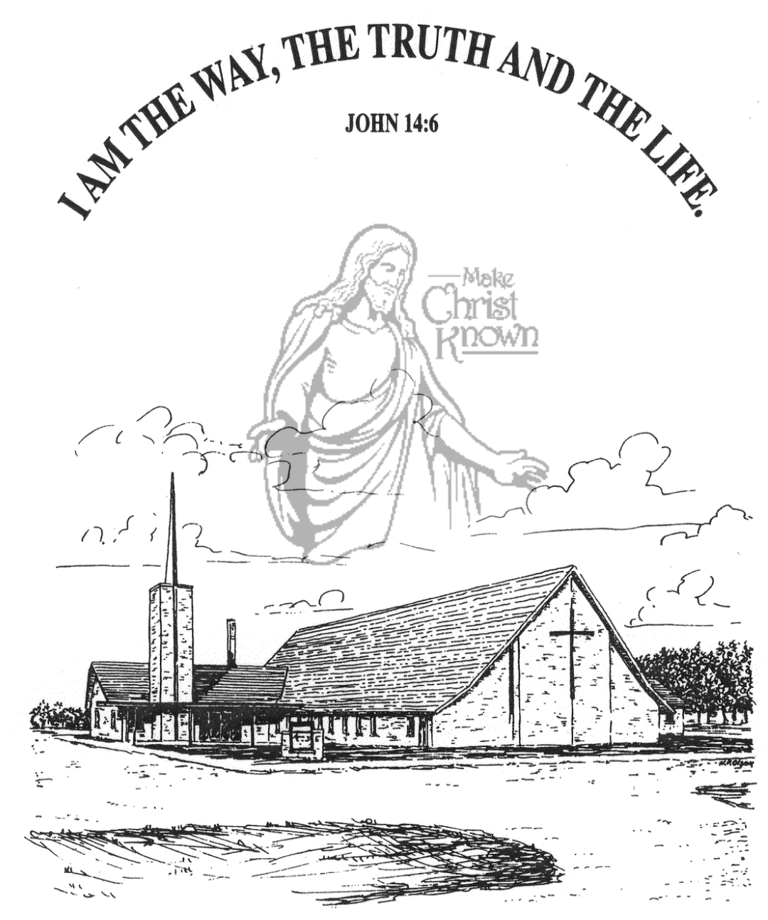

**Sunday, February 25, 2024**

**Salem Reformed Church**

**Menno, South Dakota**

**Office Hours for Pastor Hecht**

Tuesday – Friday: 8:00 AM to Noon (Church Office)

Afternoons: Visitation or Church Office

Church: (605) 387-5334 Parsonage: (605) 387-2855

Pastor Mike’s Cell #: (605) 660-1803

Church Web Page: ***salemreformedchurch.com***

**Opportunities**

Greeters Today: Lee and Dianne Herrboldt

Greeters Feb. 28th: Johnny and Lori Woehl

Greeters March 03rd: Jim and Deb Christensen

Sunday Prayer Time: 8:30 a.m.

Sunday School Classes: 9:15 a.m.

Praise Music: 10:15 a.m.

Worship Service: 10:30 a.m.

**Announcements**

**Welcome:** We extend a warm welcome to our visiting guests this morning. Please sign our guest book in the Narthex. We ask God’s blessing upon you and we pray that you will return and worship with us again soon.

**Congratulations:** We rejoice with the family of Clara Ann Stepanek at her baptism! Clara’s parents are Kyle and Loni Stepanek. She joins her older brother, Nolan. We extend a warm welcome to all of their family and friends who may be present in our worship service today.

**Gideons Ministry:** The offering received last Sunday for the Gideons was $1,004.00. Thank you so much for having a part in spreading God’s Word around our world!

**Assistant Pastor Search Committee:** This Committee will consist of 3 Consistory Reps and 6 members from the congregation. TODAY is the last day to contact the church office if you are interested in serving. The Consistory will make the final decision if more than 6 respond.

**Sunday Offerings:** Please note that we have an Offering Box/Pulpit at the back of the Sanctuary for people to place their tithes and offerings in.

***“God loves a cheerful giver.”* II Corinthians 9:7**

**Upcoming Lenten Services**

**Wednesday, Feb. 28th @ 7 PM** (w/High School Youth Helping)

**Wednesday, March 13th @ 7 PM**

**Maundy Thursday, March 28th @ 7 PM**  (w/Holy Communion)

**SALEM REFORMED CHURCH**

Menno, South Dakota

Rev. Michael Hecht Pastor

Sharyl Herrboldt Pianist

10:30 AM – Worship Service February 25, 2024

2nd Sunday in Lenten Season

**Meditation:** *“Jesus replied, ‘If anyone loves Me, He will obey My teaching. My Father will love him, and We will come to him and make Our home with him. He who does not love Me will not obey My teaching. These words you hear are not My own; they belong to the Father who sent Me.’ “*  John 14:23,24 NIV

**Praise Music:** #1, #5, #96, #59, #43

**Ringing of the Bell**

**Welcome / Announcements**

**Opening Prayer**

**\*Hymn:** #87 “Fairest Lord Jesus”

**Sharing of Joys and Concerns**

**Our Time of Offering**  Proverbs 22:6 AMP

**\*Doxology** sung on page #815

**\*Lord’s Prayer** debts and debtors

**Baptism: Clara Ann Stepanek**

**Questions of Candidates / Congregational Assent**

**Education Committee Pledge** Kevin Holzwarth

**Act of Baptism**

**Congregational Song**: “Yes, Jesus Loves You!”

**Kingdom Kids:** “Jesus Is The Vine“

**Special Music:** “How Great Thou Art”

by Jay and Sharyl Herrboldt

**The Holy Scriptures**

John 15:1-10

Large Print NIV 1984 Edition, pg. 1676

**Sermon: “Abiding in the Vine”**

**\*Hymn:** #630 “What a Friend We Have in Jesus”

**\*Benediction:**

**\*Prayer for Our Nation:** “God Bless America”

**Postlude**

(*denotes standing for those able)

The congregation will be ushered out after the Benediction

Youth Ushers: Ethan McCoy, Austen Soukup, Jaxon Stoebner