**Calendar of Events**

Feb 19 Men’s Christian Fellowship @ 7:00 p.m.

Cantata Practice at Olivet Church @ 7:30 p.m.

Feb 20 W.O.C. Program at M/OCC @ 2:00 p.m.

Feb 21 Women’s Bible Study @ 9:30 a.m.

6/7th Grade Confirmation @ 3:30-5:15 p.m.

8th Grade Confirmation @ 5:30-7:00 p.m.

Women’s Bible Study @ 6:00 p.m.

FCA at Menno Gym @ 7:30 p.m.

Feb 22 Prayer Group @ 12 Noon

Feb 25 Prayer Time for Service @ 8:30 a.m.

Sunday School Classes @ 9:15 a.m.

Praise Music @ 10:15 a.m.

Worship Service @ 10:30 a.m.

**w/Baptism of Clara Ann Stepanek**

**Upcoming Special Music**

Sunday, February 18 - Available

Sunday, February 25 - Jay and Sharyl Herrboldt

**Announcements**

**Church Office Closed:** The Church Office will be closed this coming Friday, February 23rd.

**Annual Report:** Church Members may pick up a copy of the Annual Report from the Information Cabinet.

**W.O.C. Program:** Please sign the sheet in the Narthex if you are able to help with the program at the M/O Care Center on Tuesday, February 20th @ 2:00 p.m.

**Family Fun Event:** This is scheduled for Sunday, March 3rd at the Bowling Alley in Yankton @ 3:00 p.m., followed by supper at Pizza Ranch. Bring the whole family and we’ll have a great time! Please sign the sheet in the Narthex if you are planning to attend. **NOTE:** Bowling is $4.50 per game; Shoe rental is $3.00. Melanie Walter will be collecting the money for our church group at the bowling alley.

**Alpha Center Banquet:** The Alpha Center Friends & Fellowship Dinner will be Friday, April 26, 2024 at the Sioux Falls Convention Center. Please contact Lee Herrboldt if you are interested in attending. We will celebrate the Sanctity of Human Life here at church on Sunday, March 10th.

**Salem Reformed Church – Who Are We?**

**We believe the Bible to be the inspired, inerrant, infallible Word of God in its original manuscripts. It is our supreme authority in all matters doctrine and practice. We are affiliated with the Conservative Congregational Christian Conference.**

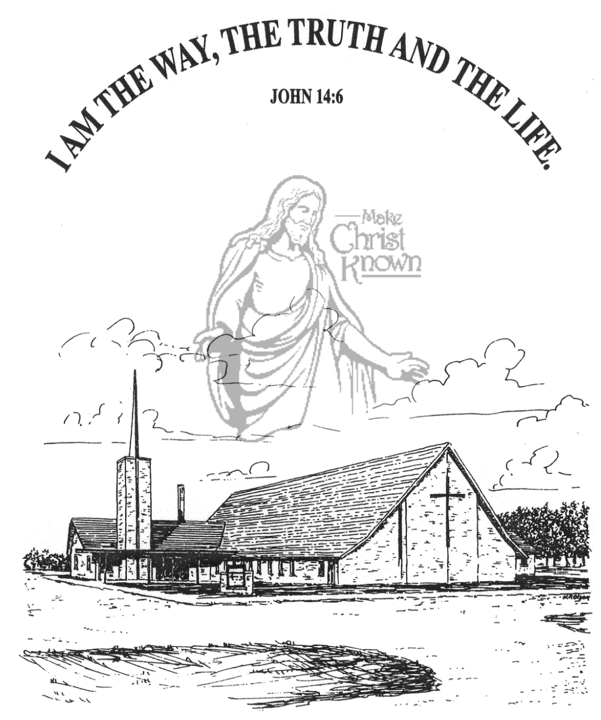

**Sunday, February 18, 2024**

**Salem Reformed Church**

**Menno, South Dakota**

**SALEM REFORMED CHURCH**

Menno, South Dakota

Rev. Michael Hecht Pastor

Joan Nusz Pianist

10:30 AM – Worship Service February 18, 2024

1st Sunday in Lenten Season

**Meditation:** *“Examine yourselves to see if your faith is really genuine. Test yourselves. If you cannot tell that Jesus Christ is among you, it means you have failed the test. I hope you recognize that we have passed the test and are approved by God. We pray to God that you will not do anything wrong. We pray this, not to show that our ministry to you has been successful, but because we want you to do right even if we ourselves seem to have failed. Our responsibility is never to oppose the truth, but to stand for the truth at all times. We are glad to be weak, if you are really strong. What we pray for is your restoration to maturity.”*  II Corinthians 13:5-9 NLT

**Praise Music:** #78, #110, #24, #60, #69

**Ringing of the Bell**

**Welcome / Announcements**

**Opening Prayer**

**\*Hymn:** #45 “Crown Him with Many Crowns”

**Sharing of Joys and Concerns**

**Our Time of Offering**  Psalm 96:8,9 NKJ

**\*Doxology** sung on page #815

**\*Apostles’ Creed** see words on screen

**Kingdom Kids:** “Everyone Needs Tuning“

**\*Hymn:** #654 “Change My Heart, O God”

**The Holy Scriptures**

John 15:1-8

Large Print NIV 1984 Edition, pg. 1676

**Sermon: “Cut Off or Pruned?”**

**Gideons Ministry Sharing:** Roger Tieszen

**\*Hymn:** #327 “The Old Rugged Cross”

**\*Benediction:**

**\*Prayer for Our Nation:** “God Bless America”

**Postlude** (*denotes standing for those able)

The congregation will be ushered out after the Benediction

Youth Ushers: Ethan McCoy, Austen Soukup, Jaxon Stoebner

**Office Hours for Pastor Hecht**

Tuesday – Friday: 8:00 AM to Noon (Church Office)

Afternoons: Visitation or Church Office

Church: (605) 387-5334 Parsonage: (605) 387-2855

Pastor Mike’s Cell #: (605) 660-1803

Church Web Page: ***salemreformedchurch.com***

**Opportunities**

Greeters Today: Robert and Elaine Balogh

Greeters Feb. 25th: Lee and Dianne Herrboldt

Greeters Feb. 28th: Johnny and Lori Woehl

Sunday Prayer Time: 8:30 a.m.

Sunday School Classes: 9:15 a.m.

Praise Music: 10:15 a.m.

Worship Service: 10:30 a.m.

**Announcements**

**Welcome:** We extend a warm welcome to our visiting guests this morning. Please sign our guest book in the Narthex. We ask God’s blessing upon you and we pray that you will return and worship with us again soon.

**Coffee Hour:** Join us after church for a time of coffee, cookies and fellowship with one another in the Social Hall.

**Gideons Ministry:** Roger Tieszen from the Gideons is with us today to share briefly at the close of our service about their ministry. An offering plate is placed at the back of the sanctuary to receive a special offering for the Ministry of the Gideons.

**Assistant Pastor Search Committee:** This Committee will consist of 3 Consistory Reps and 6 members from the congregation. Please contact the church office by Sunday, Feb. 25th, if you are interested in serving. The Consistory will make the final decision if more than 6 respond.

**W.O.C. Program:** Please sign the sheet in the Narthex if you are able to help with the program at the M/O Care Center on Tuesday, February 20th @ 2:00 p.m.

**Sunday Offerings:** Please note that we have an Offering Box/Pulpit at the back of the Sanctuary for people to place their tithes and offerings in.

***“God loves a cheerful giver.”* II Corinthians 9:7**