**Calendar of Events**

**Upcoming Special Music**

Feb 15 Prayer Group @ 12 Noon

Feb 18 Prayer Time for Service @ 8:30 a.m.

Sunday School Classes @ 9:15 a.m.

Praise Music @ 10:15 a.m.

Worship Service @ 10:30 a.m.

**w/Coffee Hour Following**

Feb 19 Men’s Christian Fellowship @ 7:00 p.m.

Cantata Practice at Olivet Church @ 7:30 p.m.

Feb 20 W.O.C. Program at M/OCC @ 2:00 p.m.

Feb 21 Women’s Bible Study @ 9:30 a.m.

6/7th Grade Confirmation @ 3:30-5:15 p.m.

8th Grade Confirmation @ 5:30-7:00 p.m.

Women’s Bible Study @ 6:00 p.m.

FCA at Menno Gym @ 7:30 p.m.

Sunday, February 18 - Available

Sunday, February 25 - Jay & Sharyl Herrboldt

**Announcements**

**Annual Report:** Church Members may pick up a copy of the Annual Report from the Information Cabinet.

**W.O.C. Program:** Please sign the sheet in the Narthex if you are able to help with the program at the M/O Care Center on Tuesday, February 20th @ 2:00 p.m.

**Family Fun Event:** This is scheduled for Sunday, March 3rd at the Bowling Alley in Yankton @ 3:00 p.m., followed by supper at Pizza Ranch. Bring the whole family and we’ll have a great time! Please sign the sheet in the Narthex if you are planning to attend.

**Alpha Center Banquet:** Mark your Calendars! The Alpha Center Friends & Fellowship Dinner will be Friday, April 26, 2024 at the Sioux Falls Convention Center. Please contact Lee Herrboldt if you are interested in attending this Banquet. We will celebrate the Sanctity of Human Life on Sunday, March 10th, with guest speaker Jenna Spellerberg.

**Coffee Hour:** Our next Coffee Hour will be this coming Sunday, February 18th, following our worship service.

**Salem Reformed Church – Who Are We?**

**We believe the Bible to be the inspired, inerrant, infallible Word of God in its original manuscripts. It is our supreme authority in all matters doctrine and practice. We are affiliated with the Conservative Congregational Christian Conference.**

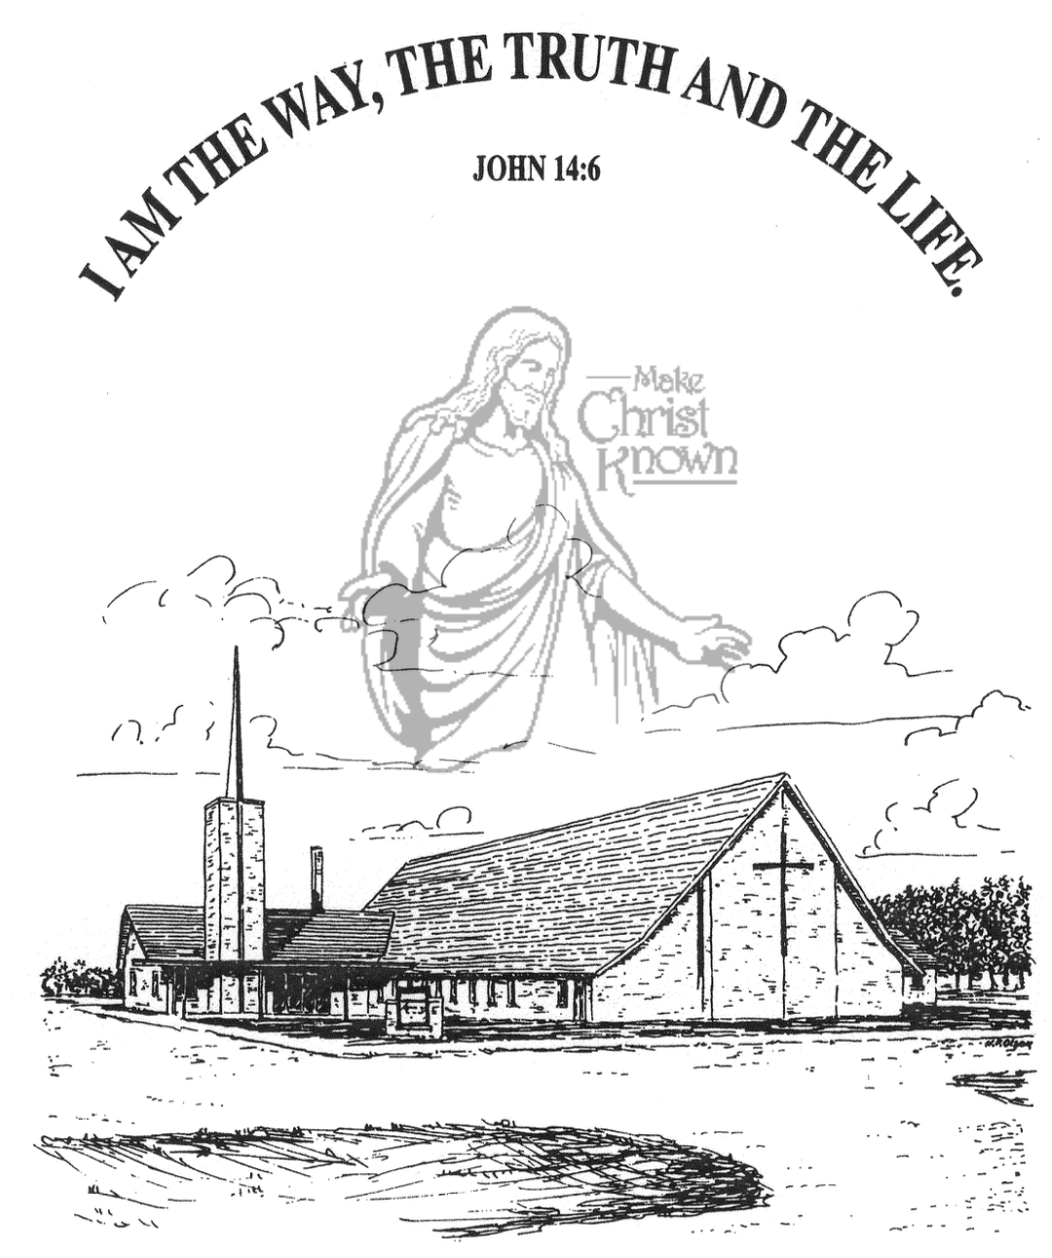

**Wednesday, February 14, 2024**

**Salem Reformed Church**

**Menno, South Dakota**

**Office Hours for Pastor Hecht**

Tuesday – Friday: 8:00 AM to Noon (Church Office)

Afternoons: Visitation or Church Office

Church: (605) 387-5334 Parsonage: (605) 387-2855

Pastor Mike’s Cell #: (605) 660-1803

Church Web Page: ***salemreformedchurch.com***

**Opportunities**

Greeter Tonight: Shirley Mettler

Greeters Feb. 18: Robert and Elaine Balogh

Sunday Prayer Time: 8:30 a.m.

Sunday School Classes: 9:15 a.m.

Praise Music: 10:15 a.m.

Worship Service: 10:30 a.m.

**Announcements**

**Welcome:** We extend a warm welcome to our visiting guests this evening. Please sign our guest book in the Narthex. We ask God’s blessing upon you and we pray that you will return and worship with us again soon.

**Special Thanks:** THANKS to our High School Youth Group for helping lead in our worship service this evening! Thanks to Mick Huber and Jennifer Herrboldt for working with them to sing the special music during our service!

**Gideons Ministry:** A member of the Gideons will be present next Sunday, Feb. 18th, to share briefly at the close of our service about their ministry. An offering plate will be placed at the back of the sanctuary to receive a special offering for the Ministry of the Gideons.

**Easter Lilies in Memory of Loved Ones:** On Easter Sunday, March 31st, we have the opportunity to place Easter Lilies in the sanctuary in memory of departed loved ones. Please contact the florist of your choice if you desire to give a plant this year, and let the church office know who it is memory of. Thanks!

**Assistant Pastor Search Committee:** This Committee will consist of 3 Consistory Reps and 6 members from the congregation. Please contact the church office by Sunday, Feb. 25th, if you are interested in serving. The Consistory will make the final decision if more than 6 respond.

**Sunday Offerings:** Please note that we have an Offering Box/Pulpit at the back of the Sanctuary for people to place their tithes and offerings in.

***“God loves a cheerful giver.”* II Corinthians 9:7**

**SALEM REFORMED CHURCH**

Menno, South Dakota

Rev. Michael Hecht Pastor

Jennifer Herrboldt Pianist

7:00 PM – Worship Service February 14, 2024

Ash Wednesday Service

**Meditation:** *“May I never boast except in the cross of our Lord Jesus Christ, through which the world has been crucified to me, and to the world. Neither circumcision nor uncircumcision means anything; what counts is a new creation. Peace and mercy to all who follow this rule, even to the Israel of God. Finally, let no one cause me trouble, for I bear on my body the marks of Jesus. The grace of our Lord Jesus Christ be with your spirit, brothers. Amen.”*

Galatians 6:14-18 NIV

**Prelude Music:**  Jennifer Herrboldt

**Ringing of the Bell**

**Welcome / Announcements**

**Opening Prayer** Brockton Kocourek

**Responsive Reading – Psalm 92** Jaxon Stoebner

**\*Hymn:** #309 “I Will Sing of My Redeemer”

**Scripture Reading: II Corinthians 1:3-7** Addisyn Friesen

**Kingdom Kids:** “Anger Scars” Kaelie Derby & Taylor Freier

**Special Music:** “Scars” sung by the High School Youth Group

**Scripture Readings:** Zoe Schaeffer and Ashlynn Fergen

Luke 24:36-43 John 20:24-29

Large Print NIV 1984 Edition, pg. 1644 pg. 1687

**Sermon: “Look At My Hands and My Feet”**

**Hymn:** #134 “Lord, I Need You” (praise book)

**Special Prayer Offered:** Carter Fischer

**Our Time of Offering**

**Invitation to Give** Amanda Rames Romans 1:17 NIV

**\*Doxology** sung on page #815

**\*Lord’s Prayer** Hunter Masterson(debts and debtors)

**\*Hymn:** #417 “I’ve Had Many Tears & Sorrows” (bulletin insert)

**\*Benediction:** Austen Soukup

**Postlude**

(*denotes standing for those able)

The congregation will be ushered out after the Benediction

Youth Ushers: Ethan McCoy, Austen Soukup, Jaxon Stoebner