**Calendar of Events**

Feb 29 Prayer Group @ 12 Noon

March 03 Prayer Time for Service @ 8:30 a.m.

Sunday School Classes @ 9:15 a.m.

Praise Music @ 10:15 a.m.

Worship Service @ 10:30 a.m.

Youth Group Meeting @ 11:45 a.m.

Family Fun Event in Yankton @ 3:00 p.m.

March 04 Men’s Christian Fellowship @ 7:00 p.m.

Cantata Practice at Zion Reformed @ 7:30p.m.

March 05 M/O Ministerial Mtg. at Roosters @ 11:30 a.m.

March 06 Women’s Bible Study @ 9:30 a.m.

6/7th Grade Confirmation @ 3:3—5:15 p.m.

8th Grade Confirmation @ 5:30-7:00 p.m.

Women’s Bible Study @ 6:00 p.m.

FCA at Menno Gym @ 7:30 p.m.

**Upcoming Special Music**

Sunday, March 03 - Available

Sunday, March 10 - Available

**Announcements**

**Family Fun Event:** This is scheduled for Sunday, March 3rd at the Bowling Alley in Yankton @ 3:00 p.m., followed by supper at Pizza Ranch. Bring the whole family and we’ll have a great time! Please sign the sheet in the Narthex if you are planning to attend.

**Women’s Salad Supper:** This is scheduled for Monday, April 1st at 6PM! The guest speaker will be Holly Hoffman, who was actually a contestant on Season 21 of Survivor. Invite your friends and come to this enjoyable and inspirational evening! **MEN:** We’ll need your help again with serving the coffee/water and washing the dishes.

**Alpha Center Banquet:** Mark your Calendars! The Alpha Center Friends & Fellowship Dinner will be Friday, April 26, 2024 at the Sioux Falls Convention Center. Please contact Lee Herrboldt if you are interested in attending this Banquet. We will celebrate the Sanctity of Human Life on Sunday, March 10th, with guest speaker Jenna Spellerberg.

**Salem Reformed Church – Who Are We?**

**We believe the Bible to be the inspired, inerrant, infallible Word of God in its original manuscripts. It is our supreme authority in all matters doctrine and practice. We are affiliated with the Conservative Congregational Christian Conference.**

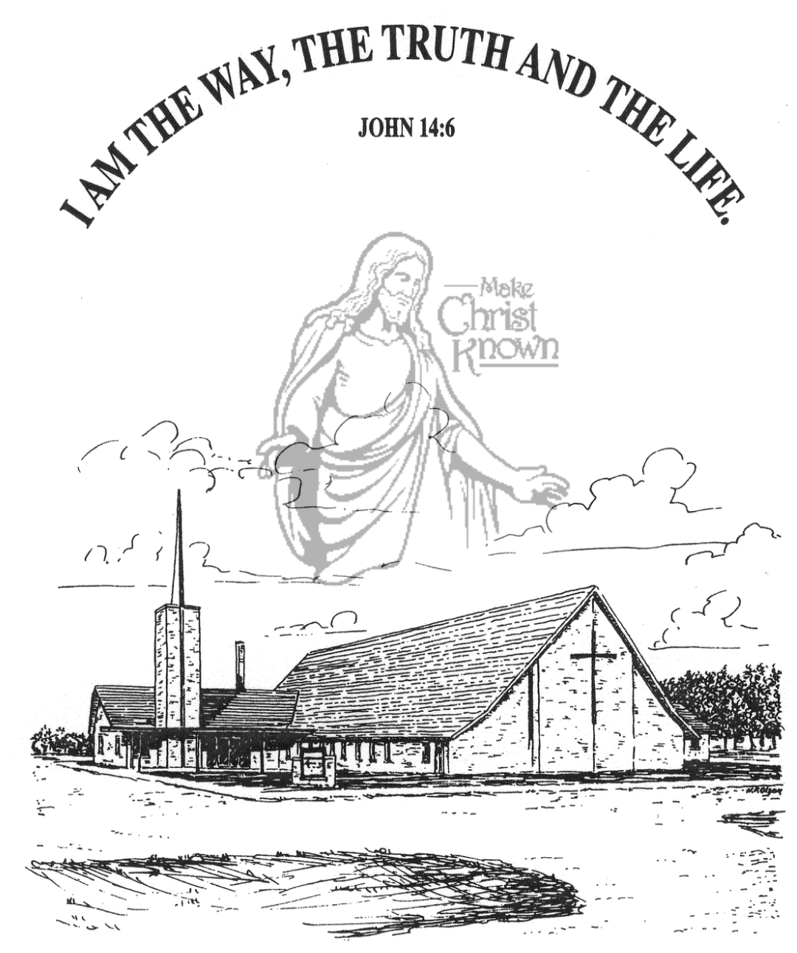

**Wednesday, February 28, 2024**

**Salem Reformed Church**

**Menno, South Dakota**

**Office Hours for Pastor Hecht**

Tuesday – Friday: 8:00 AM to Noon (Church Office)

Afternoons: Visitation or Church Office

Church: (605) 387-5334 Parsonage: (605) 387-2855

Pastor Mike’s Cell #: (605) 660-1803

Church Web Page: ***salemreformedchurch.com***

**Opportunities**

Greeters Tonight: Johnny and Lori Woehl

Greeters March 03: Jim and Deb Christensen

Sunday Prayer Time: 8:30 a.m.

Sunday School Classes: 9:15 a.m.

Praise Music: 10:15 a.m.

Worship Service: 10:30 a.m.

**Announcements**

**Welcome:** We extend a warm welcome to our visiting guests this evening. Please sign our guest book in the Narthex. We ask God’s blessing upon you and we pray that you will return and worship with us again soon.

**Special Thanks:** THANKS to our High School Youth Group for helping lead in our worship service this evening! Thanks to our Youth Advisors – Scott & Amy Nusz and Matt & Trishia Fischer for all that they do throughout the year in working with our youth!

**Easter Lilies in Memory of Loved Ones:** On Easter Sunday, March 31st, we have the opportunity to place Easter Lilies in the sanctuary in memory of departed loved ones. Please contact the florist of your choice if you desire to give a plant this year, and let the church office know who it is memory of. Thanks!

**Adult Sunday School Class:** The Older Adult Class will be starting a study on the Book of Revelation on Sunday, March 3rd. This will be a DVD led study by Rev. Adrian Rogers. Please consider joining the class for this exciting and informative study through the Book of Revelation!

**Cherub Choir:** Parents of the Cherub Choir (3yrs. - 3rd Grade), please note that your children will be singing in church on Palm Sunday, March 24th.

**Sunday Offerings:** Please note that we have an Offering Box/Pulpit at the back of the Sanctuary for people to place their tithes and offerings.

***“God loves a cheerful giver.”* II Corinthians 9:7**

**SALEM REFORMED CHURCH**

Menno, South Dakota

Rev. Michael Hecht Pastor

Marina Schaeffer Pianist

7:00 PM – Worship Service February 28, 2024

Mid-Week Lenten Service

**Meditation:** *“In your struggle against sin, you have not yet resisted to the point of shedding your blood. And you have forgotten that word of encouragement that addresses you as sons: ‘My son, do not make light of the Lord’s discipline, and do not lose heart when He rebukes you, because the Lord disciplines those He loves, and He punishes everyone He accepts as a son.’ Endure hardship as discipline; God is treating you as sons. For what son is not disciplined by his father? If you are not disciplined (and everyone undergoes discipline), then you are illegitimate children and not true sons.”* Hebrews 12:4-8 NIV

**Prelude Music:**  Marina Schaeffer

**Ringing of the Bell**

**Welcome / Announcements**

**Opening Prayer**  Rylan Derby

**Responsive Reading – Psalm 51:1-12**  Lexie McNinch

**\*Hymn:** #115 “The Wonderful Cross” (praise book)

**Scripture Reading: Hebrews 12:9-11**  Eli Soukup

**Kingdom Kids:** “The True Vine” Jaxon Stoebner & Ethan McCoy

**Responsive Reading – Psalm 37** All High School Youth

**Scripture Reading:** Madison Schaeffer

John 15:1-10

Large Print NIV 1984 Edition, pg. 1676

**Sermon: “The Father’s Pruning Tool”**

**Hymn:** #126 “Once Again” (praise book)

**Special Prayer Offered:**  Joslynn Fischer

**Our Time of Offering**

**Invitation to Give** Bryce Sattler John 15:12,13 NIV

**\*Doxology** sung on page #815

**\*Lord’s Prayer** Michael Nusz(debts and debtors)

**\*Hymn:** #49 “Above All” (praise book)

**\*Benediction:** Elly Fischer

**Postlude** (*denotes standing for those able)

The congregation will be ushered out after the Benediction

Youth Ushers: Ethan McCoy, Austen Soukup, Jaxon Stoebner