**Calendar of Events**

Jan 10 Women’s Bible Study @ 9:30 a.m.

6/7th Grade Confirmation @ 3:30 – 5:15 p.m.

8th Grade Confirmation @ 5:30 – 6:45 p.m.

Consistory Meeting @ 7:00 p.m.

Jan 11 Prayer Group @ 12 Noon

Jan 14 **Sanctity of Human Life Sunday**

Prayer Time for Service @ 8:30 a.m.

Sunday School Classes @ 9:15 a.m.

Praise Music @ 10:15 a.m.

Worship Service @ 10:30 a.m.

with Coffee Hour Following

with W.O.C. Meeting Following

**Upcoming Special Music**

Sunday, January 14 - Available

Sunday, January 21 - Available

**Announcements**

**Sanctity of Human Life Sunday:** On Sun, January 14, Jenna Spellerberg from the Alpha Center will be present with us to share about their pro-life work/ministry in our region. A special offering will be received for the Alpha Center on that day.

**Annual Meeting:** The Annual Meeting of the Congregation is scheduled for Sunday, January 28, 2024 at 12:45 p.m. The snow date is set for Sunday, February 4th at the same time. *The Consistory and Spouses will host a lunch for the congregation immediately following our worship service on the day of the Annual Meeting. Everyone is welcome to stay and enjoy, and also stay for the Annual Meeting.

**Nominations to Consistory:** The Consistory has voted to nominate the following individuals for office:

Ken Stepanek Elder 2nd Term

Shirley Mettler Elder 2nd Term

Tyler Miller Deacon 2nd Term

The Consistory would like to remind the voting membership that they may bring nominations from the floor at the Annual Meeting.

**Special Note:** We will also be voting on the new position of an Assistant Pastor at the Annual Meeting.

We are thankful for the many volunteers who work so hard in the life of this local church throughout the year! God Bless You!

**Salem Reformed Church – Who Are We?**

**We believe the Bible to be the inspired, inerrant, infallible Word of God in its original manuscripts. It is our supreme authority in all matters doctrine and practice. We are affiliated with the Conservative Congregational Christian Conference.**

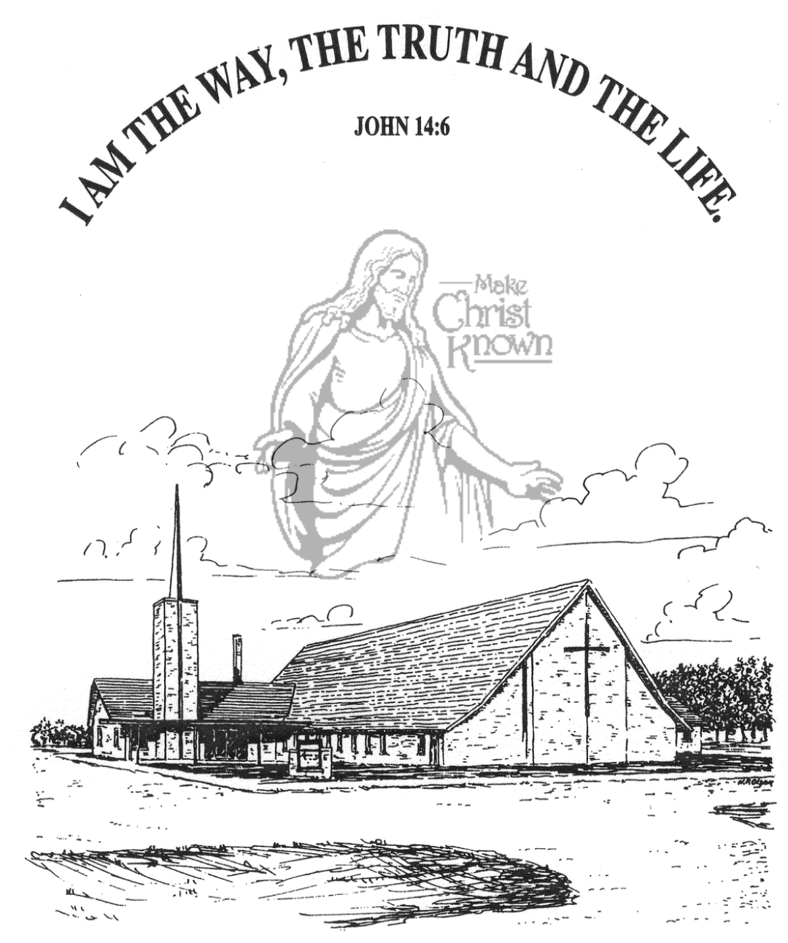

**Sunday, January 07, 2024**

**Salem Reformed Church**

**Menno, South Dakota**

**SALEM REFORMED CHURCH**

Menno, South Dakota

Rev. Michael Hecht Pastor

Marina Schaeffer Pianist

10:30 AM – Worship Service January 07, 2024

First Sunday after Epiphany

**Meditation:** *“Now there was a man of the Pharisees named Nicodemus, a member of the Jewish ruling council. He came to Jesus at night and said, ‘Rabbi, we know You are a teacher who has come from God. For no one could perform the miraculous signs You are doing if God were not with him.’ In reply Jesus declared, ‘I tell you the truth, no one can see the kingdom of God unless he is born again.’ ‘How can a man be born when he is old?’ Nicodemus asked. ‘Surely he cannot enter a second time into his mother’s womb to be born!’ Jesus answered, ‘I tell you the truth, no one can enter the kingdom of God unless he is born of water and the Spirit.* *Flesh gives birth to flesh, but the Spirit gives birth to spirit. You should not be surprised at My saying, ‘You must be born again.’ “* John 3:1-7 NIV

**Praise Music:** #101, #135, #139, #120

**Ringing of the Bell / Welcome / Announcements**

**Opening Prayer**

**\*Hymn:** #8 “Come, Thou Almighty King”

**Sharing of Joys and Concerns**

**Our Time of Offering**  Galatians 4:4,5 NIV

**\*Doxology** sung on page #815

**\*Apostles’ Creed** words on screen

**Kingdom Kids:** “The Gospel in a Nutshell“

**\*Hymn:** #31 “I Exalt Thee”

**The Holy Scriptures**

John 3:16-21

Large Print NIV 1984 Edition, pg. 1650

**Sermon: “Don’t You Understand These Things?”**

**\*Hymn:** #133 “Whom Shall I Fear?” (praise book)

**\*Benediction:**

**\*Prayer for Our Nation:** “God Bless America”

**Postlude**

(*denotes standing for those able)

The congregation will be ushered out after the Benediction

Youth Ushers: Michael Nusz, Eli Soukup, Rylan Derby

**Office Hours for Pastor Hecht**

Tuesday – Friday: 8:00 AM to Noon (Church Office)

Afternoons: Visitation or Church Office

Church: (605) 387-5334 Parsonage: (605) 387-2855

Pastor Mike’s Cell #: (605) 660-1803

Church Web Page: ***salemreformedchurch.com***

**Opportunities**

Greeters Today: Jerry and Joan Nusz

Greeters Jan 14: Steph and Brian Mehlhaf

Sunday Prayer Time: 8:30 a.m.

Sunday School Classes: 9:15 a.m.

Praise Music: 10:15 a.m.

Worship Service: 10:30 a.m.

**Announcements**

**Welcome:** We extend a warm welcome to our visiting guests this morning. Please sign our guest book in the Narthex. We ask God’s blessing upon you and we pray that you will return and worship with us again soon.

**Coffee Hour/W.O.C. Business Meeting:**  Our next Coffee Hour will be held on Sunday, January 14, in conjunction with the W.O.C. Annual Business Meeting. We are looking for 1 more volunteer to bring 2 dozen goodies for Coffee Hour that day. Please sign the sheet in the Narthex if you are able to help.

**M/O Care Center Offering:** The Offering received last Sunday for the M/O Care Center was $7,030.00.

**Christmas Eve Offering:** The offering received on Christmas Eve was $6,279.00! The Abbott House received $3,139.50; Swan Lake Christian Camp received $1,883.70; and Healing Hope Ministries received $1,255.80. We praise the Lord for such generous giving to these ministries!

**Poinsettias:** Special Thanks to all who have been sharing poinsettias with us in Memory of Loved Ones. You may take your plant home today.

**CE Committee Meeting:** The next CE Committee meeting is scheduled for Sunday, January 21, following the Worship Service. Committee Members, please mark your calendars.

**Annual Reports:** If you are responsible for completing a report for our Annual Meeting, please have it turned into the church office by Wednesday, January 10, 2024. You may also email your report: ***salemref2@goldenwest.net***