**Calendar of Events**

Jan 31 Women’s Bible Study @ 9:30 a.m.

6/7th Grade Confirmation @ 3:30 – 5:00 p.m.

8th Grade Confirmation @ 5:00 – 6:15 p.m.

Women’s Bible Study @ 6:30 p.m.

Consistory/Spouse Supper @ 6:30 p.m.

Feb 01 Prayer Group @ 12 Noon

Feb 04 Prayer Time for Service @ 8:30 a.m.

Sunday School Classes @ 9:15 a.m.

Praise Music @ 10:15 a.m.

Worship Service @ 10:30 a.m.

**w/Holy Communion**

HS Youth Group Meeting Following Church

Confirmation Classes to Sioux Falls @ 12:00

Feb 05 Men’s Christian Fellowship @ 7:00 p.m.

**Upcoming Special Music**

Sunday, February 04 - Holy Communion

Sunday, February 11 - Available

**Announcements**

**8th Grade Parent Meeting:** Pastor Mike would like to meet with the Parents of the 8th Grade Confirmation Students on Sunday, Feb. 4th, following the morning worship service. This will be in preparation for Confirmation Sunday, which is scheduled for Sunday, April 14th.

**Confirmation Fun Trip:** Our Trip will be to Air Madness in Harrisburg on Sunday, February 4th. We will plan to leave from church after the 8th Grade Parents Meeting. Lunch will be at Pizza Ranch in Tea, and then on to Air Madness.

**Alpha Center Banquet:** Mark your Calendars! The Alpha Center Friends & Fellowship Dinner will be Friday, April 26, 2024 at the Sioux Falls Convention Center. We will celebrate the Sanctity of Human Life on Sunday, March 10th.

**Meals-on-Wheels:** Special Thanks to all who have helped deliver meals during the month of January! You have been a blessing to many others in our community!

**Special Thanks:** Special thanks to Sherry Freier for placing the flowers in the sanctuary during the month of January!

**Salem Reformed Church – Who Are We?**

**We believe the Bible to be the inspired, inerrant, infallible Word of God in its original manuscripts. It is our supreme authority in all matters doctrine and practice. We are affiliated with the Conservative Congregational Christian Conference.**

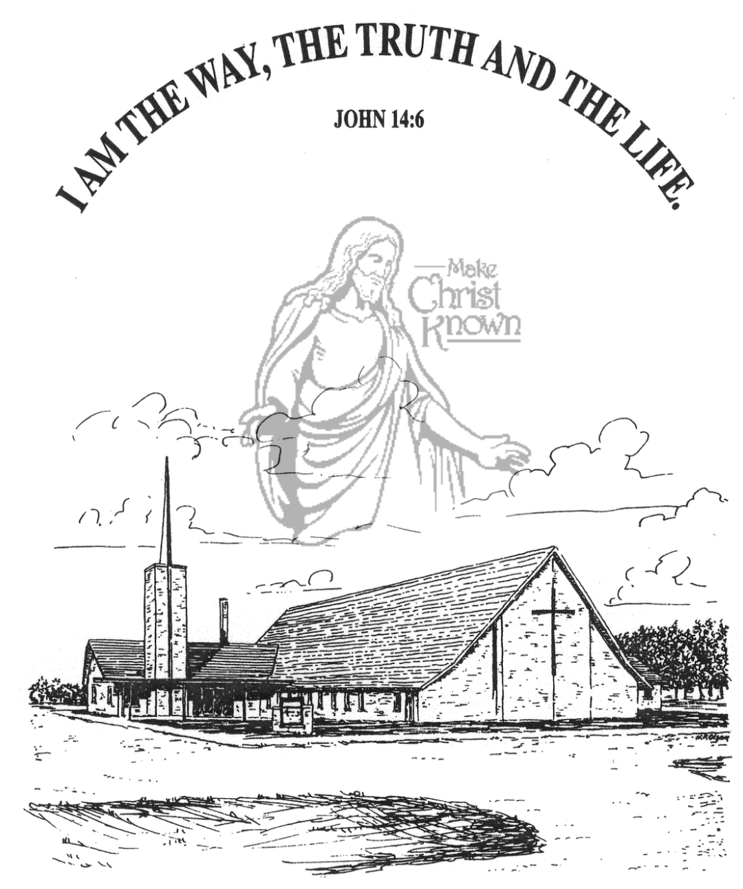

**Sunday, January 28, 2024**

**Salem Reformed Church**

**Menno, South Dakota**

**SALEM REFORMED CHURCH**

Menno, South Dakota

Rev. Michael Hecht Pastor

Jennifer Herrboldt Pianist

10:30 AM – Worship Service January 28, 2024

4th Sunday After Epiphany

**Meditation:** *“Against all hope, Abraham in hope believed and so became the father of many nations, just as it had been said to him, ‘So shall your offspring be.’ Without weakening in his faith, he faced the fact that his body was as good as dead – since he was about a hundred years old – and that Sarah’s womb was also dead. Yet he did not waiver through unbelief regarding the promise of God, but was strengthened in his faith and gave glory to God, being fully persuaded that God had power to do what He had promised. This is why ‘it was credited to him as righteousness.’ The words ‘it was credited to him’ were written not for him alone, but also for us, to whom God will credit righteousness – for us who believe in Him who raised Jesus our Lord from the dead.”* Romans 4:18-24 NIV

**Praise Music:** #83, #131, #82, #16

**Ringing of the Bell / Welcome / Announcements**

**Opening Prayer**

**\*Hymn:** #3 “Holy, Holy, Holy! Lord God Almighty”

**Sharing of Joys and Concerns**

**Our Time of Offering**  Malachi 3:10 NIV

**\*Lord’s Prayer** sung on page #631

**\*Apostles’ Creed** words of screen

**Kingdom Kids:** “Have Faith Like Abraham”

**\*Hymn:** #149 “Ah Lord God”

**The Holy Scriptures**

Hebrews 11:8-16

Large Print NIV 1984 Edition, pg. 1874

**Sermon: “Abraham – A Life of Faith”**

**\*Hymn:** #23 “In Christ Alone”

**\*Benediction:**

**\*Prayer for Our Nation:** “God Bless America”

**Postlude** (*denotes standing for those able)

The congregation will be ushered out after the Benediction

Youth Ushers: Michael Nusz, Eli Soukup, Rylan Derby

**Office Hours for Pastor Hecht**

Tuesday – Friday: 8:00 AM to Noon (Church Office)

Afternoons: Visitation or Church Office

Church: (605) 387-5334 Parsonage: (605) 387-2855

Pastor Mike’s Cell #: (605) 660-1803

Church Web Page: ***salemreformedchurch.com***

**Opportunities**

Greeters Today: Robert and Elaine Balogh

Greeters Feb 04: Brian and Steph Mehlhaf

Sunday Prayer Time: 8:30 a.m.

Sunday School Classes: 9:15 a.m.

Praise Music: 10:15 a.m.

Worship Service: 10:30 a.m.

**Announcements**

**Welcome:** We extend a warm welcome to our visiting guests this morning. Please sign our guest book in the Narthex. We ask God’s blessing upon you and we pray that you will return and worship with us again soon.

**Annual Meeting:** The Annual Meeting of the Congregation is **TODAY** at 12:45 p.m. *The Consistory and Spouses will host a lunch for the congregation immediately following our worship service on the day of the Annual Meeting. Everyone is welcome to stay and enjoy, and also encouraged to stay for the Annual Meeting.

**Nominations to Consistory:** The Consistory has voted to nominate the following individuals for office:

Ken Stepanek Elder 2nd Term

Shirley Mettler Elder 2nd Term

Tyler Miller Deacon 2nd Term

The Consistory would like to remind the voting membership that they may bring nominations from the floor at the Annual Meeting.

**Special Note:** We will also be voting on the new position of an Assistant Pastor at the Annual Meeting.

We are thankful for the many volunteers who work so hard in the life of this local church throughout the year!

**Sunday Offerings:** Please note that we have an Offering Box/Pulpit at the back of the Sanctuary for people to place their tithes and offerings in.

***“God loves a cheerful giver.”* II Corinthians 9:7**