**Calendar of Events**

Jan 01 **Happy New Year 2024!**

Men’s Christian Fellowship @ 7:00 p.m.

Jan 03 6/7th Grade Confirmation @ 3:30 – 5:15 p.m.

8th Grade Confirmation @ 5:30 – 7:00 p.m.

FCA at Menno Gym @ 7:30 p.m.

Jan 04 Prayer Group @ 12 Noon

Jan 07 Prayer Time for Service @ 8:30 a.m.

Sunday School Classes @ 9:15 a.m.

Praise Music @ 10:15 a.m.

Worship Service @ 10:30 a.m.

League Meeting @ 12:00 p.m.

**Upcoming Special Music**

Sunday, January 07 - Available

Sunday, January 10 - Available

**Announcements**

**Sanctity of Human Life Sunday:** On Sun, January 14, Jenna Spellerberg from the Alpha Center will be present with us to share about their pro-life work/ministry in our region. A special offering will be received for the Alpha Center on that day.

**Annual Meeting:** The Annual Meeting of the Congregation is scheduled for Sunday, January 28, 2024 at 12:45 p.m. The snow date is set for Sunday, February 4th at the same time. *The Consistory and Spouses will host a lunch for the congregation immediately following our worship service on the day of the Annual Meeting. Everyone is welcome to stay and enjoy, and also stay for the Annual Meeting.

**Annual Reports:** If you are responsible for completing a report for our Annual Meeting, please have it turned into the church office by Wednesday, January 10, 2024. You may also email your report to the office at: salemref2@goldenwest.net

**Nominations to Consistory:** The Consistory has voted to nominate the following individuals for office:

Ken Stepanek Elder 1st Term

Shirley Mettler Elder 1st Term

Tyler Miller Deacon 1st Term

**CE Committee Meeting:** The next CE Committee meeting is scheduled for Sunday, January 21, following the Worship Service. Committee Members, please mark your calendars.

**Salem Reformed Church – Who Are We?**

**We believe the Bible to be the inspired, inerrant, infallible Word of God in its original manuscripts. It is our supreme authority in all matters doctrine and practice. We are affiliated with the Conservative Congregational Christian Conference.**

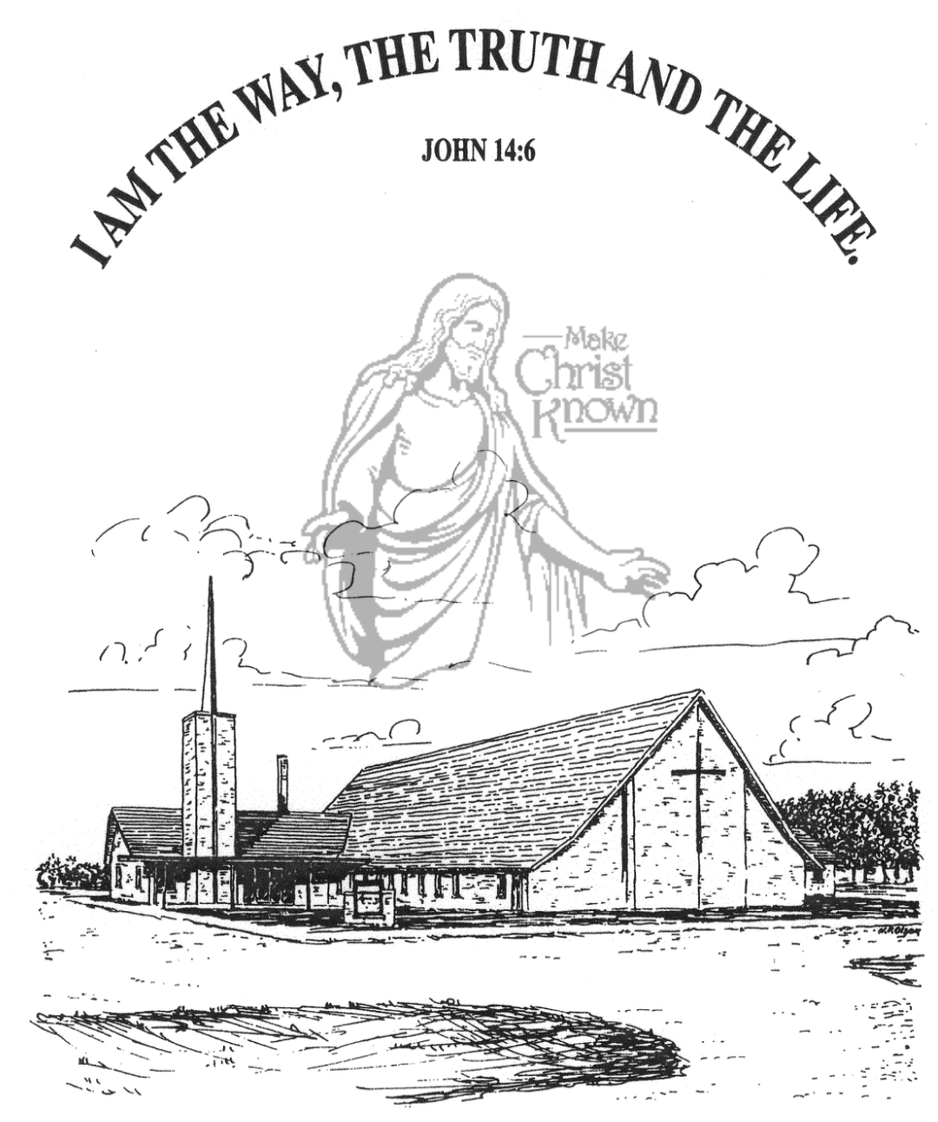

**Sunday, December 31, 2023**

**Salem Reformed Church**

**Menno, South Dakota**

**SALEM REFORMED CHURCH**

Menno, South Dakota

Rev. Michael Hecht Pastor

Jennifer Herrboldt Pianist

10:30 AM – Worship Service December 31, 2023

First Sunday after Christmas

**Meditation:** *“Brothers, I do not consider myself yet to have taken hold of it. But one thing I do: Forgetting what is behind and straining toward what is ahead, I press on toward the goal to win the prize for which God has called me heavenward in Christ Jesus.”* Philippians 3:13-14 NIV

**Praise Music:** #56, #10, #22, #72, #43

**Ringing of the Bell / Welcome / Announcements**

**Opening Prayer**

**\*Hymn:** #273 “Good Christian Men, Rejoice”

**Sharing of Joys and Concerns**

**Our Time of Offering**  Romans 12:1-2NIV

**\*Doxology** sung on page #815

**\*Lord’s Prayer** debts and debtors

**Kingdom Kids:**  shared by Ken Wintersteen

**\*Hymn:** #254 “Isn’t He”

**The Holy Scriptures**

Exodus 17: 1-7; James 1:19-27

Large Print NIV 1984 Edition, pg. 114 and pg. 1881

**Sermon: “How Are You Doing?”**

shared by Ken Wintersteen

**\*Hymn:** #258 “Go Tell It On The Mountain”

**\*Benediction:**

**Postlude**

(*denotes standing for those able)

The congregation will be ushered out after the Benediction

Youth Ushers: Bryce Sattler, Carter Fischer, Brockton Kocourek

**Office Hours for Pastor Hecht**

Tuesday – Friday: 8:00 AM to Noon (Church Office)

Afternoons: Visitation or Church Office

Church: (605) 387-5334 Parsonage: (605) 387-2855

Pastor Mike’s Cell #: (605) 660-1803

Church Web Page: ***salemreformedchurch.com***

**Opportunities**

Greeters Today: Ben and Julie Crick

Greeters Jan 07:

Sunday Prayer Time: 8:30 a.m.

Sunday School Classes: 9:15 a.m.

Praise Music: 10:15 a.m.

Worship Service: 10:30 a.m.

**Announcements**

**Welcome:** We extend a warm welcome to our visiting guests this morning. Please sign our guest book in the Narthex. We ask God’s blessing upon you and we pray that you will return and worship with us again soon.

**Special Welcome:** We extend a special welcome to Ken and Lynn Wintersteen and a big THANK YOU to Ken for filling in during Pastor Mike’s absence.

**Taking Down of Greens:** The Christmas Tree/Greens will be taken down after church TODAY by the CE Committee and others that would like to help.

**Christmas Day Offering:** Our Christmas Day Offering will be received TODAY. The offering will be given to the M/O Care Center to assist with on-going needs and upgrades.

**Christmas Eve Offering:** The offering received on Christmas Eve was $6,279.00! The Abbott House received $3,139.50; Swan Lake Christian Camp received $1,883.70; and Healing Hope Ministries received $1,255.80. We praise the Lord for such generous giving to these ministries!

**Meals-on-Wheels:** Our church will be delivering meals during the month of **JANUARY.** If you signed up to deliver, the meals can be picked up at the M/O Care Center at 11:20 a.m. Thank you to all who signed up!

**Poinsettias:** Special Thanks to all who have been sharing poinsettias with us in Memory of Loved Ones. You may take your plant home today.