**Calendar of Events**

Dec 17 Christmas Caroling @ 4:00 p.m.

Dec 18 Men’s Christian Fellowship @ 7:00 p.m.

Dec 20 No Confirmation Classes Today

Filling Christmas Sacks @ 6:00 p.m.

FCA at Menno Gym @ 7:30 p.m.

Dec 21 Prayer Group @ 12 Noon

Dec 24 Prayer Time for Service @ 8:30 a.m.

Christmas Program Practice @ 9:15 a.m.

Piano/Organ Duets @ 10:15 a.m.

Worship Service @ 10:30 a.m.

**Christmas Eve Program/Service @ 7:00 PM**

Dec 25 **Merry Christmas!**

Prayer Time for Service @ 9:00 a.m.

Piano/Organ Duets @ 9:45 a.m.

**Christmas Day Worship @ 10:00 AM**

**Upcoming Special Music**

Sunday, December 24 - Caden Fischer

Monday, December 25 - Available

Sunday, December 31 - Available

**Announcements**

**Special Thanks:** Thanks to Chelsea Summerside, Chandra van Zyl, Alyssa Bendt, and Katie Huber for coordinating and serving the lunches for the Christmas Program Practices!

**Meals-on-Wheels:** Our church will be delivering meals during the month of **JANUARY.** Drivers are needed for delivering lunches on Mon-Friday. They should be picked up at the M/O Care Center at 11:20 a.m. Sign the calendar in the Narthex to help.

**Advent Season:** During the Advent Season the pianists and organist will be playing prelude music before the services, This is to be used as a time to prepare your hearts and minds for the worship service.

**FCCLA Project:** Ashlynn Fergen, Zoe Schaeffer, Elly Fischer will be doing a winter drive for children in Foster Care. Items needed are children’s socks, underwear, gloves and hats. Items need to be brought to church by TODAY, Dec. 17th. Thanks!

**Annual Reports:** If you are responsible for completing a report for our Annual Meeting, please have it turned into the church office by Wednesday, January 10, 2024. You may also email your report to the office at: ***salemref2@goldenwest.net***

**Salem Reformed Church – Who Are We?**

**We believe the Bible to be the inspired, inerrant, infallible Word of God in its original manuscripts. It is our supreme authority in all matters doctrine and practice. We are affiliated with the Conservative Congregational Christian Conference.**

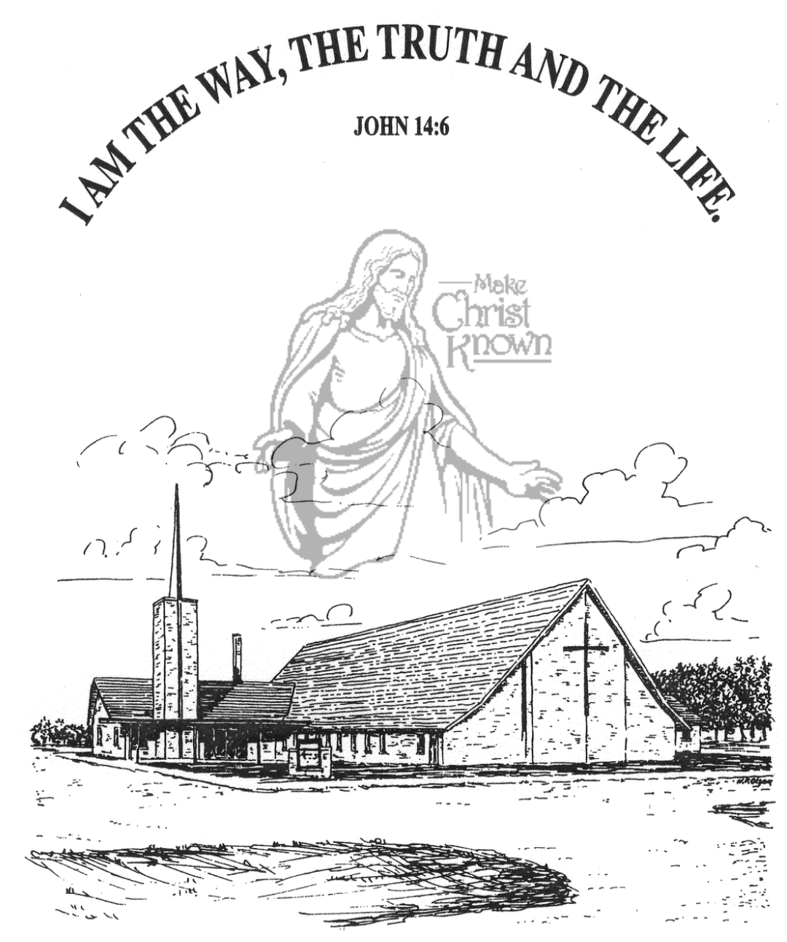

**Sunday, December 17, 2023**

**Salem Reformed Church**

**Menno, South Dakota**

**Office Hours for Pastor Hecht**

Tuesday – Friday: 8:00 AM to Noon (Church Office)

Afternoons: Visitation or Church Office

Church: (605) 387-5334 Parsonage: (605) 387-2855

Pastor Mike’s Cell #: (605) 660-1803

Church Web Page: ***salemreformedchurch.com***

**Opportunities**

Greeters Today: Ray and Beverly Gossen

Greeters Dec. 24 AM: Robert and Elaine Balogh

Greeters Dec. 24 PM: Steve and Sheri Preszler

Sunday Prayer Time: 8:30 a.m.

Sunday School Classes: 9:15 a.m.

Praise Music: 10:15 a.m.

Worship Service: 10:30 a.m.

**Announcements**

**Welcome:** We extend a warm welcome to our visiting guests this morning. Please sign our guest book in the Narthex. We ask God’s blessing upon you and we pray that you will return and worship with us again soon.

**Poinsettias in Memory of Loved Ones:** During the Advent Season we have the opportunity to place poinsettias in the sanctuary in memory of loved ones. Please contact the florist of your choice if you desire to place a plant this year.

**Christmas Eve Program Practice:** Program Practices for all children, Ages 3yr.old thru 8th Grade will begin at 9:15 a.m. next Sunday. This practice also includes the Pre-School Class. Please be PROMPT and ready to practice at 9:15 a.m. Thanks! We are excited about our Christmas Eve Program and Candle Light Service!

**Christmas Eve Offering:** Our Christmas Eve Program & Candle Light Service is at 7:00 p.m. The offering received will be divided as follows: 50% to the Abbott House in Mitchell; 30% to the Swan Lake Christian Camp; 20% to Healing Hope Ministries.

**Christmas Day Offering:** Our Christmas Day Offering will be given to the M/O Care Center to assist with on-going needs and upgrades. **Christmas Day Service @ 10:00 AM!**

**Christmas Caroling:** We will plan to meet at the church TODAY @ 4 PM to go caroling in Menno. We’ll come back to the church afterwards for some chili soup, other goodies and fellowship!

**SALEM REFORMED CHURCH**

Menno, South Dakota

Rev. Michael Hecht Pastor

Joan Nusz Pianist

10:30 AM – Worship Service December 17, 2023

Third Sunday of Advent

**Meditation:** *“At that time Mary got ready and hurried to a town in the hill country of Judea, where she entered Zechariah’s home and greeted Elizabeth. When Elizabeth heard Mary’s greeting, the baby leaped in her womb, and Elizabeth was filled with the Holy Spirit. In a loud voice she exclaimed: ‘Blessed are you among women, and blessed is the Child you will bear! But why am I so favored, that the mother of my Lord should come to me? As soon as the sound of your greeting reached my ears, the baby in my womb leaped for joy. Blessed is she who has believed that what the Lord has said to her will be accomplished!’ “* Matthew 1:39-45 NIV

**Prelude Music:** by Joan Nusz

**Ringing of the Bell / Welcome**

**Announcements**

**Opening Prayer**

**Lighting of the Advent Wreath**

by Ashlyn Derby, Autumn and Emmarie Rames

**\*Hymn:** #259 “Angels From the Realms of Glory”

**Sharing of Joys and Concerns**

**Our Time of Offering** Philippians 4:4,5 NIV

**\*Doxology** sung on page #815

**\*Lord’s Prayer** debts and debtors

**Kingdom Kids:** “Joy to the World“

**Special Music:** “Breath of Heaven” sung by Natasha Auch

**The Holy Scriptures**

Luke 2:8-20

Large Print NIV 1984 Edition, pg. 1591

**Sermon: “Good News of Great Joy”**

**\*Hymn:** #270 “Joy to the World”

**\*Benediction:**

**Postlude**

(*denotes standing for those able)

The congregation will be ushered out after the Benediction

Youth Ushers: Bryce Sattler, Carter Fischer, Brockton Kocourek