**Calendar of Events**

Nov 12 Youth Rally @ 6:30 p.m.

Nov 15 6/7th Grade Confirmation @ 3:30 – 5:15 p.m.

8th Grade Confirmation @ 5:30 – 7:00 p.m.

FCA at Menno Gym @ 7:30 p.m.

Nov 16 Prayer Group @ 12 Noon

Nov 19 Prayer Time for Service @ 8:30 a.m.

Sunday School Classes @ 9:15 a.m.

Praise Music @ 10:15 a.m.

Worship Service @ 10:30 a.m.

with Coffee Hour Following

Nov 20 Men’s Christian Fellowship @ 7:00 p.m.

Nov 22 **Thanksgiving Eve Service @ 7:00 p.m.**

No Confirmation Classes Today

**Upcoming Special Music**

Sunday, November 19 - Available

Wed., November 22 - Available

**Announcements**

**W.O.C. Program Coordinator:** We are seeking ladies to serve as the Coordinator(s) for the program/activity and snack at the Menno-Olivet Care Center for the months of Dec. and June. The program is on the 3rd Tuesday of the month at 2:00 p.m. Please contact Ann Schultz or the Church Office if interested.

**Christmas Program Lunches:** Please sign the list in the Social Hall for food items or monetary donations needed to make the lunches served before our Christmas Program Practices. Lunches will be served on Sundays, Dec. 3rd, 10th, and 17th. Lunch coordinators are Chandra van Zyl and Chelsea Summerside.

**4-O’s Women:** Will meet at Roosters on Wed., Nov. 15th for Lunch and Fellowship. Please sign the sheet in the Narthex if you plan to attend. Thanks!

**Human Services Center Gifts:** The Women of the Church are sponsoring a donation drive for Christmas gifts for the residents at HSC. A list of acceptable gifts is available by the donation box in the Social Hall. Deadline to bring donations is December 3rd.

**Thanksgiving Eve Service:** This Service will be on Wed., Nov. 22nd at 7:00 p.m. The offering received will be given to the M.O.R.E. Committee (Menno/Olivet Resources for the Elderly) to purchase gift certificates for those in need of a holiday meal.

**Salem Reformed Church – Who Are We?**

**We believe the Bible to be the inspired, inerrant, infallible Word of God in its original manuscripts. It is our supreme authority in all matters doctrine and practice. We are affiliated with the Conservative Congregational Christian Conference.**

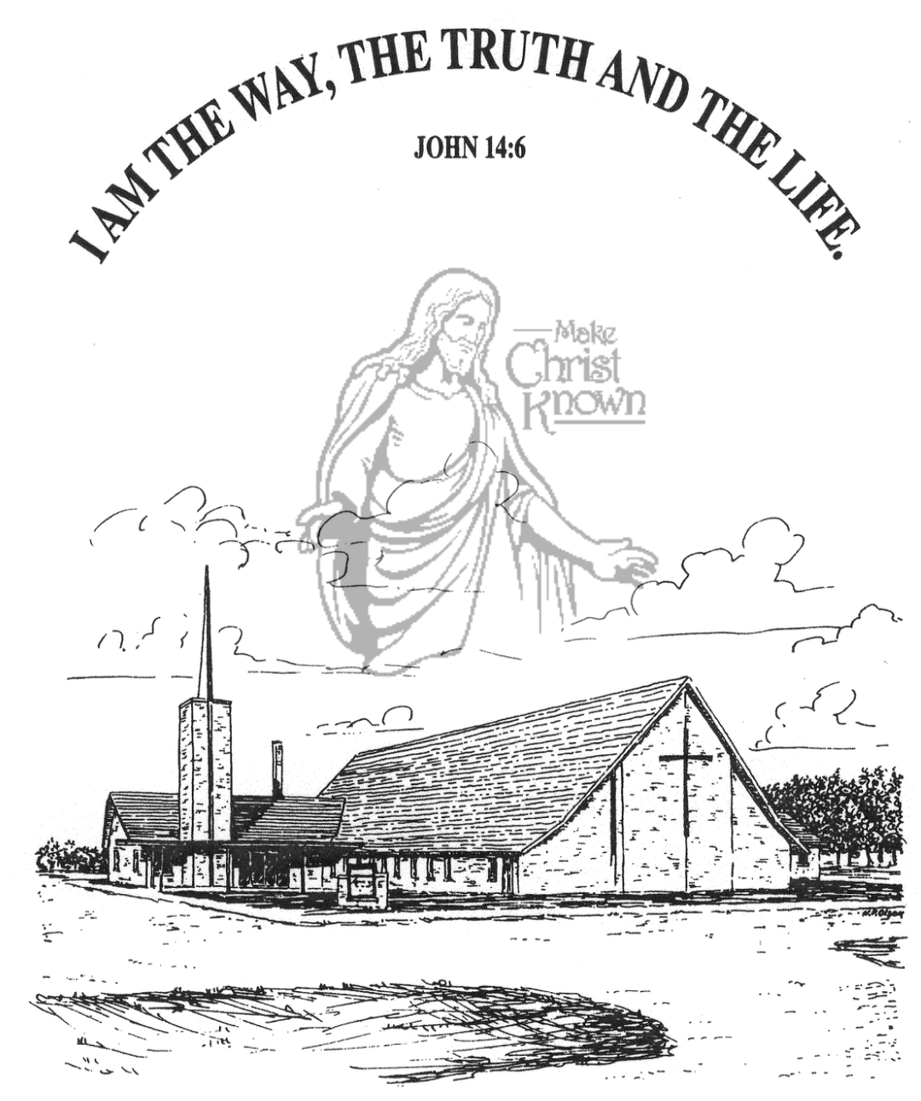

**Sunday, November 12, 2023**

**Salem Reformed Church**

**Menno, South Dakota**

**Office Hours for Pastor Hecht**

Tuesday – Friday: 8:00 AM to Noon (Church Office)

Afternoons: Visitation or Church Office

Church: (605) 387-5334 Parsonage: (605) 387-2855

Pastor Mike’s Cell #: (605) 660-1803

Church Web Page: ***salemreformedchurch.com***

**Opportunities**

Greeters Today: Tim and Sherry Freier

Greeters Nov. 19: Greg and Melanie Wilcoxon

Sunday Prayer Time: 8:30 a.m.

Sunday School Classes: 9:15 a.m.

Praise Music: 10:15 a.m.

Worship Service: 10:30 a.m.

**Announcements**

**Welcome:** We extend a warm welcome to our visiting guests this morning. Please sign our guest book in the Narthex. We ask God’s blessing upon you and we pray that you will return and worship with us again soon.

**Congratulations:** We rejoice with the family of Beau Bruce Mehlhaf at his baptism! Beau’s parents are Devin and Emily Mehlhaf. He joins his older sister, Cassandra. We extend a warm welcome to all of their family and friends who may be present in our worship service today.

**Mission Festival Services:** The total amount given for the Mission Fest Offering last Sunday was $11,559.00. 45% to Hannah Mettler = $5,201.55; 45% to YWAM = $5,201.55; and 10% to our local FCA at Menno High School = $1,155.90. Praise the Lord for such generous giving!

**CE Committee:** The Christian Ed. Comm. will plan to meet TODAY, following our morning worship service.

**Youth Rally:** TONIGHT @ 6:30 p.m. Guest Speaker will be Luke Winger from Mountain Lake, MN. Luke uses his experiences learned from 4 years living in China, 25 years as a nationally competitive cyclist, and blends them with his juggling & balancing skills to encourage and inspire people to grow in their relationship with Jesus. ALL ages are welcome, so invite your friends!

**Soup Kitchen:** We would like to remind you to sign up for working at the annual soup kitchen and for providing donations. Please stop by the social hall today if you have not had the opportunity to volunteer for the event. Reminder slips & recipes will be distributed on 11/19&26.

**SALEM REFORMED CHURCH**

Menno, South Dakota

Rev. Michael Hecht Pastor

Cindy Herrboldt Organist

10:30 AM – Worship Service November 12, 2023

Twenty-fourth Sunday after Pentecost

**Meditation:** *“According to the Lord’s own word, we tell you that we who are still alive, who are left till the coming of the Lord, will certainly not precede those who have fallen asleep. For the Lord Himself will come down from heaven, with a loud command, with the voice of the archangel and with the trumpet call of God, and the dead in Christ will rise first. After that, we who are still alive and are left will be CAUGHT UP together with them in the clouds to meet the Lord in the air. And so we will be with the Lord forever. Therefore encourage each other with these words.”* Thessalonians 4:15-18 NIV

**Praise Music:** #7, #37, #67, #22, #53, #52

**Ringing of the Bell / Welcome / Announcements**

**Opening Prayer**

**\*Hymn:** #210 “Praise to the Lord, the Almighty”

**Sharing of Joys and Concerns**

**Our Time of Offering** Ephesians 1:13,14 NIV

**\*Doxology** sung on page #815

**\*Lord’s Prayer** debts and debtors

**Baptism: Beau Bruce Mehlhaf**

**Questions of Candidates / Congregational Assent**

**Education Committee Pledge** Lee Heckenlaible

**Act of Baptism**

**Congregational Song: “Yes, Jesus Loves You!”**

**Kingdom Kids:** “God’s Branding Iron“

**Special Music:** “My Lighthouse”

sung by Junior Choir (4th thru 8th Grade)

**The Holy Scriptures**

Revelation 13:11-18

Large Print NIV 1984 Edition, pg. 1927

**Sermon: “The Mark of the Beast”**

**\*Hymn:** #774 “When the Roll Is Called Up Yonder”

**\*Benediction:**

**\*Prayer for Our Nation:** “God Bless America”

**Postlude** (*denotes standing for those able)

The congregation will be ushered out after the Benediction

Youth Ushers: Ashlynn Fergen, Elly Fischer, Zoe Schaeffer