**Calendar of Events**

Nov 29 6/7th Grade Confirmation @ 3:30 – 5:15 p.m.

8th Grade Confirmation @ 5:30 – 7:00 p.m.

Women’s Bible Study @ 6:30 p.m.

Nov 30 Prayer Group @ 12 Noon

Dec 02 Soup Kitchen/Bake Sale 11 a.m. to 7 p.m.

Dec 03 Prayer Time for Service @ 8:30 a.m.

Sunday School Classes @ 9:15 a.m.

Praise Music @ 10:15 a.m.

Worship Service @ 10:30 a.m.

Program Practice @ 12 Noon to 1:30 p.m.

M/OCC Worship Service @ 2:00 p.m.

High School Youth Christmas at Gym @ 5:00 p.m.

Dec 04 Men’s Christian Fellowship @ 7:00 p.m.

**Upcoming Special Music**

Sunday, December 03 - Available

Sunday, December 10 - Holy Communion

**Announcements**

**Christmas Eve Program Practices:** Program Practices for grades K-8 will be on Sundays, Dec. 3, 10, 17, following the worship service. A lunch for the children/teachers will be served prior to practice. The last practice will be Sun., Dec. 24th during the Sunday School Hour. This practice will also include the Pre-School Class. Emily Guthmiller & Ashley Holzwarth are the Directors.

**Christmas Program Lunches:** Please sign the list in the Social Hall for food items needed to make the lunches served before our Christmas Program Practices. Lunch coordinators are Chelsea Summerside, Chandra van Zyl, Alyssa Bendt and Katie Huber.

**Human Services Center Gifts:** The Women of the Church are sponsoring a donation drive for Christmas gifts for the residents at HSC. A list of acceptable gifts is available by the donation box in the Social Hall. Deadline to bring donations is December 3rd.

**Heidelberg League Bake Sale:** The High School Youth will be hosting a Bake Sale at the Soup Kitchen on Sat., December 2nd. Parents of the youth will be providing baked goods for sale. Others from the congregation are also welcome to donate baked items to the youth group. Donations go towards the youth ministry of our church and their various activities and events throughout the year.

**Salem Reformed Church – Who Are We?**

**We believe the Bible to be the inspired, inerrant, infallible Word of God in its original manuscripts. It is our supreme authority in all matters doctrine and practice. We are affiliated with the Conservative Congregational Christian Conference.**

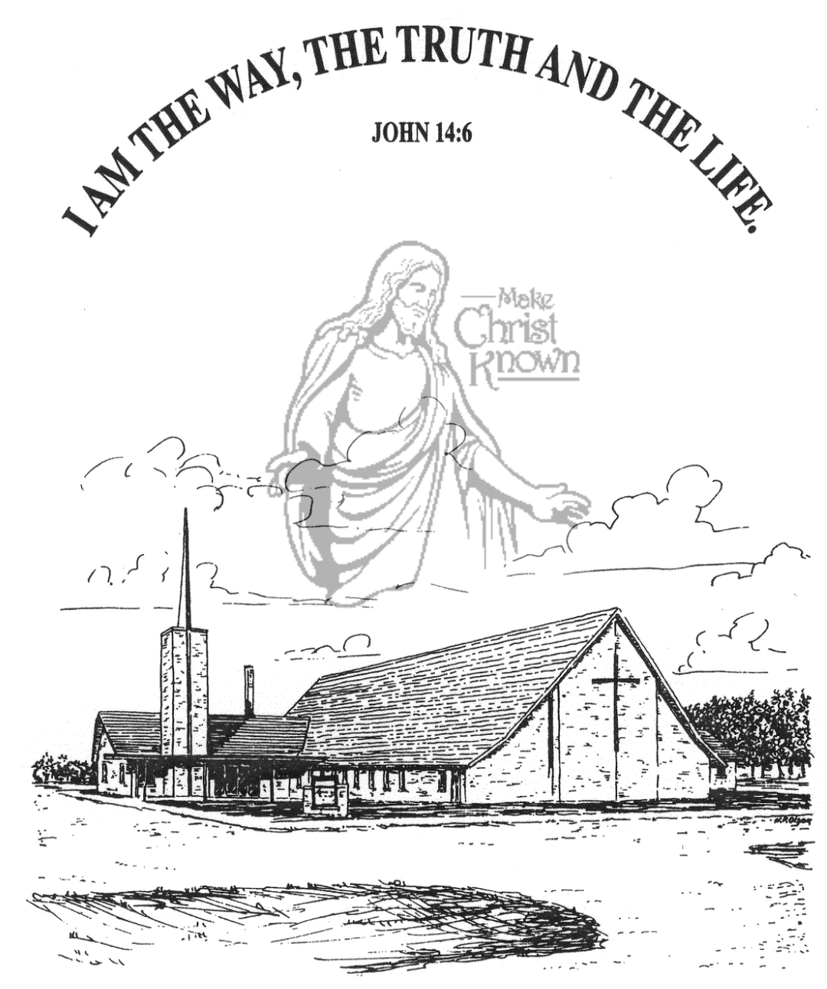

**Sunday, November 26, 2023**

**Salem Reformed Church**

**Menno, South Dakota**

**Office Hours for Pastor Hecht**

Tuesday – Friday: 8:00 AM to Noon (Church Office)

Afternoons: Visitation or Church Office

Church: (605) 387-5334 Parsonage: (605) 387-2855

Pastor Mike’s Cell #: (605) 660-1803

Church Web Page: ***salemreformedchurch.com***

**Opportunities**

Greeters Today: Gary and Jane Gramkow

Greeters Dec. 03:

Greeters Dec. 10: Dave and Peg Walloch

Sunday Prayer Time: 8:30 a.m.

Sunday School Classes: 9:15 a.m.

Praise Music: 10:15 a.m.

Worship Service: 10:30 a.m.

**Announcements**

**Welcome:** We extend a warm welcome to our visiting guests this morning. Please sign our guest book in the Narthex. We ask God’s blessing upon you and we pray that you will return and worship with us again soon.

**Soup Kitchen:** The Soup Kitchen will be held Sat., Dec. 2nd in the Social Hall from 11am to 7pm. Please stop by the Social Hall TODAY after the service to pick up your work assignment. If you have any questions, the committee members can assist you. We appreciate your donations of food and time to assist with the event. Please remember to invite your friends and family to the fundraiser!

**Thanksgiving Eve Service:** The offering received for the M.O.R.E. Committee on Thanksgiving Eve was $2,785.00! We Praise the Lord for such generous gifts to share!

**Operation Christmas Child:** THANK YOU to all who participated in filling a shoe box for a needy child in another part of our world! We received a total of 62 shoe boxes this year! Praise the Lord!

**Hanging of the Greens:** The setting up of the Christmas Tree and decorations will take place after church TODAY. The CE Committee will coordinate this event, but other available helpers are always welcome.

**Poinsettias in Memory of Loved Ones:** During the Advent Season we have the opportunity to place poinsettias in the sanctuary in memory of loved ones. Please contact the florist of your choice if you desire to place a plant this year. The first Sunday of Advent is December 03.

**SALEM REFORMED CHURCH**

Menno, South Dakota

Rev. Michael Hecht Pastor

Jennifer Herrboldt Pianist

10:30 AM – Worship Service November 26, 2023

Twenty-sixth Sunday after Pentecost

**Meditation:** *“This is what the LORD says, He who appoints the sun to shine by day, who decrees the moon and stars to shine by night, who stirs up the sea so that its waves roar – the LORD Almighty is His Name: ‘Only if these decrees vanish from My sight,’ declares the LORD, will the descendants of Israel ever cease to be a nation before Me.’ Only if the heavens above can be measured and the foundations of the earth below be searched out will I reject all the descendants of Israel because of all they have done,’ ‘The days are coming,’ declares the LORD, ‘when this city will be rebuilt for Me from the Tower of Hananel to the Corner Gate. . . . . The city will never again be uprooted or demolished.’ “*  Jeremiah 31:35-40 NIV

**Praise Music:** #143, #82, #83, #150

**Ringing of the Bell / Welcome**

**Announcements**

**Opening Prayer**

**\*Hymn:** #104 “O Worship the King”

**Sharing of Joys and Concerns**

**Our Time of Offering**  John 10:28-30 NIV

**\*Doxology** sung on page #815

**\*Lord’s Prayer** debts and debtors

**Kingdom Kids:** “Exercising Your Faith“

**Hymn:** 101 “All People That on Earth Do Dwell”

**The Holy Scriptures**

II Thessalonians 2:1-12

Large Print NIV 1984 Edition, pg. 1843

**Sermon: “The Great Rebellion”**

**\*Hymn:** #762, 763 “What A Day” & “The King is Coming”

**\*Benediction:**

**\*Prayer for Our Nation:** “God Bless America”

**Postlude**

(*denotes standing for those able)

The congregation will be ushered out after the Benediction

Youth Ushers: Ashlynn Fergen, Elly Fischer, Zoe Schaeffer