**Calendar of Events**

Nov 20 Men’s Christian Fellowship @ 7:00 p.m.

Nov 22 **Thanksgiving Eve Service @ 7:00 p.m.**

No Confirmation Classes Today

Nov 23 Happy Thanksgiving!

Nov 26 Prayer Time for Service @ 8:30 a.m.

Sunday School Classes @ 9:15 a.m.

Praise Music @ 10:15 a.m.

Worship Service @ 10:30 a.m.

with Hanging of Greens Following

Nov 29 6/7th Grade Confirmation @ 3:30 – 5:15 p.m.

8th Grade Confirmation @ 5:30 – 7:00 p.m.

Women’s Bible Study @ 6:30 p.m.

Nov 30 Prayer Group @ 12 Noon

Dec 02 Soup Kitchen/Bake Sale 11 a.m. to 7 p.m.

**Upcoming Special Music**

Wed., November 22 - Available

Sunday, November 26 - Available

**Announcements**

**Christmas Eve Program Practices:** Program Practices for grades K-8 will be on Sundays, Dec. 3, 10, 17, following the worship service. A lunch for the children/teachers will be served prior to practice. The last practice will be Sun., Dec. 24th during the Sunday School Hour. This practice will also include the Pre-School Class. Emily Guthmiller & Ashley Holzwarth are the Directors.

**W.O.C. Program Coordinator:** We are seeking ladies to serve as the Coordinator(s) for the program/activity and snack at the Menno-Olivet Care Center for the month of June 2024. The program is on the 3rd Tuesday of the month at 2:00 p.m. Please contact Ann Schultz or the Church Office if interested.

**Christmas Program Lunches:** Please sign the list in the Social Hall for food items or monetary donations needed to make the lunches served before our Christmas Program Practices. Lunches will be served on Sundays, Dec. 3rd, 10th, and 17th. Lunch coordinators are Chandra van Zyl and Chelsea Summerside.

**Human Services Center Gifts:** The Women of the Church are sponsoring a donation drive for Christmas gifts for the residents at HSC. A list of acceptable gifts is available by the donation box in the Social Hall. Deadline to bring donations is December 3rd.

**Salem Reformed Church – Who Are We?**

**We believe the Bible to be the inspired, inerrant, infallible Word of God in its original manuscripts. It is our supreme authority in all matters doctrine and practice. We are affiliated with the Conservative Congregational Christian Conference.**

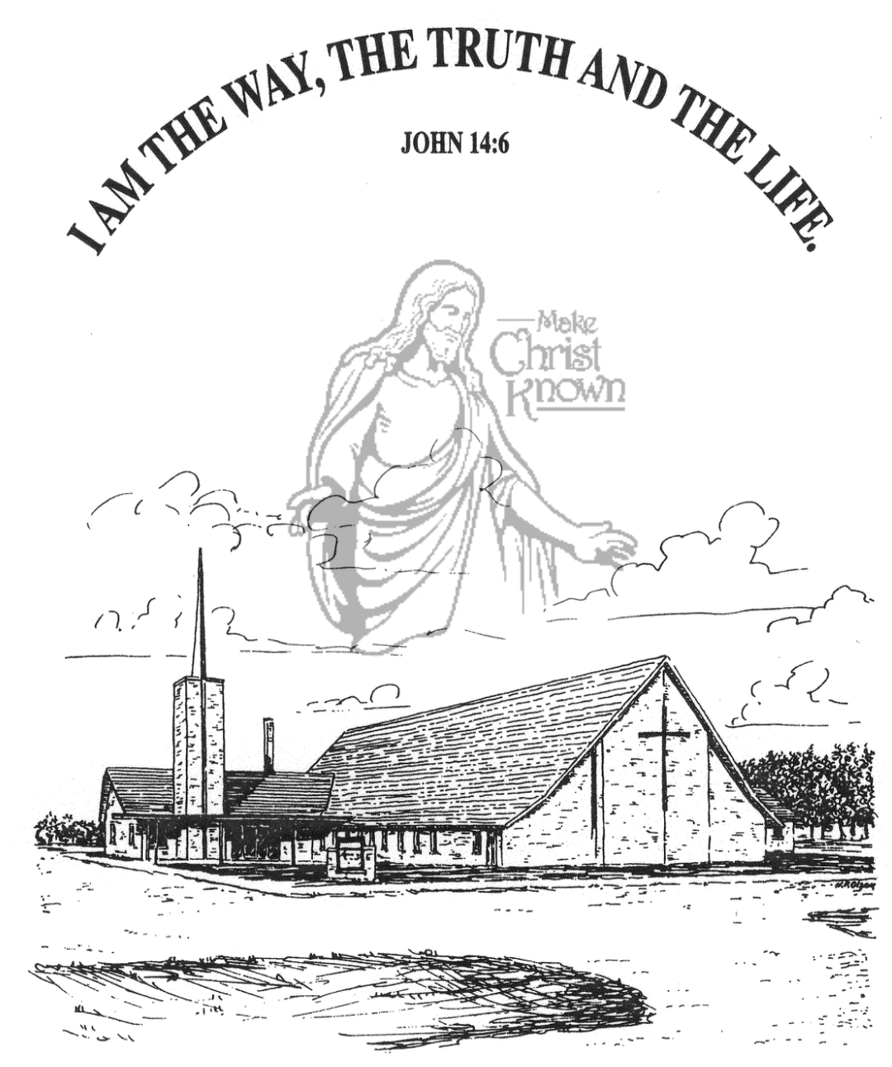

**Sunday, November 19, 2023**

**Salem Reformed Church**

**Menno, South Dakota**

**Office Hours for Pastor Hecht**

Tuesday – Friday: 8:00 AM to Noon (Church Office)

Afternoons: Visitation or Church Office

Church: (605) 387-5334 Parsonage: (605) 387-2855

Pastor Mike’s Cell #: (605) 660-1803

Church Web Page: ***salemreformedchurch.com***

**Opportunities**

Greeters Today: Greg and Melanie Wilcoxon

Greeters Nov. 22: Brian and Jessie Goehring

Greeters Nov. 26:

Sunday Prayer Time: 8:30 a.m.

Sunday School Classes: 9:15 a.m.

Praise Music: 10:15 a.m.

Worship Service: 10:30 a.m.

**Announcements**

**Welcome:** We extend a warm welcome to our visiting guests this morning. Please sign our guest book in the Narthex. We ask God’s blessing upon you and we pray that you will return and worship with us again soon.

**Coffee Hour:** Please join us after church TODAY for a time of coffee, cookies and fellowship with one another in the Social Hall.

**Soup Kitchen:** The Soup Kitchen will be held Saturday, December 2nd in the Social Hall from 11am to 7pm. Please take time to stop by the Social Hall TODAY after the service to pick up your work schedule for the Soup Kitchen. If you have any questions, the committee members can assist you. They are: Jennifer Vaith, Lori Smith, Michelle Friesen and Melanie Wilcoxon.

**Thanksgiving Eve Service:** This Service will be on Wed., Nov. 22nd at 7:00 p.m. The offering received will be given to the M.O.R.E. Committee (Menno/Olivet Resources for the Elderly) to purchase gift certificates for those in need of a holiday meal.

**Operation Christmas Child:** THANK YOU to all who participated in filling a shoe box for a needy child in another part of our world! We received a total of 62 shoe boxes this year! Praise the Lord!

**Hanging of the Greens:** The setting up of the Christmas Tree and decorations will take place after church next Sunday, Nov. 26th. The CE Committee will coordinate this event, but other available help is always welcome.

**SALEM REFORMED CHURCH**

Menno, South Dakota

Rev. Michael Hecht Pastor

Sharyl Herrboldt Pianist

10:30 AM – Worship Service November 19, 2023

Twenty-fifth Sunday after Pentecost

**Meditation:** *“For you are a people holy to the LORD your God. The LORD your God has chosen you out of all the peoples on the face of the earth to be His people, His treasured possession. The LORD did not set His affection on you and choose you because you were more numerous than other peoples, for you were the fewest of all peoples. But it was because the LORD loved you and kept the oath He swore to your forefathers that He brought you out with a mighty hand and redeemed you from the land of slavery, from the power of Pharaoh king of Egypt. Know therefore that the LORD your God is God; He is the faithful God, keeping His covenant of love to a thousand generations of those who love Him and keep His commands.”*

Deuteronomy 7:6-9 NIV

**Praise Music:** #1, #5, #144, #96, #43

**Ringing of the Bell / Welcome**

**Announcements**

**Opening Prayer**

**\*Hymn:** #17 “Our Great Savior”

**Sharing of Joys and Concerns**

**Our Time of Offering** I John 3:16-18 NIV

**\*Doxology** sung on page #815

**\*Apostles’ Creed** words on screen

**Kingdom Kids:** “Are You Thankful?“

**Hymn:** 170 “Give Thanks”

**The Holy Scriptures**

Zechariah 8:1-8

Large Print NIV 1984 Edition, pg. 1478

**Sermon: “The City of Truth”**

**\*Hymn:** #571 “Trust and Obey” (Verses 1,2,4,5)

**\*Benediction:**

**\*Prayer for Our Nation:** “God Bless America”

**Postlude** (*denotes standing for those able)

The congregation will be ushered out after the Benediction

Youth Ushers: Ashlynn Fergen, Elly Fischer, Zoe Schaeffer