**Calendar of Events**

Oct 11 Women’s Bible Study @ 9:30 a.m.

6/7 Grade Confirmation @ 3:30 – 5:15 p.m.

8 Grade Confirmation @ 5:30 – 7:00 p.m.

Women’s Bible Study @ 6:30 p.m.

Consistory Meeting @ 7:30 p.m.

Oct 12 Prayer Group @ 12 Noon

Oct 15 Prayer Time for Service @ 8:30 a.m.

Sunday School Classes @ 9:15 a.m.

Praise Music @ 10:15 a.m.

Worship Service @ 10:30 a.m.

High School Youth Group @ 11:45 a.m.

Patrick Ireland in Social Hall @ 7:00 p.m.

Oct 16 Men’s Christian Fellowship @ 7:30 p.m.

Oct 18 Women’s Bible Study @ 9:30 a.m.

4-O’s Women in Social Hall @ 11:30 a.m.

**Upcoming Special Music**

Sunday, October 15 - Available

Sunday, October 22 - Available

**Announcements**

**Congregational Meeting:** The Consistory is planning to hold a congregational meeting on Sun., Oct. 29th, following our worship service. This is for the purpose of presenting information regarding the possibility of having an assistant pastor here at Salem Reformed.

**Food Pantry:** Our church youth group will be sponsoring a Food Drive for the Bethany Food Pantry in Freeman. This will start Today and go through Sunday, Oct. 22nd. In addition to non-perishable food items, you may also bring personal care items such as tooth paste, shampoo, deodorant, tooth brushes, laundry detergent. Winter caps, gloves and scarves are also welcome. Items may be placed in the Social Hall.

**4-O’s Women:** Will meet in the Social Hall for lunch and fellowship on Wed., Oct. 18th at 11:30 a.m. Lunch will be brought from the Dairy Bar. Sign the sheet in the Narthex.

**Sound Crew Help:** Do you like sound, video technology? Would you be willing to be a part of the sound crew here at church – sound, video or projection? Please contact Joanie Handel or Ken Stepanek for more information. High School students are also welcome to be a part of this ministry!

**Salem Reformed Church – Who Are We?**

**We believe the Bible to be the inspired, inerrant, infallible Word of God in its original manuscripts. It is our supreme authority in all matters doctrine and practice. We are affiliated with the Conservative Congregational Christian Conference.**

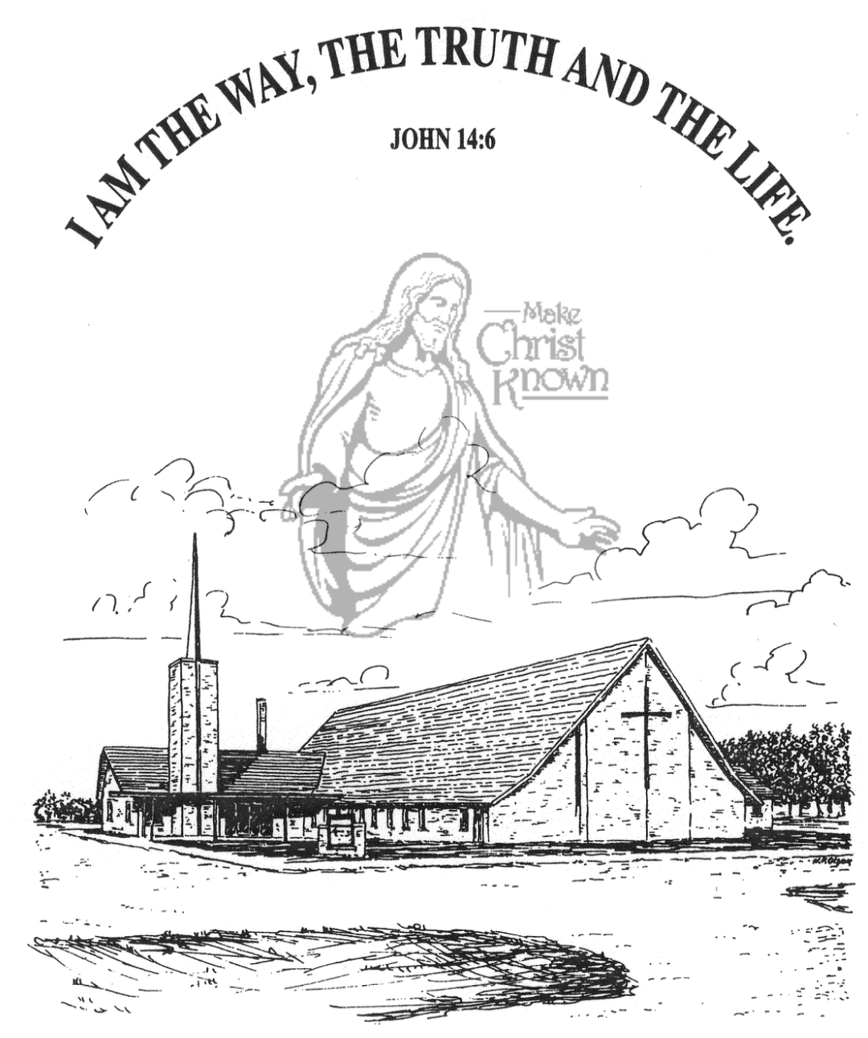

**Sunday, October 08, 2023**

**Salem Reformed Church**

**Menno, South Dakota**

**Office Hours for Pastor Hecht**

Tuesday – Friday: 8:00 AM to Noon (Church Office)

Afternoons: Visitation or Church Office

Church: (605) 387-5334 Parsonage: (605) 387-2855

Pastor Mike’s Cell #: (605) 660-1803

Church Web Page: ***salemreformedchurch.com***

**Opportunities**

Greeters Today: Lee and Dianne Herrboldt

Greeters Oct. 15: Donna Friesen, Harriet Schaeffer

Sunday Prayer Time: 8:30 a.m.

Sunday School Classes: 9:15 a.m.

Praise Music: 10:15 a.m.

Worship Service: 10:30 a.m.

**Announcements**

**Welcome:** We extend a warm welcome to our visiting guests this morning. Please sign our guest book in the Narthex. We ask God’s blessing upon you and we pray that you will return and worship with us again soon.

**Coffee Hour:** Please join us after church TODAY for a time of coffee, cookies and fellowship with one another in the Social Hall.

**W.O.C. Fall Meeting:** The Women of the Church will plan to meet after church **TODAY** to plan for Fall Events. Please join them for this meeting in the Sunday School wing.

**Church Pictorial Committee:** Thanks to Shirley Mettler, Stephanie Wagner, Cassie Wielenga, and Mary Heckenlaible for being willing to serve on this committee. More details will be given in the future. Thanks!

**Cherub Choir:** The Cherub Choir (ages 3 yrs thru 3rd Grade) will plan to sing in church on Sunday, Nov. 5th! This is also our Mission Fest Sunday. Please have your children here for Sunday School promptly at 9:15 a.m. Thanks!

**Men Standing Together:** Sat., October 21st at 6:00 p.m. in our Social Hall. We are excited to have Jared Wockenfuss, Scotland, as our guest speaker. Please sign the sheet in the Narthex if you plan to attend. Supper will be provided. Invite your friends! Let’s have a great turnout! Middle School & High School age young men are also welcome!

**Patrick Ireland:** A 1981 Menno High School Graduate, and 20 year Army Chaplain will be here on Sun., Oct. 15th @ 7PM to share in the Social Hall.

**SALEM REFORMED CHURCH**

Menno, South Dakota

Rev. Michael Hecht Pastor

Sharyl Herrboldt Pianist

10:30 AM – Worship Service October 08, 2023

Nineteenth Sunday after Pentecost

**Meditation:** *“Therefore, I urge you, brothers, in view of God’s mercy, to offer your bodies as living sacrifices, holy and pleasing to God – this is your spiritual act of worship. Do not conform any longer to the pattern of this world, but be transformed by the renewing of your mind. Then you will be able to test and approve what God’s will is – His good, pleasing and perfect will. For by the grace given me I say to every one of you: Do not think of yourself more highly than you ought, but rather think of yourself with sober judgment, in accordance with the measure of faith God has given you. Just as each of us has one body with many members, and these members do not all have the same function, so in Christ we who are many form one body, and each member belongs to all the others.”*

Romans 12:1-5 NIV

**Praise Music:** #38, #21, #22, #66, #90, #144

**Ringing of the Bell / Welcome / Announcements**

**Opening Prayer**

**\*Hymn:** #11 “Come, Thou Fount of Every Blessing”

**Sharing of Joys and Concerns**

**Our Time of Offering** Romans 6:13 NIV

**\*Doxology** sung on page #815

**\*Apostles’ Creed** (words on screen)

**Kingdom Kids:** “Follow Me“

**Hymn:** #130 “His Glorious Name”

**The Holy Scriptures**

Mark 8:30-38

Large Print NIV 1984 Edition, pg. 1567

**Sermon: “Take Up Your Cross”**

**\*Hymn:** #358 “Because He Lives”

**\*Benediction:**

**\*Prayer for Our Nation:** “God Bless America”

**Postlude** (*denotes standing for those able)

The congregation will be ushered out after the Benediction

Youth Ushers: Joslynn Fischer and Addisyn Friesen