**Calendar of Events**

Oct 29 M/OCC Service @ 2:00 p.m.

Nov 01 Women’s Bible Study @ 9:30 a.m.

6/7 Grade Confirmation @ 3:30 – 5:15 p.m.

8 Grade Confirmation @ 5:30 – 7:00 p.m.

FCA at Menno Gym @ 7:30 p.m.

Nov 02 Prayer Group @ 12 Noon

Nov 04 **Daylight Savings Time Ends/Set Clocks Back!**

Nov 05 **Mission Fest Sunday**

Prayer Time for Service @ 8:30 a.m.

Sunday School Classes @ 9:15 a.m.

Praise Music @ 10:15 a.m.

Worship Service @ 10:30 a.m.

With Hannah Mettler Sharing

With Pot Luck Dinner Following

Nov 06 Concert at Scotland Comm. Church @ 6:30pm

Men’s Christian Fellowship @ 7:00 p.m.

Nov 07 M/O Ministerial Meeting @ 11:30 a.m.

**Upcoming Special Music**

Sunday, November 05 - Cherub Choir

Sunday, November 12 - Junior Choir

**Announcements**

**Daylight Savings Time Ends:** Remember to set your clocks **BACK** 1 Hour this coming Saturday evening, November 4th!

**Food Pantry:** Thanks to everyone who donated items for the Bethany Food Pantry! You are a blessing to so many others!

**W.O.C. Program Coordinator:** We are seeking ladies to serve as the Coordinator(s) for the program/activity and snack at the Menno-Olivet Care Center for the months of Dec. and June. The program is on the 3rd Tuesday of the month at 2:00 p.m. Please contact Ann Schultz or the Church Office if interested.

**Soup Kitchen:** The annual Soup Kitchen will soon be here and is set for Sat., Dec. 2nd. The committee will have the work schedule and donation sheets available in the Social Hall TODAY and for the next two weeks. This is a great time to participate and enjoy a time of serving and fellowship. Work sign-up sheets are also available for grades 4-8. Contact committee members: Jennifer Vaith, Lori Smith, Michelle Friesen, or Melanie Wilcoxon with any questions.

**Salem Reformed Church – Who Are We?**

**We believe the Bible to be the inspired, inerrant, infallible Word of God in its original manuscripts. It is our supreme authority in all matters doctrine and practice. We are affiliated with the Conservative Congregational Christian Conference.**

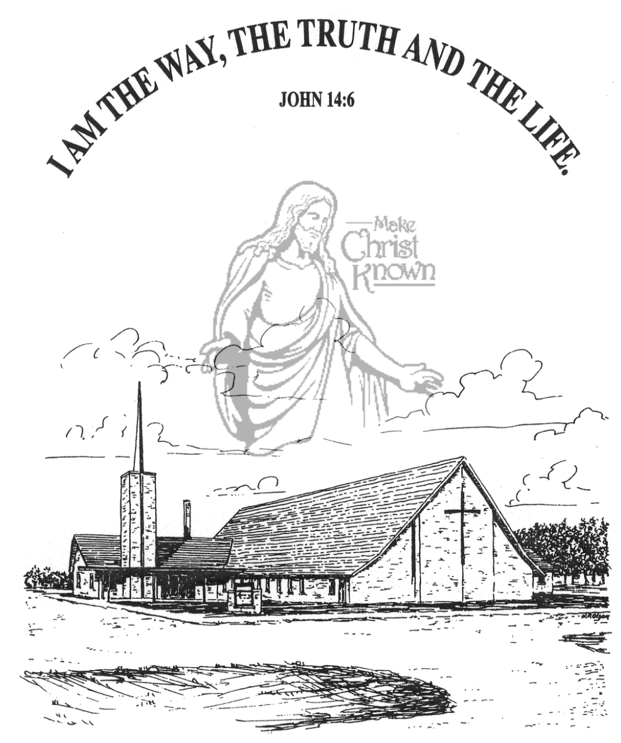

**Sunday, October 29, 2023**

**Salem Reformed Church**

**Menno, South Dakota**

**Office Hours for Pastor Hecht**

Tuesday – Friday: 8:00 AM to Noon (Church Office)

Afternoons: Visitation or Church Office

Church: (605) 387-5334 Parsonage: (605) 387-2855

Pastor Mike’s Cell #: (605) 660-1803

Church Web Page: ***salemreformedchurch.com***

**Opportunities**

Greeters Today: Brian and Steph Mehlhaf

Greeters Nov. 05:

Sunday Prayer Time: 8:30 a.m.

Sunday School Classes: 9:15 a.m.

Praise Music: 10:15 a.m.

Worship Service: 10:30 a.m.

**Announcements**

**Welcome:** We extend a warm welcome to our visiting guests this morning. Please sign our guest book in the Narthex. We ask God’s blessing upon you and we pray that you will return and worship with us again soon.

**Congregational Meeting:** The Consistory is planning to hold a congregational meeting TODAY, following our worship service. This meeting is for the purpose of presenting information regarding the possibility of having an assistant pastor here at Salem Reformed.

**Cherub Choir:** The Cherub Choir (ages 3 years thru 3rd Grade) will plan to sing in church on Sunday, Nov. 5th! This is also our Mission Fest Sunday. Please have your children here for Sunday School promptly at 9:15 a.m. Thanks!

**Junior Choir:** The Junior Choir (grades 4-8) will plan to sing in church on Sunday, November 12th.

**Mission Festival Services:** Our Mission Fest is scheduled for Sunday, Nov. 5th, with guest speaker Hannah Mettler. Hannah is the granddaughter of Jeff & Linda Nusz, and serves full-time as a missionary with YWAM (Youth With A Mission), and raises all of her own support. The Mission Fest Offering has been designated as follows: 45% to Hannah Mettler; 45% to YWAM; and 10% to our local FCA at Menno High School. The Consistory will be hosting a Pot Luck Dinner following the worship service.

**CE Committee:** The Christian Ed. Comm. will plan to meet on Sun., Nov. 12th, following our morning worship service.

**Special Thanks:** Special Thanks to Sheri Preszler for placing the flowers in the Sanctuary during October.

**SALEM REFORMED CHURCH**

Menno, South Dakota

Rev. Michael Hecht Pastor

Jennifer Herrboldt Pianist

10:30 AM – Worship Service October 29, 2023

Twenty-second Sunday after Pentecost

**Meditation:** *“Therefore, my dear friends, as you have always obeyed – not only in my presence, but now much more in my absence – continue to work out your salvation with fear and trembling, for it is God who works in you to will and to act according to His good purpose. Do everything without complaining or arguing, so that you may become blameless and pure, children of God without fault in a crooked and perverse generation, in which you shine like stars in the universe as you hold out the word of life – in order that I may boast on the day of Christ that I did not run or labor for nothing. But even if I am being poured out like a drink offering on the sacrifice and service coming from your faith, I am glad and rejoice with all of you. So you too should be glad and rejoice with me.”*

Philippians 2:12-18 NIV

**Praise Music:** #48, #70, #16, #23

**Ringing of the Bell / Welcome / Announcements**

**Opening Prayer**

**\*Hymn:** #151 “A Mighty Fortress Is Our God”

**Sharing of Joys and Concerns**

**Our Time of Offering** Ephesians 3:20,21 NIV

**\*Lord’s Prayer** sung on page #631

**\*Apostles’ Creed** see words on screen

**Kingdom Kids:** “Our Life Saver!“

**Hymn:** #520 “The Longer I Serve Him”

**The Holy Scriptures**

Luke 10:1-20

Large Print NIV 1984 Edition, pg. 1611

**Sermon: “The Life Saving Station”**

**\*Hymn:** #56 “To God Be the Glory”

**\*Benediction:**

**\*Prayer for Our Nation:** “God Bless America”

**Postlude** (*denotes standing for those able)

The congregation will be ushered out after the Benediction

Youth Ushers: Joslynn Fischer and Addisyn Friesen