**Calendar of Events**

Oct 15 Patrick Ireland in Social Hall @ 7:00 p.m.

Oct 16 Men’s Christian Fellowship @ 7:30 p.m.

Oct 17 W.O.C. Program at M/OCC @ 2:00 p.m.

Oct 18 Women’s Bible Study @ 9:30 a.m.

4-O’s Women in Social Hall @ 11:30 a.m.

6/7 Grade Confirmation @ 3:30 – 5:15 p.m.

8 Grade Confirmation @ 5:30 – 7:00 p.m.

FCA at Menno Gym @ 7:30 p.m.

Oct 19 Prayer Group @ 12 Noon

Oct 21 Men Standing Together @ 6:00 p.m.

Oct 22 Prayer Time for Service @ 8:30 a.m.

Sunday School Classes @ 9:15 a.m.

Praise Music @ 10:15 a.m.

Worship Service @ 10:30 a.m.

with New Members being Received

Contemporary Service @ 7:00 p.m.

**Upcoming Special Music**

Sunday, October 22 - Available

Sunday, October 29 - Available

**Announcements**

**Contemporary Service:** Our next Contemporary Service will be Sunday, October 22nd at 7:00 p.m. Dennis Auch will be sharing with us during the service.

**Congregational Meeting:** The Consistory is planning to hold a congregational meeting on Sun., Oct. 29th, following our worship service. This meeting is for the purpose of presenting information regarding the possibility of having an assistant pastor here at Salem Reformed.

**Food Pantry:** Our church youth group will be sponsoring a Food Drive for the Bethany Food Pantry in Freeman. You may bring items to the church now through Sunday, Oct. 22nd. In addition to non-perishable food items, you may also bring personal care items such as tooth paste, shampoo, deodorant, tooth brushes, laundry detergent. Winter caps, gloves and scarves are also welcome. Items may be placed in the Social Hall.

**4-O’s Women:** Will meet in the Social Hall for lunch and fellowship on Wed., Oct. 18th at 11:30 a.m. Lunch will be brought from the Dairy Bar. Sign the sheet in the Narthex.

**Salem Reformed Church – Who Are We?**

**We believe the Bible to be the inspired, inerrant, infallible Word of God in its original manuscripts. It is our supreme authority in all matters doctrine and practice. We are affiliated with the Conservative Congregational Christian Conference.**

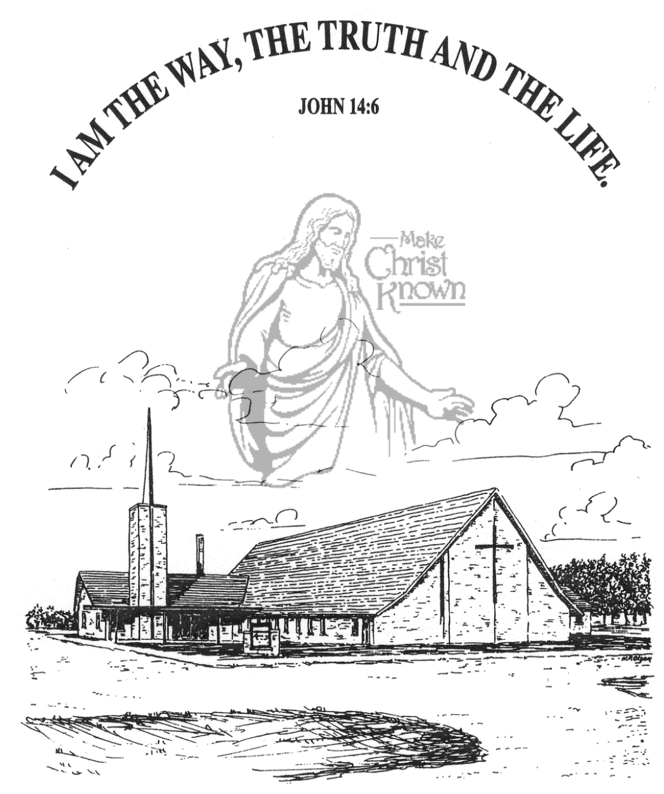

**Sunday, October 15, 2023**

**Salem Reformed Church**

**Menno, South Dakota**

**Office Hours for Pastor Hecht**

Tuesday – Friday: 8:00 AM to Noon (Church Office)

Afternoons: Visitation or Church Office

Church: (605) 387-5334 Parsonage: (605) 387-2855

Pastor Mike’s Cell #: (605) 660-1803

Church Web Page: ***salemreformedchurch.com***

**Opportunities**

Greeters Today: Donna Friesen, Harriet Schaeffer

Greeters Oct. 22: Sally Sayler

Sunday Prayer Time: 8:30 a.m.

Sunday School Classes: 9:15 a.m.

Praise Music: 10:15 a.m.

Worship Service: 10:30 a.m.

**Announcements**

**Welcome:** We extend a warm welcome to our visiting guests this morning. Please sign our guest book in the Narthex. We ask God’s blessing upon you and we pray that you will return and worship with us again soon.

**Patrick Ireland:** A 1981 Menno High School Graduate, and 20 year Army Chaplain will be here THIS EVENING at 7PM to share in the Social Hall.

**Men Standing Together:** Sat., Oct. 21st at 6:00 p.m. in our Social Hall. Jared Wockenfuss, Scotland, will be our guest speaker. Please sign the sheet in the Narthex if you plan to attend. Supper will be provided. Invite your friends! Middle/High School age young men are welcome!

**Cherub Choir:** The Cherub Choir (ages 3 years thru 3rd Grade) will plan to sing in church on Sunday, Nov. 5th! This is also our Mission Fest Sunday. Please have your children here for Sunday School promptly at 9:15 a.m. Thanks!

**Mission Festival Services:** Our Mission Fest is scheduled for Sunday, Nov. 5th, with guest speaker Hannah Mettler. Hannah is the granddaughter of Jeff & Linda Nusz, and serves full-time as a missionary with YWAM (Youth With A Mission), and raises all of her own support. The Mission Fest Offering has been designated as follows: 45% to Hannah Mettler; 45% to YWAM; and 10% to our local FCA at Menno High School. The Consistory will be hosting a Pot Luck Dinner following the worship service.

**Program at M/OCC:** The Women of the Church will be leading a program at M/OCC on Tues., Oct. 17th @ 2 PM. Please sign the sheet in the Narthex if you can attend.

**SALEM REFORMED CHURCH**

Menno, South Dakota

Rev. Michael Hecht Pastor

Marina Schaeffer Pianist

10:30 AM – Worship Service October 15, 2023

Twentieth Sunday after Pentecost

**Meditation:** *“After this the Lord appointed seventy-two others and sent them two by two ahead of Him to every town and place where He was about to go. He told them, ‘The harvest is plentiful, but the workers are few. Ask the Lord of the harvest, therefore, to send out workers, into His harvest field. Go! I am sending you out like lambs among wolves. Do not take a purse or bag or sandals; and do not greet anyone on the road. . . . He who listens to you listens to Me; he who rejects you rejects Me; but he who rejects Me rejects Him who sent Me. The seventy-two returned with joy and said, ‘Lord, even the demons submit to us in Your Name.’ He replied, ‘I saw Satan fall like lightning from heaven. I have given you authority to trample on snakes and scorpions and to overcome all the power of the enemy; nothing will harm you.’ “* Luke 10:1-4, 16-19 NIV

**Praise Music:** #51, #123, #120, #150

**Ringing of the Bell / Welcome / Announcements**

**Opening Prayer**

**\*Hymn:** #368 “He Lives!”

**Sharing of Joys and Concerns**

**Our Time of Offering** I Corinthians 12:18-20 NIV

**\*Doxology** sung on page #815

**\*Lord’s Prayer** debts and debtors

**Kingdom Kids:** “Let’s Do the Hokey Pokey!“

**Hymn:** #96 “I’m Forever Grateful”

**The Holy Scriptures**

Exodus 18:1-27

Large Print NIV 1984 Edition, pg. 115

**Sermon: “You Cannot Handle It Alone”**

**\*Hymn:** #133 “Whom Shall I Fear?”

**\*Benediction:**

**\*Prayer for Our Nation:** “God Bless America”

**Postlude** (*denotes standing for those able)

The congregation will be ushered out after the Benediction

Youth Ushers: Joslynn Fischer and Addisyn Friesen