**Calendar of Events**

Sept 10 High School Youth Supper/Games @ 6:00 pm

Sept 11 Homecoming Coronation at MHS @ 7:30 p.m.

Sept 13 Women’s Bible Study @ 9:30 a.m.

6/7 Grade Confirmation @ 3:30 – 5:15 p.m.

8 Grade Confirmation @ 5:30 – 7:00 p.m.

Consistory Meeting @ 7:30 p.m.

Sept 14 Prayer Group @ 12 Noon

Sept 17 Prayer Time for Service @ 8:30 a.m.

Sunday School Classes @ 9:15 a.m.

Praise Music @ 10:15 a.m.

Worship Service @ 10:30 a.m.

w/Baptism of August Alan Munkvold

Contemporary Service @ 7:00 p.m.

Sept 18 Men’s Christian Fellowship @ 7:30 p.m.

**Upcoming Special Music**

Sunday, September 17 - Available

Sunday, September 24 - Available

**Announcements**

**Kuchen Donations:** Please sign the sheet in the Narthex if you are willing to bake and donate some kuchen for the Youth Group Food Stand at the Power Show. The Menno Pioneer Power Show is the weekend of September 23/24.

**Adult S.S. Class Options:** 1) The Older Adult Class will be studying through the Gospel of John, meeting in Rms 6/7.

2) A Women’s Class will be studying 2 Cor. with a DVD led study, *“All Things New”,* by Kelly Minter, meeting in Room 10.

3) The Young Adult Class will be meeting and studying through the Book of James, meeting in Room 11. Please consider attending one of these classes and learning God’s Word at the same time that your children are. Thanks!

**Contemporary Service:** We will plan to have a Contemporary Worship Service next Sunday evening, Sept. 17th at 7:00 p.m.

**Potato Topper Supper:** You are invited to the Friedens Reformed Church, Tripp, SD, on Wed., Sept. 13th, for this event. They will be serving from 5-8 p.m.

**Sunday Flowers:**  Please sign the sheet in the Narthex if you are able to place flowers in the Sanctuary during Nov. or Dec.

**Salem Reformed Church – Who Are We?**

**We believe the Bible to be the inspired, inerrant, infallible Word of God in its original manuscripts. It is our supreme authority in all matters doctrine and practice. We are affiliated with the Conservative Congregational Christian Conference.**

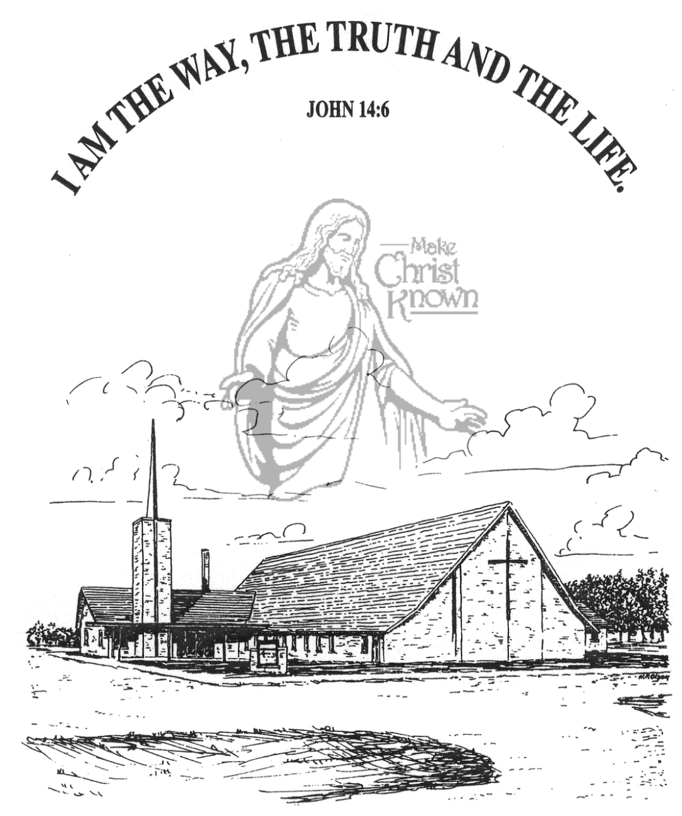

**Sunday, September 10, 2023**

**Salem Reformed Church**

**Menno, South Dakota**

**Office Hours for Pastor Hecht**

Tuesday – Friday: 8:00 AM to Noon (Church Office)

Afternoons: Visitation or Church Office

Church: (605) 387-5334 Parsonage: (605) 387-2855

Pastor Mike’s Cell #: (605) 660-1803

Church Web Page: ***salemreformedchurch.com***

**Opportunities**

Greeters Today: Johnny and Lori Woehl

Greeters Sept. 17: Kevin Holzwarth Family

Sunday Prayer Time: 8:30 a.m.

Sunday School Classes: 9:15 a.m.

Praise Music: 10:15 a.m.

Worship Service: 10:30 a.m.

**Announcements**

**Welcome:** We extend a warm welcome to our visiting guests this morning. Please sign our guest book in the Narthex. We ask God’s blessing upon you and we pray that you will return and worship with us again soon.

**Pot Luck Dinner:** The CE Committee will host a Pot Luck Dinner after church TODAY! All are welcome to stay for a time of lunch and fellowship. Outside Games will follow for the children and youth.

**High School Youth:** The High School Youth will meet THIS EVENING @ 6 p.m. in the Social Hall for supper and games.

**Summer Camps:** If your child(ren) have attended a Christian Camp this summer the W.O.C. are willing to help with the cost. If you would like reimbursement, you must turn in a copy of the camp registration to Joanie Handel or to the church office. Please do this ASAP; the final deadline is September 24th.

**Sound Crew Help:** Do you like sound, video technology? Would you be willing to be a part of the sound crew here at church – sound, video or projection? Please contact Joanie Handel or Ken Stepanek for more information. High School students are also welcome to be a part of this ministry!

**Menno FCA:** The Fellowship of Christian Athletes will be meeting on the 1st & 3rd Wednesdays of each month at 7:30 p.m. in the Menno Gym. This is open to students in 8th thru 12th Grade. Please come and join us!

**Happy Grandparents Day!** We have a baggie of Hershey Kisses for each grandparent to pick up after church today! May God bless you with health and strength for each day!

**SALEM REFORMED CHURCH**

Menno, South Dakota

Rev. Michael Hecht Pastor

Sharyl Herrboldt Pianist

10:30 AM – Worship Service September 10, 2023

Fifteenth Sunday after Pentecost

**Meditation:** *“Blessed is the man who does not walk in the counsel of the wicked or stand in the way of sinners or sit in the seat of mockers. But his delight is in the law of the LORD, and on His law he meditates day and night. He is like a tree planted by streams of water, which yields its fruit in season and whose leaf does not wither. Whatever he does prospers. Not so the wicked! They are like chaff that the wind blows away. Therefore the wicked will not stand in the judgment, nor sinners in the assembly of the righteous. For the LORD watches over the way of the righteous, but the way of the wicked will perish.”* Psalm 1:1-6 NIV

**Praise Music:** #19, #1, #5, #144, #43

**Ringing of the Bell**

**Welcome / Announcements / Opening Prayer**

**\*Hymn:** #3 “Holy, Holy, Holy! Lord God Almighty”

**Sharing of Joys and Concerns**

**Our Time of Offering** Deut. 6:4-7 NIV

**\*Doxology** sung on page #815

**\*Lord’s Prayer** debts and debtors

**Presentation of Sunday School Teachers**

**Responsive Reading – taken from Romans 12:3-8**

**Covenant / Prayer of Affirmation**

**Hymn:** #185 “Jesus Loves Me”

**Presentation Of:** by Lee Heckenlaible, S.S. Superintendent

**ESV Children’s Bibles - 2nd/3rd Grade**

**Heidelberg Catechism - 4th Grade**

**Egermeier’s Bible Story Book - 6th Grade**

**The Holy Scriptures**

I Corinthians 9:24-27 NLT

Large Print NIV 1984 Edition, pg. 1782

**Sermon/Skit: “Run In Such A Way”**

**\*Hymn:** #526 “The Solid Rock”

**\*Benediction:**

**\*Prayer for Our Nation:** “God Bless America”

**Postlude** (*denotes standing for those able)

The congregation will be ushered out after the Benediction

Youth Ushers: Hunter Masterson and Kaelie Derby