**Calendar of Events**

Oct 02 Men’s Christian Fellowship @ 7:30 p.m.

Oct 03 Ministerial Meeting at Roosters @ 11:30 a.m.

Oct 04 Women’s Bible Study @ 9:30 a.m.

6/7 Grade Confirmation @ 3:30 – 5:15 p.m.

8 Grade Confirmation @ 5:30 – 7:00 p.m.

FCA at Menno Gym @ 7:30 p.m.

Oct 05 Prayer Group @ 12 Noon

Oct 018 Prayer Time for Service @ 8:30 a.m.

Sunday School Classes @ 9:15 a.m.

Praise Music @ 10:15 a.m.

Worship Service @ 10:30 a.m.

With Coffee Hour Following

Women of Church Meeting @ 11:45 a.m.

**Upcoming Special Music**

Sunday, October 08 - Available

Sunday, October 15 - Available

**Announcements**

**Congregational Meeting:** The Consistory is planning to hold a congregational meeting on Sun., Oct. 29th, following our worship service. This is for the purpose of presenting information regarding the possibility of having an assistant pastor here at Salem Reformed.

**Patrick Ireland:** A 1981 Menno Grad, and 20 year Army Chaplain will be here on Sun., Oct. 15th @ 7PM to share in the Social Hall.

**Food Pantry:** Our church youth group will be sponsoring a Food Drive for the Bethany Food Pantry in Freeman. This will start Today and go through Sunday, Oct. 22nd. In addition to non-perishable food items, you may also bring personal care items such as tooth paste, shampoo, deodorant, tooth brushes, laundry detergent. Winter caps, gloves and scarves are also welcome. Items may be placed in the Social Hall.

**4-O’s Women:** Will meet in the Social Hall for lunch and fellowship on Wed., Oct. 18th at 11:30 a.m. Lunch will be brought from the Dairy Bar. Sign the sheet in the Narthex.

**Sound Crew Help:** Do you like sound, video technology? Would you be willing to be a part of the sound crew here at church – sound, video or projection? Please contact Joanie Handel or Ken Stepanek for more information. High School students are also welcome to be a part of this ministry!

**Salem Reformed Church – Who Are We?**

**We believe the Bible to be the inspired, inerrant, infallible Word of God in its original manuscripts. It is our supreme authority in all matters doctrine and practice. We are affiliated with the Conservative Congregational Christian Conference.**

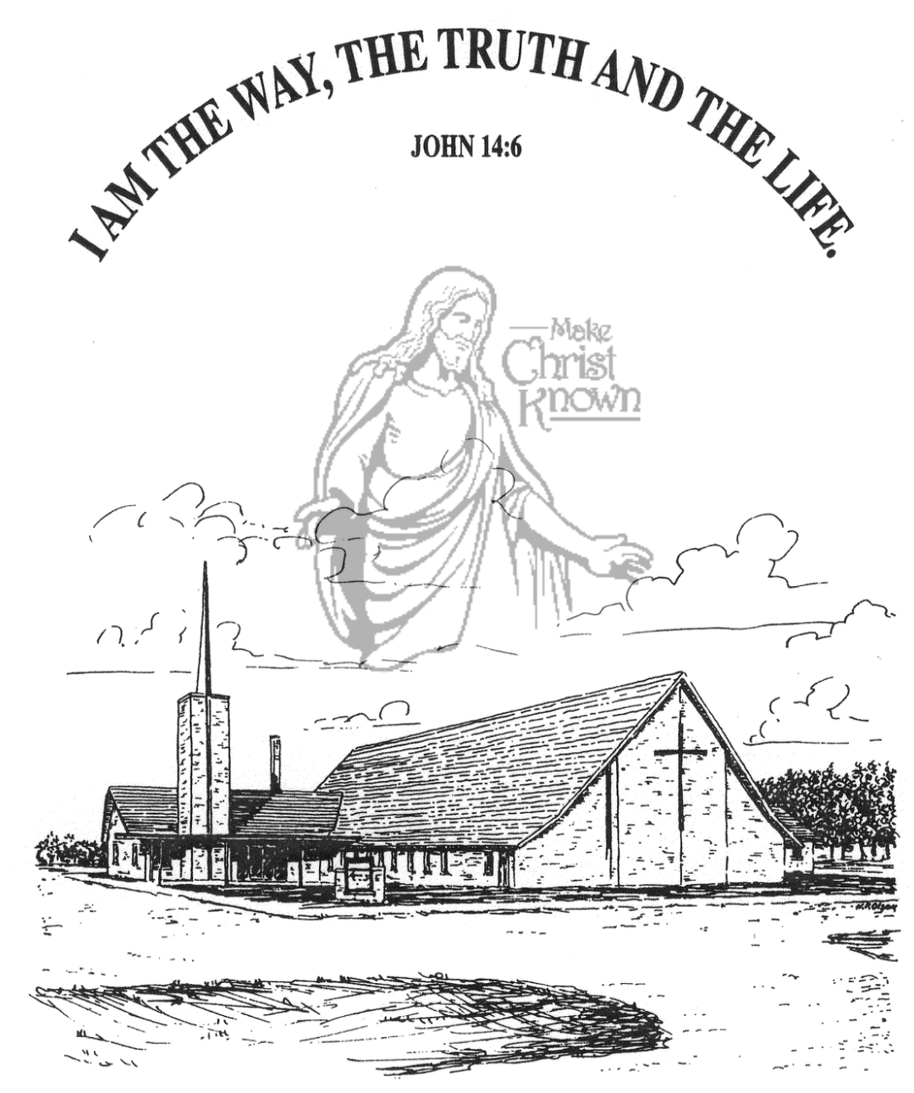

**Sunday, October 01, 2023**

**Salem Reformed Church**

**Menno, South Dakota**

**Office Hours for Pastor Hecht**

Tuesday – Friday: 8:00 AM to Noon (Church Office)

Afternoons: Visitation or Church Office

Church: (605) 387-5334 Parsonage: (605) 387-2855

Pastor Mike’s Cell #: (605) 660-1803

Church Web Page: ***salemreformedchurch.com***

**Opportunities**

Greeters Today: Larry and Connie Kirschenman

Greeters Oct. 08: Lee and Dianne Herrboldt

Sunday Prayer Time: 8:30 a.m.

Sunday School Classes: 9:15 a.m.

Praise Music: 10:15 a.m.

Worship Service: 10:30 a.m.

**Announcements**

**Welcome:** We extend a warm welcome to our visiting guests this morning. Please sign our guest book in the Narthex. We ask God’s blessing upon you and we pray that you will return and worship with us again soon.

**Holy Communion:** We at Salem Reformed Church recognize an open communion table. All are welcome to partake of the bread and wine and accept the gift of grace that God offers to us through Jesus Christ, our Savior and Lord. **The inner most ring of the communion tray contains grape juice. All other rings contain wine.

**Power Show Food Stand:** THANK YOU to everyone who helped with the Youth Concession Stand at the Power Show last weekend! A BIG THANK YOU to Matt/Trishia Fischer and Scott/Amy Nusz for coordinating this fund raiser for our High School Youth! **\*NOTE:** There are left over items for sale today in the kitchen following our worship service.

**Coffee Hour:** We are looking for 2 more volunteers to bring 2 dozen goodies for Coffee Hour on Sun., Oct. 8th.

**W.O.C. Fall Meeting:** The Women of the Church will plan to meet after church on Sunday, October 8th.

**Church Pictorial Committee:** Thanks to Shirley Mettler, Stephanie Wagner, Cassie Wielenga, and Mary Heckenlaible for being willing to serve on this committee. More details will be given in the future. Thanks!

**Cherub Choir:** The Cherub Choir (ages 3 yrs thru 3rd Grade) will plan to sing in church on Sunday, Nov. 5th! This is also our Mission Fest Sunday. Please have your children here for Sunday School promptly at 9:15 a.m. Thanks!

**SALEM REFORMED CHURCH**

Menno, South Dakota

Rev. Michael Hecht Pastor

Jennifer Herrboldt Pianist

10:30 AM – Worship Service October 01, 2023

Eighteenth Sunday after Pentecost

**Meditation:** *“That if you confess with your mouth, ‘Jesus is Lord,’ and believe in your heart that God raised Him from the dead, you will be saved. For it is with your heart that you believe and are justified, and it is with your mouth that you confess and are saved. As the Scripture says, ‘Anyone who trusts in Him will never be put to shame.’ For there is no difference between Jew and Gentile – the same Lord is Lord of all and richly blesses all who call on Him, for, ‘Everyone who calls on the name of the Lord will be saved.’*

Romans 10:9-13 NIV

**Praise Music:** #49, #147, #131, #140

**Ringing of the Bell**

**Welcome / Announcements**

**Opening Prayer**

**\*Hymn:** #90 “Joyful, Joyful, We Adore Thee”

**Sharing of Joys and Concerns**

**Our Time of Offering** John 15:13,14 NIV

**\*Doxology** sung on page #815

**\*Lord’s Prayer** debts and debtors

**Kingdom Kids:** “The Savior’s Happy Meal“

**Hymn:** #304 “Behold The Lamb”

**The Holy Scriptures**

Mark 8:30-38

Large Print NIV 1984 Edition, pg. 1567

**Sermon: “The Message of the Cross”**

**Special Music:** “Come To The Altar” sung by Julie Mooney

**Prayer of Confession**

#63 “Amazing Love”

#115 “The Wonderful Cross”

**Sacrament of Holy Communion**

**\*Hymn:** #318 “I Believe In a Hill Called Mount Calvary”

**\*Benediction:**

**Postlude** (*denotes standing for those able)

The congregation will be ushered out after the Benediction

Youth Ushers: Joslynn Fischer and Addisyn Friesen