**Calendar of Events**

Sept 27 Women’s Bible Study @ 9:30 a.m.

6/7 Grade Confirmation @ 3:30 – 5:15 p.m.

8 Grade Confirmation @ 5:30 – 7:00 p.m.

Sept 28 Prayer Group @ 12 Noon

Oct 01 Prayer Time for Service @ 8:30 a.m.

Sunday School Classes @ 9:15 a.m.

Praise Music @ 10:15 a.m.

Worship Service @ 10:30 a.m.

**with Holy Communion!**

Oct 02 Men’s Christian Fellowship @ 7:30 p.m.

Oct 03 Ministerial Meeting at Roosters @ 11:30 a.m.

**Upcoming Special Music**

Sunday, October 01 - Julie Mooney

Sunday, October 08 - Available

**Announcements**

**Adult S.S. Class Options:** 1) The Older Adult Class will be studying through the Gospel of John, meeting in Rms 6/7.

2) A Women’s Class will be studying 2 Cor. with a DVD led study, *“All Things New”,* by Kelly Minter, meeting in Rm 10.

3) The Young Adult Class will be meeting and studying through the Epistle of I John, meeting in Room 11. Please consider attending one of these classes and learning God’s Word at the same time that your children are. Thanks!

**Food Pantry:** Our church youth group will be sponsoring our Annual Food Drive for the Bethany Food Pantry in Freeman. This will start next Sunday, October 1st and go through Sunday, Oct. 22nd. In addition to non-perishable food items, you may also bring personal care items such as tooth paste, shampoo, deodorant, tooth brushes, laundry detergent. Winter caps, gloves and scarves are also welcome. Items may be placed in the Social Hall.

**4-O’s Women:** The 4-O’s Women will plan to meet in the Social Hall for lunch and fellowship on Wed., Oct. 18th at 11:30 a.m. Lunch will be brought from the Dairy Bar. Please sign the sheet in the Narthex if you plan to attend.

**Salem Reformed Church – Who Are We?**

**We believe the Bible to be the inspired, inerrant, infallible Word of God in its original manuscripts. It is our supreme authority in all matters doctrine and practice. We are affiliated with the Conservative Congregational Christian Conference.**

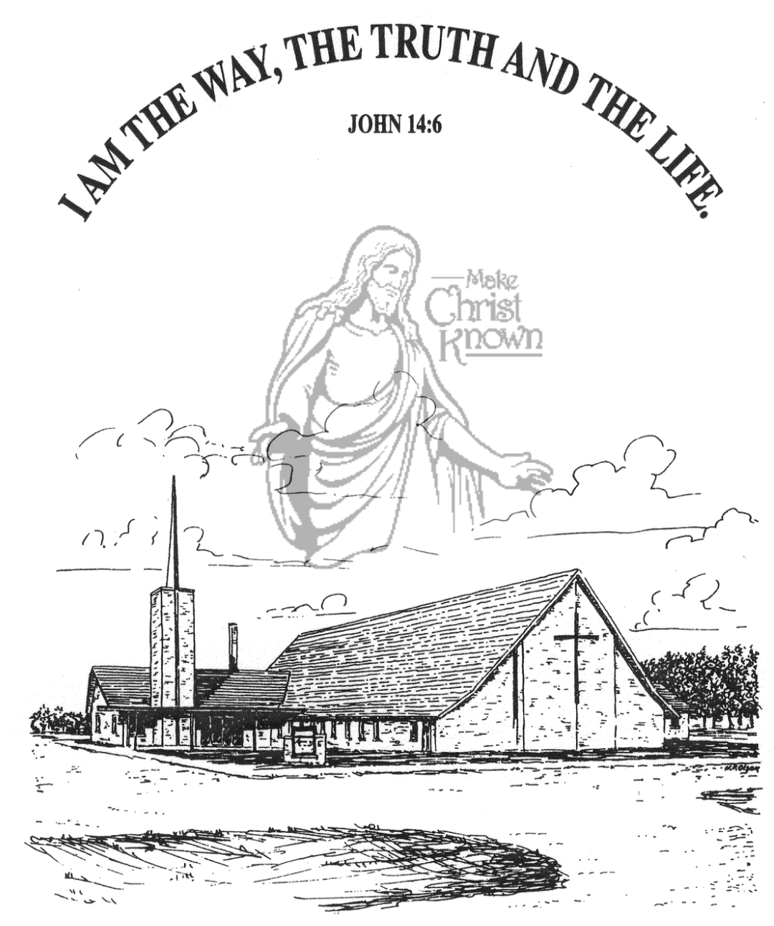

**Sunday, September 24, 2023**

**Salem Reformed Church**

**Menno, South Dakota**

**Office Hours for Pastor Hecht**

Tuesday – Friday: 8:00 AM to Noon (Church Office)

Afternoons: Visitation or Church Office

Church: (605) 387-5334 Parsonage: (605) 387-2855

Pastor Mike’s Cell #: (605) 660-1803

Church Web Page: ***salemreformedchurch.com***

**Opportunities**

Greeters Today: Carl and Linda Zeeb

Greeters Oct. 01: Larry and Connie Kirschenman

Sunday Prayer Time: 8:30 a.m.

Sunday School Classes: 9:15 a.m.

Praise Music: 10:15 a.m.

Worship Service: 10:30 a.m.

**Announcements**

**Welcome:** We extend a warm welcome to our visiting guests this morning. Please sign our guest book in the Narthex. We ask God’s blessing upon you and we pray that you will return and worship with us again soon.

**Sound Crew Help:** Do you like sound, video technology? Would you be willing to be a part of the sound crew here at church – sound, video or projection? Please contact Joanie Handel or Ken Stepanek for more information. High School students are also welcome to be a part of this ministry!

**Power Show Food Stand:** Our High School Youth Group will once again be hosting a Food Stand at the Power Show **TODAY**! They will be serving chislic, burgers, hot dogs, and kuchen! Thanks to everyone who has been helping with this youth fundraiser! God Bless You!

**Coffee Hour:** We are looking for 5 more volunteers to bring 2 dozen goodies for Coffee Hour on Sun., October 8th. Please sign the sheet in the Narthex if you can help.

**W.O.C. Fall Meeting:** The Women of the Church will plan to meet after church on Sunday, October 8th.

**Church Pictorial Committee:** We are looking for individuals willing to serve on a Committee for our next Church Pictorial Directory. Our last one was done in 2017! We have found a company similar to Life Touch that still does this for churches. Please contact the Church Office if you would like to serve on the planning and organizing of our next Directory. Thanks!

**Special Thanks:** Thanks to Stephanie Wagner for placing the flowers in the sanctuary during September!

**SALEM REFORMED CHURCH**

Menno, South Dakota

Rev. Michael Hecht Pastor

Cindy Herrboldt Organist

10:30 AM – Worship Service September 24, 2023

Seventeenth Sunday after Pentecost

**Meditation:** *“When Jesus came to the region of Caesarea Philippi, He asked His disciples, ‘Who do people say the Son of Man is?’ They replied, ‘Some say John the Baptist; others say Elijah; and still others, Jeremiah or one of the prophets.’ ‘But what about you?’ He asked. ‘Who do you say I am?’ Simon Peter answered, ‘You are the Christ, the Son of the living God.’ Jesus replied, ‘Blessed are you, Simon son of Jonah, for this was not revealed to you by man, but by My Father in heaven. And I tell you that you are Peter, and on this rock I will build My church, and the gates of Hades will not overcome it. I will give you the keys of the kingdom of heaven; whatever you bind on earth will be bound in heaven, and whatever you loose on earth will be loosed in heaven.’ Then He warned His disciples not to tell anyone that He was the Christ.”*  Matthew 16:13-20 NIV

**Praise Music:** #47, #7, #59, #65, #121, #32

**Ringing of the Bell**

**Welcome / Announcements / Opening Prayer**

**\*Hymn:** #63 “All Creatures of Our God and King”

**Sharing of Joys and Concerns**

**Our Time of Offering** II Corinthians 9:8 AMP

**\*Doxology** sung on page #815

**\*Lord’s Prayer** debts and debtors

**Kingdom Kids:** “Who Is This Man?“

**Hymn:** #118 “His Name Is Wonderful”

**The Holy Scriptures**

Mark 8:27-30

Large Print NIV 1984 Edition, pg. 1566

**Sermon: “The Supreme Confession”**

**\*Hymn:** #602 “I Have Decided To Follow Jesus”

**\*Benediction:**

**\*Prayer for Our Nation:** “God Bless America”

**Postlude** (*denotes standing for those able)

The congregation will be ushered out after the Benediction

Youth Ushers: Hunter Masterson, Kaelie Derby, Hunter Yosten