**Calendar of Events**

Sept 17 Contemporary Service @ 7:00 p.m.

Sept 18 Men’s Christian Fellowship @ 7:30 p.m.

Sept 20 Women’s Bible Study @ 9:30 a.m.

6/7 Grade Confirmation @ 3:30 – 5:15 p.m.

8 Grade Confirmation @ 5:30 – 7:00 p.m.

FCA in Menno Gym @ 7:30 p.m.

Sept 21 Prayer Group @ 12 Noon

Sept 24 Prayer Time for Service @ 8:30 a.m.

Sunday School Classes @ 9:15 a.m.

Praise Music @ 10:15 a.m.

Worship Service @ 10:30 a.m.

**Upcoming Special Music**

Sunday, September 24 - Available

Sunday, October 01 - Julie Mooney

**Announcements**

**Coffee Hour:** We are looking for 6 more volunteers to bring 2 dozen goodies for Coffee Hour on Sun., October 8th. Please sign the sheet in the Narthex if you are able to help.

**W.O.C. Fall Meeting:** The Women of the Church will plan to meet after church on Sunday, October 8th.

**Kuchen Donations:** Please sign the sheet in the Narthex if you are willing to bake and donate some kuchen for the Youth Group Food Stand at the Power Show. The Menno Pioneer Power Show is the weekend of September 23/24.

**Adult S.S. Class Options:** 1) The Older Adult Class will be studying through the Gospel of John, meeting in Rms 6/7.

2) A Women’s Class will be studying 2 Cor. with a DVD led study, *“All Things New”,* by Kelly Minter, meeting in Room 10.

3) The Young Adult Class will be meeting and studying through the Epistle of I John, meeting in Room 11. Please consider attending one of these classes and learning God’s Word at the same time that your children are. Thanks!

**Power Show Food Stand:** Our High School Youth Group will once again be hosting a Food Stand at the Power Show next weekend, Sept. 23/24. They will be serving chislic, burgers, hot dogs, and kuchen! Thanks to everyone who will be helping with this youth fundraiser!

**Salem Reformed Church – Who Are We?**

**We believe the Bible to be the inspired, inerrant, infallible Word of God in its original manuscripts. It is our supreme authority in all matters doctrine and practice. We are affiliated with the Conservative Congregational Christian Conference.**

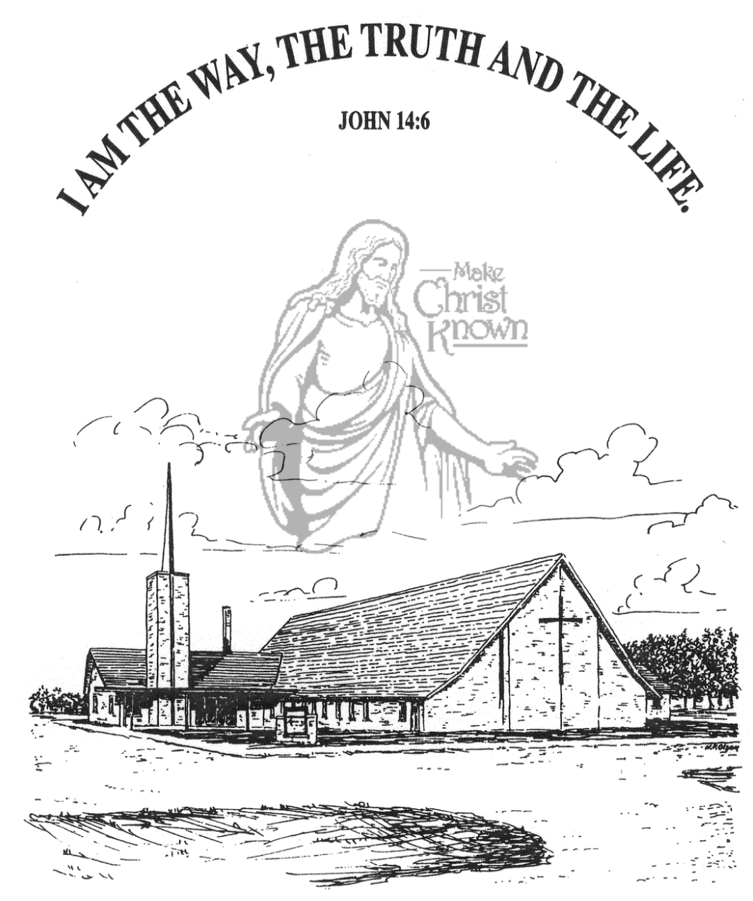

**Sunday, September 17, 2023**

**Salem Reformed Church**

**Menno, South Dakota**

**Office Hours for Pastor Hecht**

Tuesday – Friday: 8:00 AM to Noon (Church Office)

Afternoons: Visitation or Church Office

Church: (605) 387-5334 Parsonage: (605) 387-2855

Pastor Mike’s Cell #: (605) 660-1803

Church Web Page: ***salemreformedchurch.com***

**Opportunities**

Greeters Today: Kevin Holzwarth Family

Greeters Sept. 24:

Sunday Prayer Time: 8:30 a.m.

Sunday School Classes: 9:15 a.m.

Praise Music: 10:15 a.m.

Worship Service: 10:30 a.m.

**Announcements**

**Welcome:** We extend a warm welcome to our visiting guests this morning. Please sign our guest book in the Narthex. We ask God’s blessing upon you and we pray that you will return and worship with us again soon.

**Congratulations:** We rejoice with the family of August Alan Munkvold at his baptism! August’s parents are Trevor and Nicole Munkvold. He joins his older sister, Evelyn. We extend a warm welcome to all of their family and friends who may be present in our worship service today.

**Pot Luck Dinner:** THANKS to the CE Committee & Spouses for hosting the Pot Luck Dinner and Games last Sunday after church! We had a great time of Fellowship and Fun!

**Summer Camps:** If your child(ren) have attended a Christian Camp this summer the W.O.C. are willing to help with the cost. If you would like reimbursement, you must turn in a copy of the camp registration to Joanie Handel or to the church office by September 24th.

**Sound Crew Help:** Do you like sound, video technology? Would you be willing to be a part of the sound crew here at church – sound, video or projection? Please contact Joanie Handel or Ken Stepanek for more information. High School students are also welcome to be a part of this ministry!

**Menno FCA:** The Fellowship of Christian Athletes will be meeting on the 1st & 3rd Wednesdays of each month at 7:30 p.m. in the Menno Gym. This is open to students in 8th thru 12th Grade. Please come and join us!

**Contemporary Service:** JOIN US for a Contemporary Worship Service this evening at 7:00 p.m. Bring your Friends!

**SALEM REFORMED CHURCH**

Menno, South Dakota

Rev. Michael Hecht Pastor

Joan Nusz Pianist

10:30 AM – Worship Service September 17, 2023

Sixteenth Sunday after Pentecost

**Meditation:** *“Therefore, since we have a great high priest who has gone through the heavens, Jesus the Son of God, let us hold firmly to the faith we profess. For we do not have a high priest who is unable to sympathize with our weaknesses, but we have one who has been tempted in every way, just as we are – yet was without sin. Let us then approach the throne of grace with confidence, so that we may receive mercy and find grace to help us in our time of need.”*  Hebrews 4:14-16 NIV

**Praise Music:** #69, #78, #54, #110, #132

**Ringing of the Bell**

**Welcome / Announcements / Opening Prayer**

**\*Hymn:** #562 “Be Thou My Vision”

**Sharing of Joys and Concerns**

**Our Time of Offering** Psalm 127:3-5 NLT

**\*Doxology** sung on page #815

**\*Apostles’ Creed** words on screen

**Baptism: August Alan Munkvold**

**Questions of the Candidates**

**Congregational Assent** (see words on screen)

**Education Committee Pledge** Kevin Holzwarth

**Act of Baptism**

**Congregational Song: “Yes, Jesus Loves You!”**

**Kingdom Kids:** “Bring Our Friends to Jesus“

**Hymn:** #643 “O Lord, You’re Beautiful”

**The Holy Scriptures**

Mark 8:22-26

Large Print NIV 1984 Edition, pg. 1566

**Sermon: “Do You See Anything?”**

**\*Hymn:** #505 “He Touched Me”

**\*Benediction:**

**\*Prayer for Our Nation:** “God Bless America”

**Postlude** (*denotes standing for those able)

The congregation will be ushered out after the Benediction

Youth Ushers: Hunter Masterson and Kaelie Derby