**Calendar of Events**

Sept 03 M/O Care Center Service @ 2:00 p.m.

Sept 04 Men’s Christian Fellowship @7:30 p.m.

Sept 06 6/7 Grade Confirmation @ 3:30 – 5:15 p.m.

8 Grade Confirmation @ 5:30 – 7:00 p.m.

FCA at Menno Gym @ 7:30 p.m.

Sept 07 Prayer Group @ 12 Noon

Sept 10 **Sunday School Kick-Off**

Prayer Time for Service @ 8:30 a.m.

Sunday School Classes @ 9:15 a.m.

Praise Music @ 10:15 a.m.

Worship Service @ 10:30 a.m.

w/Pot Luck Dinner and Games Following

High School Youth Supper/Games @ 6:00 pm

**Upcoming Special Music**

Sunday, September 10 - Available

Sunday, September 17 - Available

**Announcements**

**Fall Women’s Bible Study:** *“All Things New”* is an 8 Session Study on 2 Corinthians – a DVD led study by Kelly Minter. Because of Jesus the old has gone, the new has come! Classes will begin Sun., Sept. 10th @ 9:15 a.m. Wednesday classes will begin on Sept. 13th @ 9:30 a.m. Please sign the sheet in the Narthex if you plan to attend.

**High School Youth:** The High School Youth will meet Sun., Sept. 10th @ 6 p.m. in the Social Hall for supper and games.

**Kuchen Donations:** Please sign the sheet in the Narthex if you are willing to bake and donate some kuchen for the Youth Group Food Stand at the Power Show. The Menno Pioneer Power Show is the weekend of September 23/24.

**Adult S.S. Class Options:** 1) The Older Adult Class will be studying through the Gospel of John, meeting in Rms 6/7.

2) A Women’s Class will be studying 2 Corinthians with a DVD let study by Kelly Minter, meeting in Room 10.

3) The Young Adult Class will be meeting and studying through the Book of James, meeting in Room 11. Please consider attending one of these classes and learning God’s Word at the same time that your children are. Thanks!

**Salem Reformed Church – Who Are We?**

**We believe the Bible to be the inspired, inerrant, infallible Word of God in its original manuscripts. It is our supreme authority in all matters doctrine and practice. We are affiliated with the Conservative Congregational Christian Conference.**

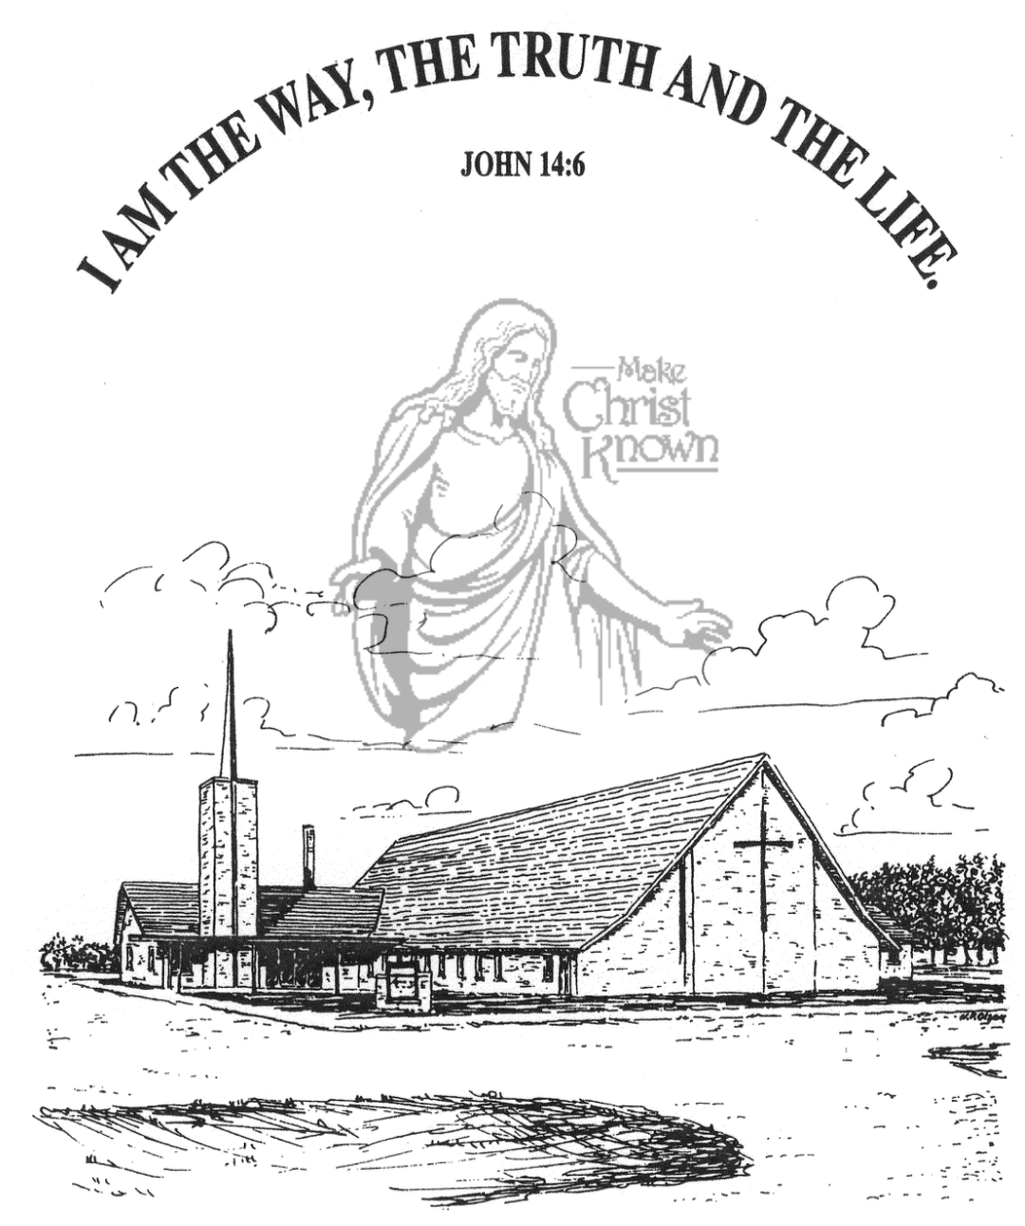

**Sunday, September 03, 2023**

**Salem Reformed Church**

**Menno, South Dakota**

**Office Hours for Pastor Hecht**

Tuesday – Friday: 8:00 AM to Noon (Church Office)

Afternoons: Visitation or Church Office

Church: (605) 387-5334 Parsonage: (605) 387-2855

Pastor Mike’s Cell #: (605) 660-1803

Church Web Page: ***salemreformedchurch.com***

**Opportunities**

Greeters Today: Ken and Ramona Bittner

Greeters Sept. 10: Johnny and Lori Woehl

Sunday Prayer Time: 8:30 a.m.

Sunday School Classes: 9:15 a.m.

Praise Music: 10:15 a.m.

Worship Service: 10:30 a.m.

**Announcements**

**Welcome:** We extend a warm welcome to our visiting guests this morning. Please sign our guest book in the Narthex. We ask God’s blessing upon you and we pray that you will return and worship with us again soon.

**Sunday School Kick-Off:** Sunday School Classes will resume on Sunday, September 10th, starting at 9:15 a.m. Praise Music will be at 10:15, with Worship Service at 10:30 a.m. There will be a **Pot Luck Dinner** following for the Congregation, with outside games for the children and youth after lunch.

**Confirmation Classes:** Classes are scheduled to begin on Wed., Sept. 6th. The 6th/7th Graders will come to church right after school and will have class until 5:15 p.m. The 8th Graders will follow, having class from 5:30-7:00 p.m.

**Summer Camps:** If your child(ren) have attended a Christian Camp this summer the W.O.C. are willing to help with the cost. If you would like reimbursement, you must turn in a copy of the camp registration to Joanie Handel or to the church office. Please do this ASAP; the final deadline is September 24th.

**Sound Crew Help:** Do you like sound, video technology? Would you be willing to be a part of the sound crew here at church – sound, video or projection? Please contact Joanie Handel or Ken Stepanek for more information. High School students are also welcome to be a part of this ministry!

**Menno FCA:** The 1st Meeting of the Fellowship of Christian Athletes will be Wed., Sept. 6th at 7:30 p.m. at the Menno Gym. This is open to students in 8th thru 12th Grade.

**SALEM REFORMED CHURCH**

Menno, South Dakota

Rev. Michael Hecht Pastor

Marina Schaeffer Pianist

9:30 AM – Worship Service September 03, 2023

Fourteenth Sunday after Pentecost

**Meditation:** *“And we pray this in order that you may live a life worthy of the Lord and may please Him in every way: bearing fruit in every good work, growing in the knowledge of God, being strengthened with all power according to His glorious might so that you may have great endurance and patience, and joyfully giving thanks to the Father, who has qualified you to share in the inheritance of the saints in the kingdom of light. For He has rescued us from the dominion of darkness and brought us into the kingdom of the Son He loves, in whom we have redemption, the forgiveness of sins. He is the image of the invisible God, the firstborn over all creation.”* Colossians 1:10-15 NIV

**Praise Music:** #108, #135, #139, #120

**Ringing of the Bell**

**Welcome / Announcements**

**Opening Prayer**

**\*Hymn:** #82 “Praise the Lord! Ye Heavens, Adore Him”

**Sharing of Joys and Concerns**

**Our Time of Offering**

**Invitation to Give** Hebrews 13:15,16 NIV

**\*Doxology** sung on page #815

**\*Apostles’ Creed** words on screen

**Kingdom Kids:** “We Believe!”

**Hymn:** #88 “More Precious Than Silver”

**The Holy Scriptures**

Mark 8:13-21

Large Print NIV 1984 Edition, pg. 1566

**Sermon: “Then They Understood”**

**\*Hymn:** #124 “Jesus Messiah” (praise book)

**\*Benediction:**

**\*Prayer for Our Nation:** “God Bless America”

**Postlude**

(*denotes standing for those able)

The congregation will be ushered out after the Benediction